Title: Improving species conservation plans under IUCN’s One Plan Approach using quantitative genetic methods
Drew Sauve¹, Jane Hudecki², Jessica Steiner², Hazel Wheeler², Colleen Lynch³, Amy A. Chabot^{1,4}
¹Department of Biology, Queen’s University, Kingston, Ontario K7L 3N6, Canada
²Wildlife Preservation Canada, 5420 Highway 6 North, Guelph, Ontario N1H 6J2
³Riverbanks Zoo and Garden, 500 Wildlife Parkway, Columbia, South Carolina USA 29210
⁴African Lion Safari, 1386 Cooper Road, Cambridge, Ontario N1R 5S2
RH: Quantitative genetics and conservation breeding
Keywords: Adaptive potential, ex situ, ecological genetics, gene flow, genetic groups, phenotypic plasticity, translocation, zoos, One Plan Approach, WCC 2020 Resolution 079
Corresponding Author: Drew Sauve, 0as69@queensu.ca, Department of Biology, Queen’s University, Kingston, Ontario K7L 3N6, Canada
Abstract
Human activities are resulting in altered environmental conditions that are impacting the demography and evolution of species globally. If we wish to prevent anthropogenic extinction and extirpation, we need to improve our ability to restore wild populations. Ex situ populations can be an important tool for species conservation. Quantitative genetic analysis can improve management of these populations and thus the success of in situ population management actions that they support. In this review we outline methods that could be used to improve the management of in situ and ex situ populations in a One Plan Approach. We discuss how quantitative genetic models can help measure genetic variation, phenotypic plasticity, and social effects on phenotypes. Finally, we discuss how phenotypic change can be predicted using measurements of additive genetic variance and selection. While previous work has highlighted the value of ex situ populations for the field of quantitative genetics, we argue that quantitative genetics can, in turn, offer opportunities to improve management and consequently conservation of populations of species at risk. We show that quantitative genetic analyses are a tool that could be incorporated into and improve ex situ management practices.
Introduction
Widespread human landscape transformations are resulting in changing conditions for species across the globe (Parmesan 2006). Biodiversity is decreasing due to habitat loss, pollution, disease, and climate change and the majority of countries have not achieved biodiversity targets for 2020 set to slow rates of species declines (United Nations Environment Program Convention on Biological Diversity, Aichi Target 12). This lack of progress calls for new approaches. In 2020, the IUCN World Conservation Congress passed a resolution promoting the integration of in situ (within a species’ natural habitat) and ex situ (in human care outside a species’ natural habitat) conservation interventions by applying the One Plan Approach (OPA; WCC-2020-Res-079n; Byers et al. 2013). Traditionally, species conservation planning has followed parallel but separate tracks: field biologists and wildlife managers’ efforts to address conservation needs in situ, zoo, aquarium, and species specific breeding centres (e.g. the United States Fish and Wildlife Service Black-footed Ferret Conservation Center), efforts to develop sustainable ex situ populations. Under the OPA developed by the IUCN’s Conservation Planning Specialist Group (CPSG), species conservation planning is conducted in an integrated manner by all responsible parties, whether inside or outside of the natural habitat (Byers et al. 2013).
As recognized by the World Conservation Congress’s 2020 Resolution 079, zoos and aquariums can be an essential component of efforts to reduce the rate of species loss and to improve the status of at risk species (Che-Castaldo, Grow, & Faust 2018;). However, in situ recovery efforts that rely on source animals from ex situ conservation breeding programs can face difficulties (Fischer & Lindenmayer 2000; Godefroid et al. 2011; Soorae 2021). The reproductive fitness of individuals released to the wild can be reduced because of genetic drift, inbreeding, and adaptation that might occur in captivity (Frankham 2008). Adaptation to captive conditions could result in phenotypes that are maladaptive in the wild, resulting in lower survival upon release, and adversely affect reintroduction efforts (Baskett, Burgess, & Waples 2013). Additionally, gene flow via introduced individuals may alter evolutionary processes in the wild resulting in negative effects on wild populations. We argue that some of these challenges can be addressed– through the incorporation of quantitative genetic management techniques– to improve ex situ population management, similar to that used to disentangle causes of phenotypic change in wild populations (Pelletier et al. 2009; Chargé et al. 2014). Monitoring phenotypic and genetic characteristics of ex situ populations would help to ensure their suitability for conservation efforts, in particular under the OPA, in which captive and wild populations are managed as a type of metapopulation (Byers et al. 2013).
Because phenotypes and genotypes can be altered by captivity, tracking the phenotypic dynamics of captive populations and quantifying underlying processes leading to change could be an effective management tool to ensure ex situ populations will have a positive conservation impact (Princée 2016, Chapter 16). Further, when comparisons can be made to wild populations, quantification of phenotypic variation in captivity will be particularly effective in OPA conservation efforts. Many breeding programs follow a mate pairing method based on matching mean kinship derived from pedigrees in an effort to minimize genetic drift, inbreeding, and selection pressure while maintaining genetic diversity (Montgomery et al. 1997; Ralls et al. 2000; Willoughby et al. 2014; Ballou et al. 2020). However, the realities of captive management (e.g. the unequal reproductive success of mate pairs and small effective population sizes) mean that evolutionary change can still occur (Schulte-Hostedde & Mastromonaco 2015). Optimal breeding designs will not always be feasible given a breeding program’s resources and outcomes of any given captive management plan could deviate from expectations because of unaccounted factors. Deviation from an optimal design either because it is not feasible or because of unaccounted factors could lead to evolutionary change. For example, a study of Houbara Bustards (Chlamydotis undulata) revealed evolutionary change in gamete production, courtship display rate, and body mass caused by unintentional selection in captivity over just 5 generations (14 years) despite a breeding management strategy based on mean kinship (Chargé et al. 2014).
Conservation breeding programs could be improved in many cases through analysis of phenotypes. Herein, we undertake a review of quantitative genetics tools that we suggest can be incorporated into ex situ population management, thereby improving the success of OPA conservation efforts by quantifying, and ultimately preventing genetic adaptation to captivity (Williams & Hoffman 2009). We describe methods that have been used in the study of ecological and evolutionary dynamics in wild populations, expanding upon a previous review by (Pelletier et al. 2009), including updated information on available tools, and suggesting how they can be extended to ex situ populations (Fig. 1). First, we review why it is valuable for breeding managers to monitor phenotypic dynamics (Section 1). Next, we describe how the plastic and evolutionary dynamics of traits in captivity can be measured, and discuss how these measurements can be used to improve the success of OPA conservation programs. We focus on three major areas of consideration, including the measurement of evolutionary change (Section 2), phenotypic plasticity (Section 3), and parental and social effects (Section 4). Finally, we describe the integration quantitative genetic information into current conservation breeding practices to help inform ex situ and in situ conservation management and conclude with tools that could be used to try to measure and predict adaptation (Section 5). We provide introductory papers to allow managers to begin to monitor these processes in their breeding programs (Fig. 2).
1. Phenotypic change in captivity
Phenotypic differences in both behaviour and morphology can occur between wild and captive-bred individuals (O’Regan & Kitchener 2005; McDougall et al. 2006), which could decrease fitness in the wild (Jolly & Phillips 2021). Differences between captive and wild phenotypes can be caused by phenotypic plasticity, changes in demographic structure, evolutionary change, or all processes. Phenotypic plasticity is the range of phenotypes an individual (or genotype) expresses across a range of environmental conditions, while evolutionary change is a change in allele frequencies underlying phenotypes caused by mutation, gene flow, genetic drift, and selection (West-Eberhard 2003; Walsh & Lynch 2018).
The captive environment can potentially alter a broad range of traits. Further, differences in breeding facilities may result in heterogeneity in these altered phenotypes. Morphological changes have been commonly observed to change due to the captive environment (Courtney Jones, Munn, & Byrne 2018; Fischer & Romero 2019). For example, differences in nutritional environment and a change in physical activity can alter tissue development (Harbers et al. 2020). Cues or social interactions that prompt development may also be altered in captivity (Monaghan 2008; Sultan 2015) . Additionally, capture biases and the captive environment can inadvertently select for specific behavioural temperaments resulting in differences between the temperament of wild and captive individuals (McDougall et al. 2006; Monk et al. 2021).
Measurements of plastic trait responses and the genetic variation present in? traits can both provide information on the adaptive potential of the population and alert managers to potentially unwanted evolutionary change (Section 2; Section 5). Even if captive and wild individuals exhibit the same average phenotype, phenotypic plasticity could be masking evolutionary change (e.g. Bonnet et al. 2017). For example, smaller individuals might be selected for in a captive environment but better nutrition could result in increases in size that would mask this evolutionary change. Only after being released into the wild where food resources are limited or more difficult to acquire, would the evolutionary change towards a smaller size become apparent.
Monitoring and quantifying evolutionary processes is of interest to ex situ population managers because phenotypic change induced by captivity has been observed to reduce survival and reproduction in the wild (Sundström et al. 2016; Cox and Lima 2006; Blumstein et al. 2002; Griffin et al. 2001,). Further, change in captivity could alter the ecological role of the organism or the societal value of organism. As the ultimate goal of ex situ populations is the restoration of viable self-sustaining populations, we argue it is useful, if not imperative, to understand environmental and genetic contributions to phenotypes in captivity. Quantitative genetics provides a toolset for disentangling the processes of evolutionary change and phenotypic plasticity. Quantitative genetics is routinely used in breeding programs for domestic livestock (Walsh & Lynch 2018). This methodology has also led to insight into the evolutionary dynamics in wild populations (Charmantier, Garant, & Kruuk 2014) and it has been highlighted that zoo populations may provide datasets, in the form of studbooks, well suited to quantitative genetic analysis (Pelletier et al. 2009). We suggest that the integration of quantitative genetics into ex situ population management will help to ensure their contribution to recovery of wild populations when incorporated into joint management strategies as per the OPA (Byers et al. 2013). Further, while molecular methods can help to track or identify loss of diversity in genetic markers, changes in neutral genetic diversity do not always correspond well to changes in adaptive genetic variation (Reed & Frankham 2001; Mittell, Nakagawa, & Hadfield 2015; Lacy, Malo, & Alaks 2018). Thus, ideally, ex situ populations are managed through monitoring of overall molecular genetic variation, quantitative genetic variation (the phenotypic variation ascribed to molecular genetic variation), and the non-genetic causes of phenotypic variation.
2. Evolutionary change
2.1 Trends in breeding values
Quantitative genetic approaches use statistical tools to separate measured phenotypes into genetic and environmental components, allowing the statistical quantification of potential evolutionary change. Using a quantitative genetics approach, those managing ex situ populations need information on pairwise additive relatedness (acquired through a pedigree, partial kinship information, or molecular markers) and phenotypic data, combined in statistical models to evaluate whether evolutionary change might be occurring in their captive population (Fig. 1). Historically, quantitative genetic analysis was focused on laboratory and agricultural studies where experimental breeding crosses were possible, but statistical techniques developed in the 1950s (Henderson 1950) and computational advances in the late 1990s allowed widespread use of the “Animal Model.” The Animal Model is a form of mixed model that uses relatedness among individuals to estimate the additive genetic variation of a trait (Wilson et al. 2010); it models an individual’s phenotype as a function of the population mean phenotype plus an additive genetic value and residual error. The additive genetic value, or the breeding value, represents the additive genetic difference of an individual and the population average, or the sum of the average effects of all the alleles the individual carries (Falconer & Mackay 1996; Lynch & Walsh 1998). Changes in the average breeding value of a trait over time in a population can be an indication of evolutionary change (Hadfield et al. 2010). Livestock producers are often interested in changing the average breeding value of a population so that it is better for production, for example in milk yield (Rendel & Robertson 1950), while evolutionary ecologists are interested in determining how and whether evolutionary change is occurring in a wild population (Walsh & Lynch 2018). In contrast, those maintaining ex situ populations for conservation purposes will probably be interested in maintaining the average breeding value of a trait in the captive population and the variance of the breeding values (the additive genetic variance) in the interest of avoiding evolutionary change and maintaining adaptive potential (Williams & Hoffman 2009). Minimizing mean kinship will reduce allele frequency change and depending on the kinship matrix used managers can maximize the amount genetic variation or maintain allele frequencies closer to the base population (Meuwissen et al. 2020; Morales-González; Saura et al. 2008). However, monitoring and controlling breeding values for specific traits could be combined with management plans to identify and control potential evolutionary change. There is often uncertainty associated with each estimate of a breeding value, and ignoring this error in the analysis of trends in breeding values can lead to an incorrect analysis (Hadfield et al. 2010; Houslay & Wilson 2017; Princée 2016, Chapter 16) however, there are techniques such as multivariate statistics or Bayesian analysis that can help with some of these issues (Fig. 2).
When working with a captive population that is maintained across multiple facilities, managers will also want to account for differences in phenotype between facilities and understand how much of any observed variance is explained by different people taking those measurements or different management practices among facilities. Shared environmental effects such as year, rearing location, and parental effects should also be accounted for in any estimation of the additive genetic variance because these values can inflate similarity among relatives and bias estimates of the additive genetic variance. The same tools that estimate additive genetic variance can also be used to account for such groupings in the data. The use of mixed or hierarchical models in quantitative genetics is used to disentangle components of variance beyond just components of genetic variance. Given the proper grouping (e.g. cohort year or rearing facility) is included in the data, we can estimate the contribution of such a grouping to the total phenotypic variance. In some cases, the variance associated with different people taking phenotypic measurements can be quantified and accounted for in the measurement of heritability or repeatability of a trait (Ponzi et al. 2018). Because of the relatively small size of captive populations, non-additive genetic variation and increased inbreeding could also contribute to variation in traits (Wade & Goodnight 1998). Quantitative genetics provides useful tools for measuring the impact of these genetic effects on observed phenotypes and may help quantify evolutionary changes in captivity more accurately (Pelletier et al. 2009; Wolak & Keller 2014).
Building an Animal Model to estimate evolutionary change using breeding values will require a significant up-front time investment, but analysis can provide invaluable information for management of quantitative genetic variation that cannot easily be estimated by other methods. Further, once a suitable model has been developed it can be updated annually as a way to monitor any potential evolution occurring in traits of interest in the captive population over time. Managers could then try to alleviate known or likely drivers of evolutionary change (see section 5). If changes in the average breeding values are determined to be of concern, managers could quantify the impact of adaptive management strategies? implemented to address these concerns, including when and if there is a need to increase gene flow from wild populations or to drive breeding values in a desired direction through selective breeding. Increasing gene flow and selective breeding comes with difficulties and depends on sampling individuals from the wild that have breeding values that can alter the average captive breeding value in a desired direction. Knowledge of the wild population will help inform strategies that use gene flow to alleviate evolutionary change in captivity (e.g. sampling offspring from families with estimated breeding values in captivity). Selective breeding should be done with caution because it could reduce genetic diversity and have unintended consequences through selection on correlated traits (Ralls et al. 2000; Lande & Arnold 1983; Arnold & Wade 1984a, 1984b).
Quantitative genetic analyses will be limited by the amount of data available for a managed population. In some cases, an additive genetic variance estimate will be possible with 100 or fewer animals, but statistical power in these analyses also depend on the number of relatives in a pedigree, the structure of the pedigree, and covariation of relatives with confounding variables (e.g. maternal effects, rearing facility). Given a specific studbook pedigree, a manager could conduct a simple power analysis to try to determine the heritability they would be able to estimate with their specific pedigree structure (Hadfield et al. 2010; Morrissey & Wilson 2010).
2.2 Genetic Groups

Founders in a population might come from populations with different genetic backgrounds that might have traits with different average breeding values. Using genetic groups, Animal Model methodology can account for known or assumed genetic structuring in a studied population (Wolak & Reid 2017; Lacy 2012). Genetic groups are researcher defined groupings that are ideally informed by knowledge of assumed or known genetic structuring in the wild (founders from distant populations or molecular marker informed population structuring).
One valuable approach for joint ex situ and in situ management could be to assign founding individuals, and those progeny produced in the first few years of a conservation breeding program to one group, and later migrants brought into captivity as a second group. The proportion of each offspring’s genome attributed to the ex situ versus in situ population can then be determined using the studbook pedigree. Beyond just accounting for biases, partitioning individuals among genetic groups in this way allows explicit measurement of the effects of wild population gene flow on an average trait value in the captive population (Wolak & Reid 2017). A difficult decision for managers will be to determine the number of genetic groups to use for a given conservation program. For example, after how much time should new individuals brought into captivity be considered a new genetic group? Molecular markers could possibly be a powerful tool to help inform the number of groups to use in a genetic group analysis. If enough data are available in the wild, trait values could also be monitored and quantified for the in situ population, which would provide comparisons to help determine the extent to which captive individuals differ from a baseline (Fig. 1). Additionally, recent advances in analytical methods allow for the measurement of different additive genetic variances between groupings and extend genetic group methods to genomic relatedness, which may be useful for comparing the adaptive potential of a trait in the wild or captive population (Muff et al. 2019; Aase et al. 2022). A study of song sparrows (Melospiza melodia) on Mandarte Island, Canada provides an empirical example of a genetic group model that mirrors an ex situ breeding program (i.e. a focal study population with measured and periodic gene flow). In this case, the analysis used a genetic group model to determine that gene flow to the island population is preventing local adaptation (Reid et al. 2020).
3. Plasticity and changes in plasticity
Phenotypic plasticity is the range of phenotypes that a single genotype, and in some cases individual, can express across a range of environmental conditions (Sultan 2015; West-Eberhard 2003). Individuals can differ in their plastic responses to the same environmental gradient (Box 1; Fig. 3). Like variation in a phenotype, the variation in an individual’s plastic response to environmental conditions can be decomposed into environmental and genetic contributions (Gienapp & Brommer 2014). If individuals differ in their plastic responses because of genetic differences, plastic responses themselves could evolve. Therefore, captivity might influence plastic responses through evolutionary change or environmental/developmental effects that alter an individual’s plastic response. Most importantly, an altered plastic response might affect the fitness of an individual or family in captivity or the wild, which is why managers must be concerned with the response, as well as understanding how management decisions are implicated.
To measure individual (combined environmental and additive genetic response; individual by environment reaction norms; IxE; Fig. 3 B, C) plastic responses to captivity, repeated measures on previously-captive individuals in wild environment are required (Nussey, Wilson, & Brommer 2007; Box 1). This approach highlights the benefits of and need for an OPA management strategy when ex situ populations are incorporated into species conservation. For non-clonal species, we can most easily measure the plastic responses of labile traits that are expressed multiple times in an individual's life (annual fecundity, timing of breeding, migratory urge). For example, to understand individual plastic responses to climate change, the breeding time of individuals in a population must be monitored annually (Bonnet et al. 2019). The genotypic component (genotype by environment interaction; GxE; Fig. 3D, E) of a response to captivity might be more easily measured and relevant to managers. Measuring this response will require the phenotypic measurement of groups of related individuals in the wild and captivity. We can get an idea of how related individuals perform or will express their phenotype in the wild and captivity. Managers could use this information to evaluate captive individuals based on their expected performance (as measured by their genotype by environment interaction) in the wild.
Understanding how captivity shapes plastic responses to environmental conditions individuals will encounter in situ may be one of the most important considerations in a reintroduction program. The captive environment is likely to differ in many ways from the wild environment, and both genetic and environmental differences between individuals may cause them to respond differently, depending on which set of circumstances they are exposed to. Managers may want to measure the plastic responses to captivity as a tool for understanding how well their captive environment emulates the wild environment, with the goal being for no, or little difference in response. Further, it may be important to understand how captivity affects the plasticity of traits and the ability of individuals to plastically respond to environmental variation. In particular, some traits might revert to wild values post-release, while others may not (Fig. 4). For example, plastic responses may be adaptive in natural environmental conditions, and plasticity is now increasingly recognized as a primary response to changing climatic conditions (Bonamour et al. 2019) . Early-life stages are particularly sensitive to environmental conditions (English et al. 2016; West-Eberhard 2003). Consequently, development during early-life in a captive environment could affect the way an individual responds to environmental variation once released (Munch et al. 2018), and thus its fitness. Finally, anti-predator behaviours will be valuable to monitor as they are sometimes, but not always, observed to disappear over time in captivity (Cox & Lima 2006; Blumstein et al. 2002) and anti-predator behavioural training may help improve survival upon release (Reading et al. 2013; Griffin et al. 2001; but see Moseby et al. 2012)
The consequences of changes depend on whether the ability to plastically respond to environmental changes determines fitness for a given species in the wild environment. For example, if there is a positive association between how quickly an individual responds to environmental variation (the slope of the plastic response) and fitness (Fig. 5A), reduced plastic responses caused by captivity could negatively impact the success of reintroduction or supplementation efforts. That said, if there is no relationship observed between fitness and the plastic response (Fig. 5D) it may not be as important to monitor or put effort into determining how to prevent the loss of this response during captive management. While likely challenging to measure, it may be worthwhile to investigate if and how (and how commonly) captivity alters plastic responses in wild conditions and how to create environmental conditions in captivity that can maintain appropriate plastic responses in the wild. Evolutionary change in captivity, or environmental differences during development could alter how individuals respond to these cues in the wild (Fig. 5).
A sampling design challenge will be to measure plastic responses of 1) wild individuals to captivity, 2) wild individuals to natural environmental variation, and 3) previously captive individuals to natural environmental variation (Fig. 4). Often hundreds of individuals are required for statistical power and each of these individuals needs to be repeatedly measured across environmental contexts (Dingemanse & Dochtermann 2013). Power analysis could be used to design data collection protocols that will ensure results can help improve a management programs ability to detect plasticity or whether an existing data set is adequate to statistically detect plasticity (Allegue et al. 2017).
Understanding the implications of differences between wild and previously captive plastic responses to natural environmental variation will require associated fitness data (Fig. 5). In many conservation management programs, data will only exist when individuals are released, and if they are monitored in situ. Regardless, we argue it is important to collect and to monitor change over time in captive populations, which should be feasible, to better understand and lessen the impacts of captivity. Shifting to an OPA and collecting phenotypic measurements on key traits in the wild and captivity will enable us to begin to understand whether captivity is strongly impacting plasticity of managed populations.
Box 1 Measuring plasticity
Quantifying plasticity allows us to try to measure the contribution of non-genetic responses to environmental change to overall population level phenotypic change. Individual responses can be measured as a straight line connecting an individual's average phenotype in the captive and wild environment (Fig. 3). When the environmental variable in such an analysis is mean-centred the intercept of such a line indicates the average trait value of an individual and the slope connecting the environment-specific trait values indicates the individual’s response to captivity (Fig. 3). Individual plastic responses are usually measured in multilevel/hierarchical/mixed models (Martin et al. 2011). Within the studied population, individuals could have the same response (Fig. 3B) or might vary in their response to captivity (Fig. 3C). Differences among individuals could be caused by genetic or permanent environmental differences (environmental effects that have a persistent effect on an individual's phenotype; see (Kruuk 2004; Wilson et al. 2010). Like individual responses, family groups might have similar (Fig. 3D) or different responses (Fig. 3E) to captivity (Gienapp & Brommer 2014).

4. Parental and indirect genetic effects
Both parental effects and social interactions (i.e. indirect genetic effects on an individual caused by the expression of genes in another individual, either a parent or conspecific) can have substantial effects on the phenotype of an individual. These indirect effects can be heritable and could impact the adaptive potential of a trait (e.g. Moiron et al. 2020). Because captivity could alter both parental effects and social interactions, the impacts of indirect genetic effect could vary drastically between wild and captive populations. Monitoring wild and captive social networks can allow measurement of the variance in a trait explained by interactions among individuals (Thomson et al. 2018). Detecting differences among social networks of captive and wild populations is important because of 1) the direct impacts a change in network might have on fitness or fitness related traits; and 2) the potential effects of an altered network on the rate of evolutionary change in captive versus wild environments.
In many species parents provide cues or care for offspring that can be altered by changes in environmental conditions which are likely to result from captivity (Munch et al. 2018). Because of the potential long-term impacts of an altered developmental environment, especially for captive-reared animals, it may be particularly important to study how the captive developmental environment affects offspring phenotypes (English et al. 2016). For example, in common marmosets (Callithrix jacchus) early life exposure to higher fat diets increases the probability of post-weaning obesity, and the milk from captive marmosets tends to have higher fat content than wild marmosets (Power et al. 2008; Tardif et al. 2013). Further, mother marmosets in captivity varied in their milk composition, suggesting that genetic and/or environmental differences exist among mothers that have health consequences for their offspring (Power, Oftedal, & Tardif 2002).
Beyond parental effects, social interactions among individuals can affect the phenotypes expressed in a population (Fisher, Haines, et al. 2019; Fisher, Wilson, et al. 2019; Laskowski, Wolf, & Bierbach 2016). For example, mates and neighbours can affect an individual’s breeding time (Fisher & McAdam 2019). The impact of this social interaction has been observed in common terns (Sterna hirundo), where the breeding time of females is affected by their mate, and in North American red squirrels (Tamiasciurus hudsonicus), where breeding time can be influenced by neighbouring squirrels (Moiron et al. 2020; Fisher, Wilson, et al. 2019). Further, impacts of indirect genetic effects likely depend on the number of conspecifics an individual interacts with (Fisher & McAdam 2019), which has the potential to be altered by captivity.
5. Putting it all together: combining quantitative genetic analyses with tools currently used by conservation breeding management
Application of quantitative genetics to ex situ and in situ conservation programs will be limited by the quality and amount of data available. Here we provide additional guidance for managers interested in collecting the data required to conduct quantitative genetic analyses, including available software, and standardized data collection. It may be most worthwhile for managers to begin with a trait that has changed over generations in captivity or is known (or hypothesized) to hamper breeding or reintroduction success (Fig. 6).
Studbooks for conservation breeding are routinely maintained in a variety of platforms, from Excel and Access databases to dedicated software such as Poplink (Faust et al. 2019). Currently approximately 1400 conservation studbooks are maintained in the web-based portal ZIMS for Studbooks (Species360 Zoological Information Management System. Retrieved from http://zims.Species360.org ). Platforms provide varying options for data storage, manipulation, and export.
Regardless of format, studbooks typically include basic data that is needed for quantitative genetic analysis, in the form of pedigrees and life history events. Studbook pedigrees can be simple pedigrees noting discrete parentage but also allow for the incorporation of parentage “assumptions” that can be used to assign animals to groups in cases where pedigree is unknown or to create cohorts for the study of gene flow. Additionally, the commonly used studbook applications include an option to incorporate User Defined Data Fields (UDFs). UDFs can be used to record phenotypic data or quantitative genetics output such as breeding value. UDFs are flexible and can be updated which will be invaluable for estimated breeding values that will change and need to be updated every time a new analysis is conducted. Studbooks are databases commonly exported into analytical softwares (e.g. PMx, Ballou et al. 2020) that are used to determine mate-pairings through a mean kinship list. PMx can also be used to compile life history events, generate demographic life tables, determine fecundity rates, estimate breeding seasonality, and other metrics of interest in the study of phenotypic change. As with studbook softwares, PMx allows for the importation of UDF fields that can be added to mean kinship lists, such as breeding value, which can then be considered in constructing pairing decisions. Therefore, the outcomes of different gene flow, social management, and breeding strategies which incorporate quantitative genetics analyses can be modeled and considered alongside gene diversity (probability-based estimate of heterozygosity) retention and inbreeding coefficients to improve management.
It is therefore clear that software exists that is needed to support quantitative genetic analysis. The challenge remains, however, of how quantitative genetics can be incorporated into management paradigms for ex situ populations. Studbooks and associated analytical software including PMx and Vortex allow managers to explore how manipulating social groupings, housing conditions, husbandry methods, setting informed schedules of geneflow, and adjusting pair selection might impact current management (Lacy & Pollak. 2021).
Accurate studbook records and standardization of trait measurements are crucial for the preservation of a long-managed species; incorrect registration, administration errors, and limited founder information will compromise pedigree authenticity. Lineages and pedigree data must be accurate for effective application of quantitative genetic analyses; although some genetic variances can still be estimated without bias if errors in paternity assignment are random (Charmantier & Réale 2005; Firth et al. 2015). In addition, repeated measurements within and across environments/facilities are required to account for measurement error and to measure individual plasticity(IxE). Pairing recommendations, either using quantitative genetics or traditional pedigree-based inbreeding coefficients, will always be presented with logistical and statistical limitations. Despite these limitations, the use of quantitative genetics in study systems with adequate data and with proper acknowledgement of uncertainty present the potential to improve management of ex situ and in situ recovery programs.
In our view, the key promise that quantitative genetics provides to conservation breeding programs is the ability to disentangle the processes that lead to phenotypic change in captivity. Quantifying the relative contribution processes to phenotypic changes will enable adaptive management and a prioritization of resources to the processes that most contribute to changes in captivity. Quantitative genetic techniques provide a set of tools that allow us to try to determine if more (or less) effort is needed to prevent causes of phenotypic change in captivity (plasticity, evolution, social environment), in addition to current best practices mate-pairing based on mean kinship. We emphasize that the One Plan Approach recommended by the IUCN is cohesive with quantitative genetic tools because the effectiveness ofquantitative genetic tools will improve with increasing data gathered jointly from in situ and ex situ populations. Further, genomic tools will make quantitative genetic analyses possible in a broader range of species and populations (Gienapp et al. 2017; e.g. Gervais et al. 2019).
Conclusions
If restoring previous ecological conditions for a species at risk is impossible, conservation must necessarily focus on maintaining or improving the adaptive potential of populations (Chevin & Lande 2010). As the goal of ex situ populations is, ultimately, the conservation of the species in the wild, their management must ensure that supported populations can adapt to changing conditions in the wild. Predicting such adaptation will depend on understanding how selection operates and is changing in the wild, how much additive genetic variance is present for selected traits, and the suite of plastic responses available to a population (Sultan 2015; Gienapp & Brommer 2014).
Determining whether and how any evolutionary or plastic responses result in demographic changes remains a challenge for population biologists (Hendry 2016; Janeiro et al. 2017). However, some models have been developed that try to predict when plasticity or evolution might prevent the extinction of a population (Vedder, Bouwhuis, & Sheldon 2013; Chevin & Lande 2010). The goal of ex situ populations is ultimately to directly support conservation efforts for wild populations, for example through population augmentation. As such, ex situ and in situ partners should work together to quantify the wild population as changes due to captivity will directly impact program success, which is the intent of the OPA. A particularly important parameter is the additive genetic variance of fitness. The additive genetic variance of fitness should be equivalent, in theory, to the rate of adaptive genetic evolution (Bonnet, Morrissey, & Kruuk 2019; Fisher 1930; de Villemereuil et al. 2016). Thus, comparison of the additive genetic variance of fitness might indicate how quickly adaptive genetic evolution is occurring in wild versus captive populations. Finally, because changes in social interaction are likely in captivity and could impact rates of evolutionary change (Fisher & McAdam 2019), it may be important to determine how evolutionary rates might change because of altered social interactions in captivity.
Integrated planning and management of wild and captive populations in an OPA can improve the impact of conservation efforts for species at risk (Lees et al. 2021). Here, we present and provide support for the argument that quantitative genetic analysis is a powerful tool that can and should be used to enhance ex situ population management, and help to integrate ex situ and in situ activities. Several examples exist demonstrating how phenotypes have come to differ between captive and wild populations, despite best management practices for ex situ populations that include efforts to reduce the loss of diversity. The consequences of these differences are not always known, but, based on evolutionary theory, may impact the fitness of individuals that are used to directly support in situ conservation efforts. Using existing pedigrees and phenotypic data in the Animal Model approach, managers can disentangle the causes of these differences and understand their consequences. By extending the approach to include genetic groups, analyses can both quantify the effects of gene flow on phenotypes, and help identify captive-origin lineages in wild populations. Finally, these models can help managers to measure rates of adaptation in captivity or predict whether captive populations are maintaining the adaptive potential necessary to persist under changing conditions in the wild. Often the largest challenges with respect to joint ex situ and in situ management will be measuring the pertinent parameters in wild populations, measuring natural selection in the wild, and determining the impact of gene flow from captive to wild populations. Throughout this paper we have highlighted some of the ways these parameters can be measured so that quantitative genetic techniques can aid in the assessment of captive breeding programs and maintenance of adaptive genetic variation beyond traditional methods. Since the data to run quantitative genetics analyses often already exists (i.e. in studbooks), we see quantitative genetic analysis as a promising tool for conservation breeding that can likely be integrated with existing management methods used for maintaining genetic diversity. In doing so, ex situ populations will ensure they are as effective as possible in supporting in situ conservation efforts and managers can better identify where to direct limited resources to answer questions critical to improving the management of a species.
Acknowledgements
We thank Alisa Samuelson for helpful comments. We respectfully acknowledge that Wildlife Preservation Canada's head office and African Lion Safari are situated on the homelands of the Anishinaabe, Haudenosaunee, and Attawandaron peoples, and on the treaty lands of the Mississaugas of the Credit First Nation. Further, we acknowledge that Queen’s University is situated on Anishinaabe and Haudenosaunee territory. We are grateful to be able to live and learn on these lands.
References
Aase, K., Jensen, H., & Muff, S. (2022). Genomic estimation of quantitative genetic parameters in wild admixed populations. Methods in Ecology and Evolution, 13(5), 1014-1026. doi: 10.1111/2041-210X.13810
Arnold, S.J., & Wade, M.J. (1984a). On the measurement of natural and sexual selection: applications. Evolution, 38(4), 720-734. doi: 10.2307/2408384
Arnold, S.J., & Wade, M.J. (1984a). On the measurement of natural and sexual selection: theory. Evolution, 38(4), 709-719. doi: 10.2307/2408383
Allegue, H., Araya-Ajoy, Y.G., Dingemanse, N.J., Dochtermann, N.A., Garamszegi, L.Z., Nakagawa, S., Réale, D., Schielzeth, H., & Westneat, D.F. (2017). Statistical quantification of individual differences (SquID): an educational and statistical tool for understanding multilevel phentypic data in linear mixed models. Methods in Ecology and Evolution, 8(2), 257-267. doi: 10.1111/2041-210X.12659
Ballou, J.D., Lacy, R.C., & Pollak, J.P. (2020). PMx: Software for demographic and genetic analysis and management of pedigreed populations (Version 1.6.2.20200110). Chicago Zoological Society, Brookfield, Illinois, USA. Available from http://www.scti.tools
Baskett, M. L., Burgess, S. C., & Waples, R. S. (2013). Assessing strategies to minimize unintended fitness consequences of aquaculture on wild populations. Evolutionary Applications, 6(7), 1090–1108. doi:10.1111/eva.12089
Blumstein, D., Mari, M., Daniel, J., Ardron, J., Griffin, A., & Evans, C. (2006). Olfactory predator recognition: wallabies may have to learn to be wary. Animal Conservation, 5(2), 87-93. doi: 10.1017/S1367943002002123
Bonamour, S., Chevin, L.-M., Charmantier, A., & Teplitsky, C. (2019). Phenotypic plasticity in response to climate change: the importance of cue variation. Philosophical Transactions of the Royal Society of London. Series B, Biological Sciences, 374(1768), 20180178. doi:10.1098/rstb.2018.0178
Bonnet, T., Morrissey, M. B., & Kruuk, L. E. B. (2019). Estimation of Genetic Variance in Fitness, and Inference of Adaptation, When Fitness Follows a Log-Normal Distribution. The Journal of Heredity, 110(4), 383–395. doi: 10.1093/jhered/esz018
Bonnet, T., Morrissey, M., Clutton-Brock, T., Pemberton, J., & Kruuk, L. E. B. (2019). The role of selection and evolution in changing parturition date in a red deer population. PloS Biology, 17(11), e3000493. doi: 10.1371/journal.pbio.3000493
Bonnet, T., Wandeler, P., Camenisch, G., & Postma, E. (2017). Bigger Is Fitter? Quantitative Genetic Decomposition of Selection Reveals an Adaptive Evolutionary Decline of Body Mass in a Wild Rodent Population. PLoS Biology, 15(1), e1002592. doi: 10.1371/journal.pbio.1002592
Byers, O., Lees, C., Wilcken, J., & Schwitzer, C. (2013). The One Plan Approach: The philosophy and implementation of CBSG’s approach to integrated species conservation planning. World association of Zoos and Aquariums Magazine, 14, 2–5.
Chargé, R., Sorci, G., Saint Jalme, M., Lesobre, L., Hingrat, Y., Lacroix, F., & Teplitsky, C. (2014). Does recognized genetic management in supportive breeding prevent genetic changes in life-history traits? Evolutionary Applications, 7(5), 521–532. doi:10.1111/eva.12150
Charmantier, A., Garant, D. D., & Kruuk, L. E. B. (2014). Quantitative genetics in the wild. Oxford University Press, Oxford.
Charmantier, A., and Réale. D. (2005). How do misassigned paternities affect the estimation of heritability in the wild? Molecular Ecology 14(9), 2839–2850.
Che-Castaldo, J. P., Grow, S. A., & Faust, L. J. (2018). Evaluating the contribution of North American zoos and aquariums to endangered species recovery. Scientific Reports, 8(1), 9789. doi:0.1038/s41598-018-27806-2
Chevin, L.-M., & Lande, R. (2010). When do adaptive plasticity and genetic evolution prevent extinction of a density‐regulated population? Evolution, 64(4), 1143–1150. doi:10.1111/j.1558-5646.2009.00875.x
Courtney Jones, S. K., Munn, A. J., & Byrne, P. G. (2018). Effect of captivity on morphology: negligible changes in external morphology mask significant changes in internal morphology. Royal Society Open Science, 5(5), 172470. doi:10.1098/rsos.172470
Cox, J.G., & Lima, S.L. (2006). Naiveté and an aquatic–terrestrial dichotomy in the effects of introduced predators. Trends in Ecology and Evolution, 21(12), 674-680. doi:10.1016/j.tree.2006.07.011
Dingemanse, N. J., & Dochtermann, N.A. (2013). Quantifying individual variation in behaviour: mixed-effect modelling approaches. Journal of Animal Ecology, 82(1), 39–54. doi: 10.1111/1365-2656.12013
English, S., Fawcett, T. W., Higginson, A. D., Trimmer, P. C., & Uller, T. (2016). Adaptive use of information during growth can explain long-term effects of early life experiences. The American Naturalist, 187(5), 620–632. doi:10.1086/685644
Falconer, D. S., & Mackay, T. F. C. (1996). Introduction to quantitative genetics (4th ed.). Harlow, Essex, UK: Longmans Green.
Faust, LJ, Bergstrom, YM, Thompson, SD, and Bier, L. 2019. PopLink Version 2.5. Lincoln Park Zoo. Chicago, IL.
Firth, J.A., Hadfield, J.D., Santure, A.W., Slate, J., Sheldon, B.C. (2015). The influence of nonrandom extra-pair paternity on heritability estimates derived from wild pedigrees. Evolution, 69(5), 1336-1344. doi:10.1111/j.1365-294X.2005.02619.x
Fischer, C. P., & Romero, M. L. (2020). Chronic captivity stress in wild animals is highly species-specific. Conservation Physiology, 7(1), coz093. doi:10.1093/conphys/coz093
Fischer, J., & Lindenmayer, D. B. (2000). An assessment of the published results of animal relocations. Biological Conservation, 96(1), 1–11. doi:10.1016/S0006-3207(00)00048-3
Fisher, D. N., Haines, J. A., Boutin, S., Dantzer, B., Lane, J. E., Coltman, D. W., & McAdam, A. G. (2019). Indirect effects on fitness between individuals that have never met via an extended phenotype. Ecology Letters, 22(4), 697–706. doi:10.1111/ele.13230
Fisher, D. N., & McAdam, A. G. (2019). Indirect genetic effects clarify how traits can evolve even when fitness does not. Evolution Letters, 3(1), 4–14. doi:10.1002/evl3.98
Fisher, D. N., Wilson, A. J., Boutin, S., Dantzer, B., Lane, J. E., Coltman, D. W., … McAdam, A. G. (2019). Social effects of territorial neighbours on the timing of spring breeding in North American red squirrels. Journal of Evolutionary Biology, 32(6), 559–571. doi:10.1111/jeb.13437
Fisher, R. A. (1930). The genetical theory of natural selection (1st ed.). Oxford: Clarendon Press.
Frankham, R. (2008). Genetic adaptation to captivity in species conservation programs. Molecular Ecology, 17(1), 325–333. doi:10.1111/j.1365-294X.2007.03399.x
Gervais, L., Perrier, C., Bernard, M., Merlet, J., Pemberton, J.M., Pujol, B., & Quéméré, E. (2019). RAD-sequencing for estimating genomic relatedness matrix-based heritability in the wild: A case study in roe deer, 19(5), 1205-1217. doi: 10.1111/1755-0998.13031
Gienapp, P., & Brommer, J. E. (2014). Evolutionary dynamics in response to climate change. In Quantitative genetics in the wild (pp. 254–273). Oxford University Press.
Gienapp, P., Fior, S., Guillaume, F., Lasky, J.R., Sork, V.L., & Csilléry, K. (2017). Genomic quantitative genetics to study evolution in the wild. Trends in Ecology & Evolution 32(12), 897-908. doi: 10.1016/j.tree.2017.09.004
Griffin, A.S., Blumstein, D.T., & Evans, C.S. (2001). Training Captive-Bred or Translocated Animals to Avoid Predators. Conservation Biology 14(5), 1317-1326. doi:10.1046/j.1523-1739.2000.99326.
Hadfield, J. D. (2010). MCMC Methods for Multi-Response Generalized Linear Mixed Models: The MCMCglmm R Package. Journal of Statistical Software, 33(2), 1–22. doi:10.18637/jss.v033.i02
Hadfield, J. D., Wilson, A. J., Garant, D., Sheldon, B. C., & Kruuk, L. E. B. (2010). The Misuse of BLUP in Ecology and Evolution. The American Naturalist, 175(1), 116–125. doi:10.1086/648604
Harbers, H., Neaux, D., Ortiz, K., Blanc, B., Laurens, F., Baly, I., … Cucchi, T. (2020). The mark of captivity: plastic responses in the ankle bone of a wild ungulate (Sus scrofa). Royal Society Open Science, 7(3), 192039. doi:10.1098/rsos.192039
Henderson, C. R. (1950). Estimation of genetic parameters. In Biometrics (Vol. 6, pp. 186–187). International Biometric Soc, Washington, DC.
Hendry, A. P. (2016). Eco-evolutionary Dynamics (1st ed.). Princeton, US: Princeton University Press.
Houslay, T. M., & Wilson, A. J. (2017). Avoiding the misuse of BLUP in behavioural ecology. Behavioral Ecology, 28(4), 948–952. doi:10.1093/beheco/arx023
Janeiro, M. J., Coltman, D. W., Festa-Bianchet, M., Pelletier, F., & Morrissey, M. B. (2017). Towards robust evolutionary inference with integral projection models. Journal of Evolutionary Biology, 30(2), 270–288. doi:10.1111/jeb.13000
Jolly, C. J., & Phillips, B. L. (2021). Rapid evolution in predator-free conservation havens and its effects on endangered species recovery. Conservation Biology, 35(1), 383–385. doi:10.1111/cobi.13521
Kruuk, L. E. B. (2004). Estimating genetic parameters in natural populations using the ‘animal model’. Philosophical Transactions of the Royal Society of London. Series B, 359(1446), 873–890. doi:10.1098/rstb.2003.1437
Lacy, R. C. (2012). Extending pedigree analysis for uncertain parentage and diverse breeding systems. The Journal of Heredity, 103(2), 197–205. doi:10.1093/jhered/esr135
Lacy, R. C., Malo, A. F., & Alaks, G. (2018). Maintenance of genetic variation in quantitative traits of a woodland rodent during generations of captive breeding. Conservation Genetics, 19(4), 789–802. doi:10.1007/s10592-018-1054-y
Lacy, R.C., & Pollak, J. P. (2021). Vortex: A stochastic simulation of the extinction process. Version 10.5.5. Chicago Zoological Society, Brookfield, Illinois, USA.
Lande, R., & Arnold, S. J. (1983). The measurement of selection on correlated characters. Evolution, 37(6), 1210-1226. doi:10.2307/2408842
Laskowski, K. L., Wolf, M., & Bierbach, D. (2016). The making of winners (and losers): how early dominance interactions determine adult social structure in a clonal fish. Proceedings. Biological Sciences, 283(1830), 1–6. doi:10.1098/rspb.2016.0183
Lees, C.M, Rutschman, A., Santure, A.W., & Beggs, J.R. 2021. Science-based, stakeholder-inclusive and participatory conservation planning helps reverse the decline of threatened species. Biological Conservation 260:109194
Lynch, M., & Walsh, B. (1998). Genetics and analysis of quantitative traits. Sunderland, MA: Sinauer Associates.
Martin, J. G. A., Nussey, D. H., Wilson, A. J., & Réale, D. (2011). Measuring individual differences in reaction norms in field and experimental studies: a power analysis of random regression models. Methods in Ecology and Evolution, 2(4), 362–374. doi:10.1111/j.2041-210X.2010.00084.x
Meuwissen, T. H. E., Sonesson, A. K., Gebreyohans, G., & Wollims, J. A. (2020). Management of genetic diversity in the era of genomics. Frontiers in Genetics, 11, 880. doi: 10.3389/fgene.2020.00880
McDougall, P. T., Réale, D., Sol, D., & Reader, S. M. (2006). Wildlife conservation and animal temperament: causes and consequences of evolutionary change for captive, reintroduced, and wild populations. Animal Conservation, 9(1), 39–48. doi:10.1111/j.1469-1795.2005.00004.x
Mittell, E. A., Nakagawa, S., & Hadfield, J. D. (2015). Are molecular markers useful predictors of adaptive potential? Ecology Letters, 18(8), 772–778. doi:10.1111/ele.12454
Moiron, M., Araya-Ajoy, Y. G., Teplitsky, C., Bouwhuis, S., & Charmantier, A. (2020). Understanding the social dynamics of breeding phenology: indirect genetic effects and assortative mating in a long-distance migrant. The American Naturalist, 196(5), 566–576. doi:10.1086/711045
Monaghan, P. (2008). Early growth conditions, phenotypic development and environmental change. Philosophical Transactions of the Royal Society of London. Series B, Biological Sciences, 363(1497), 1635–1645. doi:10.1098/rstb.2007.0011
Monk, C. T., Bekkevold, D., Klefoth, T., Pagel, T., Palmer, M., & Arlinghaus, R. (2021). The battle between harvest and natural selection creates small and shy fish: Natural vs. Harvest Selection. Proceedings of the National Academy of Sciences, 118(9), e2009451118. doi: 10.1073/pnas.2009451118.
Montgomery, M. E., Ballou, J. D., Nurthen, R. K., England, P. R., Briscoe, D. A., & Frankham, R. (1997). Minimizing kinship in captive breeding programs. Zoo Biology, 16(5), 377–389. doi:10.1002/(SICI)1098-2361(1997)16:5<377::AID-ZOO1>3.0.CO;2-7
Morales-González, E., Fernández, J., Pong-Wong, R., Toro, M.A., Villanueva, B. (2021). Changes in allele frequencies when different genomic coancestry matrices are used for maintaining genetic diversity. Genes, 12(5), 673. doi: 10.3390/genes12050673
Morrissey, M.B., & Wilson, A.J. (2010). pedantics: an r package for pedigree-based genetic simulation and pedigree manipulation, characterization and viewing. Molecular Ecology Resources, 10(4), 711–719. doi: 10.1111/j.1755-0998.2009.02817.x
Moseby, K., Cameron, A., & Crisp, H. A. (2013). Can predator avoidance training improve reintroduction outcomes for the greater bilby in arid Austrailia? Animal Behaviour, 83(4), 1011-1021. doi: 10.1016/j.anbehav.2012.01.023
Muff, S., Niskanen, A. K., Saatoglu, D., Keller, L. F., & Jensen, H. (2019). Animal models with group-specific additive genetic variances: extending genetic group models. Genetics, Selection, Evolution, 51(1). doi:10.1186/s12711-019-0449-7
Munch, K. L., Noble, D. W. A., Budd, L., Row, A., Wapstra, E., & While, G. M. (2018). Maternal presence facilitates plasticity in offspring behavior: insights into the evolution of parental care. Behavioral Ecology, 29(6), 1298–1306. doi:10.1093/beheco/ary122
Nussey, D. H., Wilson, A. J., & Brommer, J. E. (2007). The evolutionary ecology of individual phenotypic plasticity in wild populations. Journal of Evolutionary Biology, 20, 831–844. doi:10.1111/j.1420-9101.2007.01300.x
O’Regan, H. J., & Kitchener, A. C. (2005). The effects of captivity on the morphology of captive, domesticated and feral mammals. Mammal Review, 35(3-4), 215–230. doi: 10.1111/j.1365-2907.2005.00070.x
Parmesan, C. (2006). Ecological and evolutionary responses to recent climate change. Annual Review of Ecology, Evolution, and Systematics, 37(1), 637–669. doi:10.1146/annurev.ecolsys.37.091305.110100
Pelletier, F., Réale, D., Watters, J., Boakes, E. H., & Garant, D. (2009). Value of captive populations for quantitative genetics research. Trends in Ecology & Evolution, 24(5), 263–270. doi:10.1016/j.tree.2008.11.013
Pigeon, G., Festa-Bianchet, M., Coltman, D. W., & Pelletier, F. (2016). Intense selective hunting leads to artificial evolution in horn size. Evolutionary Applications, 9(4), 521–530. doi:10.1111/eva.12358
Ponzi, E., Keller, L. F., Bonnet, T., & Muff, S. (2018). Heritability, selection, and the response to selection in the presence of phenotypic measurement error: Effects, cures, and the role of repeated measurements. Evolution, 72(10), 1992–2004. doi:10.1111/evo.13573
Postma, E. (2006). Implications of the difference between true and predicted breeding values for the study of natural selection and micro-evolution. Journal of Evolutionary Biology, 19(2), 309–320. doi:10.1111/j.1420-9101.2005.01007.x
Power, M. L., Oftedal, O. T., & Tardif, S. D. (2002). Does the milk of Callitrichid monkeys differ from that of larger anthropoids? American Journal of Primatology, 56(2), 117–127. Retrieved from https://doi.org/10.1002/ajp.1068
Power, M. L., Verona, C. E., Ruiz-Miranda, C., & Oftedal, O. T. (2008). The composition of milk from free-living common marmosets (Callithrix jacchus) in Brazil. American Journal of Primatology, 70(1), 78–83. doi:10.1002/ajp.20459
Price, G. R. (1970). Selection and Covariance. Nature, 227(5257), 520–521. doi:10.1038/227520a0
Princée, F. P. G. (2016). Exploring studbooks for wildlife management and conservation. Springer International Publishing, East Rudham, Norfolk, UK.
Queller, D. C. (2017). Fundamental Theorems of Evolution. The American Naturalist, 189(4). doi:10.1086/690937
Ralls, K., Ballou, J.D., Rideout, B.A., & Frankham, R. (2000). Genetic management of chondrodystrophy in California condors. Animal Conservation, 3(2), 145-153. doi: 10.1111/j.1469-1795.2000.tb00239.x
Reading, R.P., Miller, B., and Shepherdson, D. (2013). The value of enrichment to reintroduction success. Zoo Biology, 32(3), 332-341. doi: 10.1002/zoo.21054
Reed, D. H., & Frankham, R. (2001). How closely correlated are molecular and quantitative measures of genetic variation? A meta-analysis. Evolution, 55(6), 1095–1103. doi:10.1111/j.0014-3820.2001.tb00629.x
Reid, J. M., Arcese, P., Nietlisbach, P., Wolak, M. E., Muff, S., Dickel, L., & Keller, L. F. (2020). Immigration counter-acts local micro-evolution of a major fitness component: Migration-selection balance in free-living song sparrows. Evolution Letters, 5(1), 48–60. doi:10.1002/evl3.214
Rendel, J.M., & Robertson, A. (1950). Estimation of genetic gain in milk yield by selection in a closed herd of dairy cattle. Journal of Genetics, 50(1), 1-8. doi: 10.1007/BF02986789
Saura, M., Pérez-Figueroa, A., Fernández, J., Toro, M. A., Caballero, A. (2008). Preserving population allele frequencies in ex situ conservation programs. Conservation Biology, 22(5), 1277-1287. doi: 10.1111/j.1523-1739.2008.00992.x
Schulte-Hostedde, A. I., & Mastromonaco, G. F. (2015). Integrating evolution in the management of captive zoo populations. Evolutionary Applications, 8(5), 413. doi:10.1111/eva.12258
Soorae, P.S. (ed). 2021. Global conservation translocation perspectives: 2021. Case studies from around the globe. IUCN SSC Conservation Translocation Specialist Group, Environment Agency - Abu Dhabi and Calgary Zoo, Canada. Xiv + 353pp.
Sultan, S. E. (2015). Organism and Environment. Oxford University Press.
Sundström, L. F., Lõhmus, M., & Devlin, R. H. (2016). Gene—environment interactions influence feeding and anti-predator behavior in wild and transgenic coho salmon. Ecological Applications, 26(1), 67–76. http://www.jstor.org/stable/24701221
Tardif, S. D., Power, M. L., Ross, C. N., & Rutherford, J. N. (2013). Body mass growth in common marmosets: toward a model of pediatric obesity. American Journal of Physical Anthropology, 150(1), 21–28. doi:10.1002/ajpa.22110
Tavecchia, G., Viedma, C., Martínez-Abraín, A., Bartolomé, M.-A., Gómez, J. A., & Oro, D. (2009). Maximizing re-introduction success: Assessing the immediate cost of release in a threatened waterfowl. Biological Conservation, 142(12), 3005–3012. doi:doi.org/10.1016/j.biocon.2009.07.035
Thomson, C. E., Winney, I. S., Salles, O. C., & Pujol, B. (2018). A guide to using a multiple-matrix animal model to disentangle genetic and nongenetic causes of phenotypic variance. PloS One, 13(10), e0197720. doi:10.1371/journal.pone.0197720
United Nations Environment Program Convention on Biological Diversity (2010) Montréal, UNEP/CBD/COP/DEC/X/2. https://www.cbd.int/decision/cop/?id=12268
Vedder, O., Bouwhuis, S., & Sheldon, B. C. (2013). Quantitative assessment of the importance of phenotypic plasticity in adaptation to climate change in wild bird populations. PLoS Biology, 11(7), 1–10. doi:10.1371/journal.pbio.1001605
de Villemereuil, P., Schielzeth, H., Nakagawa, S., & Morrissey, M. (2016). General methods for evolutionary quantitative genetic inference from generalized mixed models. Genetics, 204(3), 1281-1294. doi:10.1534/genetics.115.186536
Wade, M. J., & Goodnight, C. J. (1998). Perspective: The theories of Fisher and Wright in the context of metapopulations: when nature does many small experiments. Evolution, 52(6), 1537–1553. doi:10.1111/j.1558-5646.1998.tb02235.x
Walsh, B., & Lynch, M. (2018). Evolution and Selection of Quantitative Traits. Oxford, New York: Oxford University Press.
West-Eberhard, M. J. (2003). Developmental plasticity and evolution. Oxford University Press.
Williams, S.E., & Hoffman, E.A. (2009). Minimizing genetic adaptation in captive breeding programs: A review. Biological Conservation, 142(11), 2388-2400. doi:10.1016/j.biocon.2009.05.034
Willoughby, J.R., Fernandez, N.B., Lamb, M.C., Ivy, J.A., Lacy, R.C., & DeWoody, J.A. (2015). The impacts of inbreeding, drift and selection on genetic diversity in captive breeding populations. Molecular Ecology, 24(1), 98-110. doi:10.1111/mec.13020
Wilson, A. J., Réale, D., Clements, M. N., Morrissey, M. M., Postma, E., Walling, C. A., … Nussey, D. H. (2010). An ecologist’s guide to the animal model. Journal of Animal Ecology, 79(1), 13–26. doi:10.1111/j.1365-2656.2009.01639.x
Wolak, M. E. (2012). Nadiv: An R package to create relatedness matrices for estimating non-additive genetic variances in animal models. Methods in Ecology and Evolution, 3(5), 792–796. doi:10.1111/j.2041-210X.2012.00213.x
Wolak, M. E., & Keller, L. F. (2014). Dominance genetic variance and inbreeding in natural populations. In Quantitative genetics in the wild (pp. 104–127). Oxford University Press.
Wolak, M. E., & Reid, J. M. (2017). Accounting for genetic differences among unknown parents in microevolutionary studies: how to include genetic groups in quantitative genetic animal models. Journal of Animal Ecology, 86(1), 7–20. doi:10.1111/1365-2656.12597

Figure Captions
Figure 1: Key questions that may arise in a conservation breeding program and the data and models that can be used in a quantitative genetic and One Plan Approach framework to answer them. For each question references are provided that either provide code to run similar analyses or provide guides for the suggested model.
Figure 2: Introductory papers and resources for conservation managers looking to make use of quantitative genetic analyses for breeding programs.
Figure 3: Variation in plastic responses to captivity. If there is a plastic response at the population level (A) individuals might all have the same plastic response (B) or they could differ in their responses to captivity (C). If individuals differ in their responses, these differences could be caused by completely environmental differences and we would not see differences among family groups (D) or genetic differences might also have differences among families contributing to observed differences among individuals (E). We illustrate differences in responses as if they were completely caused by environmental (D) or genetic differences (E), but they can be caused by a combination of both environmental and genetic differences.
Figure 4: Three individual (or average family) responses to captivity. Responses to captivity between individuals might differ because of genetic or environmental effects. Individuals might not change a trait value to captivity at all (blue solid line), they may respond to captivity but then return to wild trait values when released (purple dashed line), or individuals might maintain the same captive phenotype despite returning to the wild environment (red dotted line).
Fig 5: Potential effects of captivity on the plastic response of a trait in the wild. Because of evolutionary or environmental effects in captivity the plastic response to environmental conditions post-release might be reduced or eliminated (A), or plastic responses post-release might remain similar to those in the wild (B). The consequences of changes in plasticity will depend on the relationship between plasticity and fitness in the wild. If plasticity is adaptive it might play an important role for population persistence (C) or plasticity might not be important under wild environmental conditions (D).
Figure 6: A decision tree for determining the steps in an analyses aimed an disentangling the various causes in captivity that could contribute to changes in a trait.

Figures
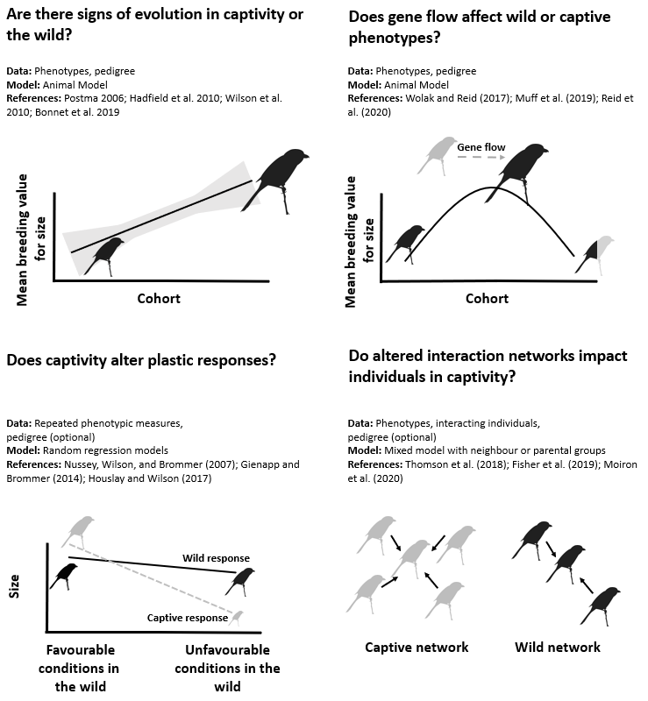
Fig. 1

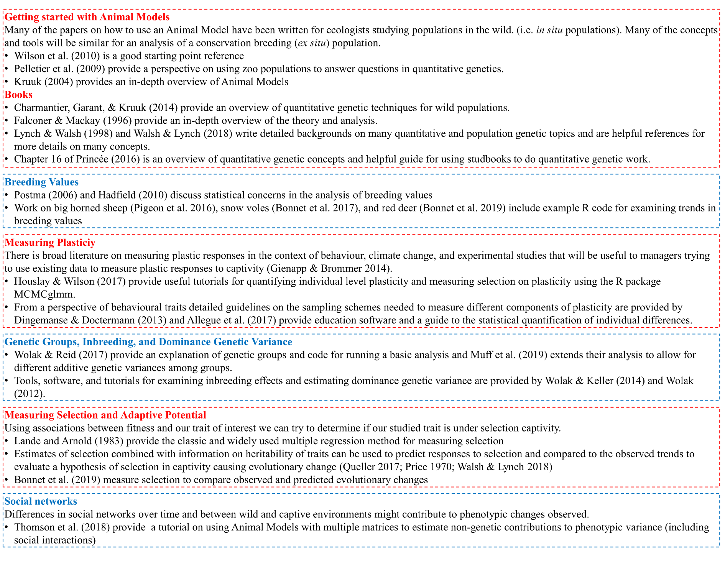
Fig. 2
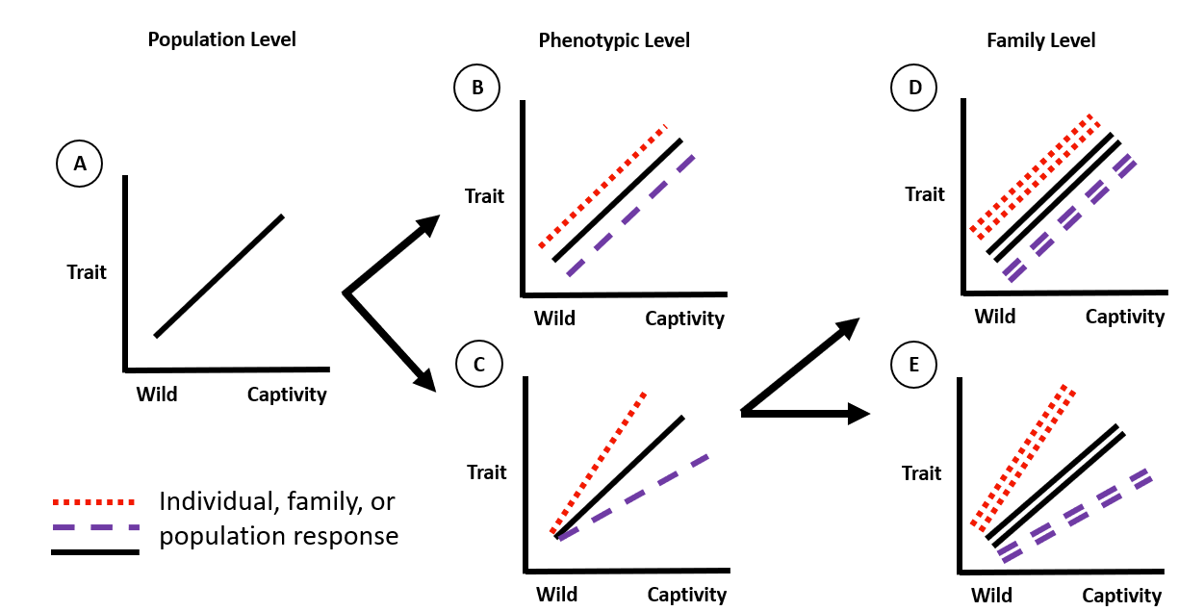
Fig. 3

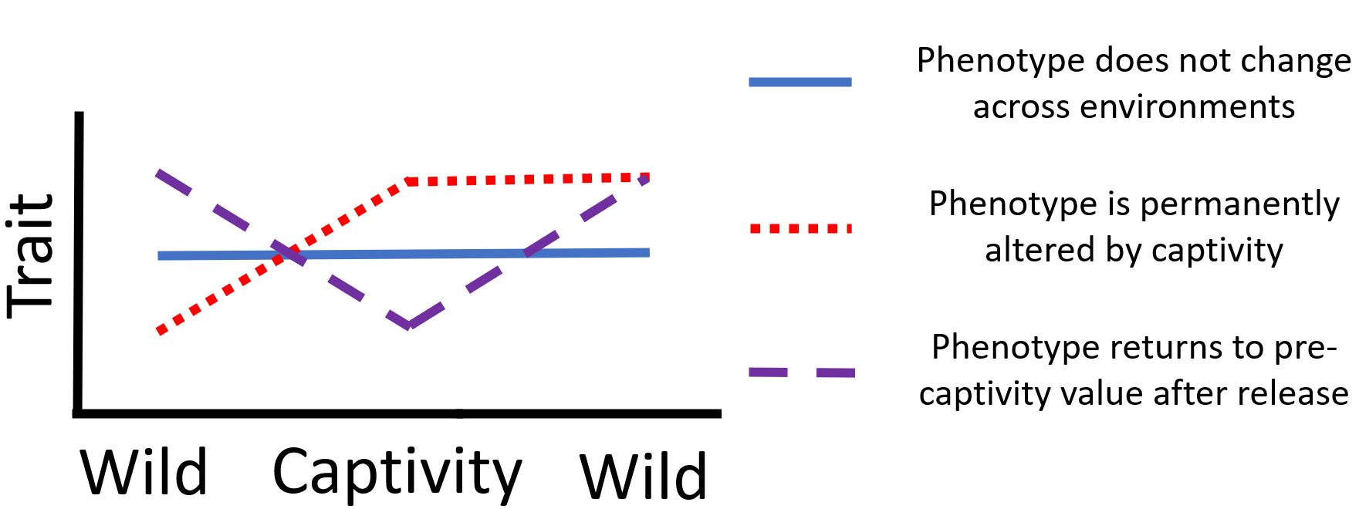
Fig. 4

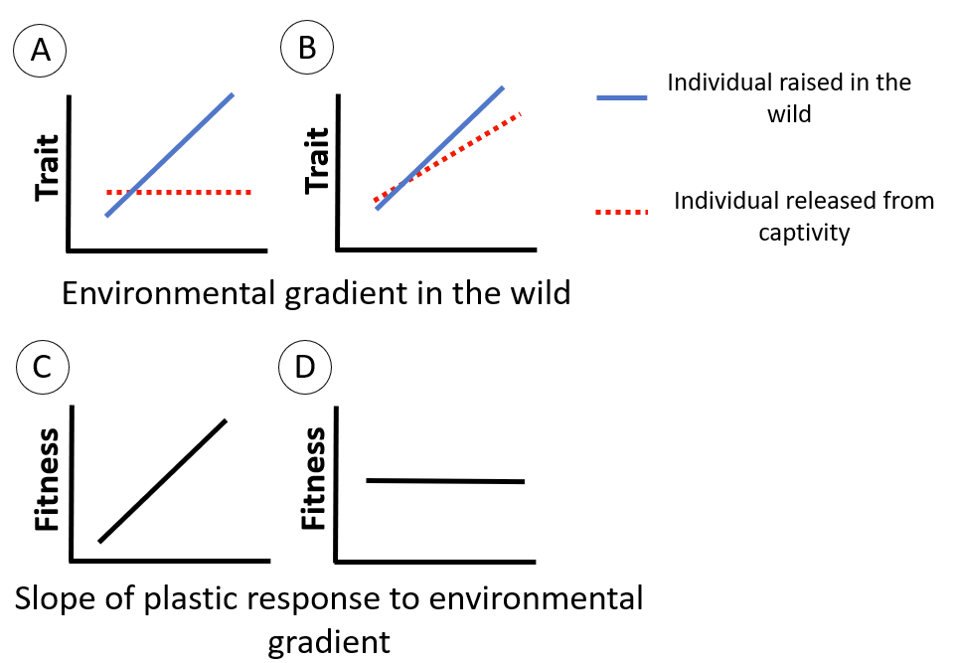
Fig. 5

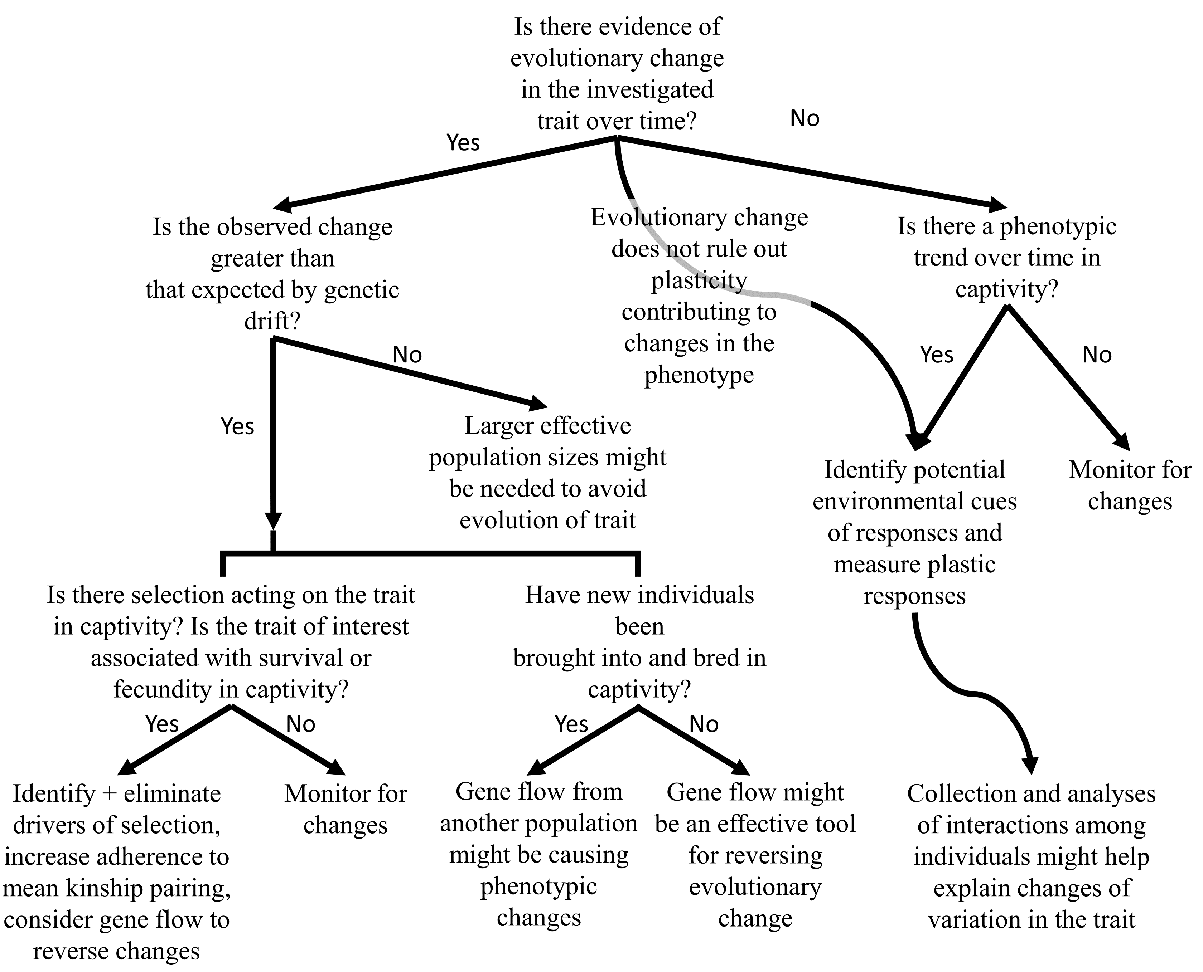
Fig. 6

