Herbivore life histories are altered by drought stress in their hosts plants

Alain Migeon, Philippe Auger, Odile Fossati-Gaschignard, Ruth A. Hufbauer, Maëva Miranda, Ghais Zriki, Maria Navajas

Alain Migeon, CBGP, INRAE, CIRAD, Institut Agro, IRD, Univ Montpellier, Montpellier, France.

Philippe Auger, CBGP, INRAE, CIRAD, Institut Agro, IRD, Univ Montpellier, Montpellier, France.

Odile Fossati-Gaschignard, CBGP, IRD, INRAE, CIRAD, Institut Agro, Univ Montpellier, Montpellier, France.

Ruth A. Hufbauer, Department of Agricultural Biology and Graduate Degree Program in Ecology, Colorado State University, Fort Collins, CO, USA.

Maëva Miranda, CBGP, INRAE, CIRAD, IRD, Institut Agro, Univ Montpellier, Montpellier, France & CIRAD, UMR AGAP INSTITUT, F-34398 Montpellier, France.

Ghais Zriki, CBGP, INRAE, CIRAD, IRD, Institut Agro, Univ Montpellier, Montpellier, France & CEFE, Univ Montpellier, CNRS, EPHE, IRD, Univ Paul Valéry Montpellier 3, Montpellier, France.

Maria Navajas, CBGP, INRAE, CIRAD, Institut Agro, IRD, Univ Montpellier, Montpellier, France.

# Abstract

Drought associated with climate change can stress plants, altering their interactions with phytophagous arthropods. Dryness not only impacts cultivated plants but also their parasites, which in some cases are favoured by drought. Herbivorous arthropods feeding on drought-stressed plants typically produce bigger offspring and develop faster. However, how much responses to abiotic factors differ among populations of a species remains poorly documented. Here, we evaluate variability among populations of a major agricultural pest, the two spotted spider mite, *Tetranychus urticae*, in response to drought-stress. We compare key life-history parameters of twelve populations that originate from climates ranging from wet and cool Atlantic locations to medium to dry hot Mediterranean locations. We evaluated how plant drought stress affects four life history traits: development time, fecundity, sex-ratio and emigration rate in an experiment comparing well-watered and drought-stressed bean plants. Mites feeding on drought-stressed plants developed faster and attempted to leave leaves less often, and young females were more fecund. The mites from wet temperate climates exhibited greater plasticity between the two water regimes than mites originating from dryer and hot climates. Thus, climate in the area of origin influences mite response to drought.

# Keywords

Acari; climate; Europe; life-history traits; Mediterranean; *Tetranychus urticae*; Two Spotted Spider Mite

# Introduction

“A Quarter of Humanity Faces Looming Water Crises”, warned The New York Times of August 6th, 2019 (Sengupta and Cain, 2019). Extreme climatic events have already increased in frequency due to climate change, and these increases are forecast to continue (IPCC, 2021). Low water availability not only impacts cultivated plants but also plant pests, which can be favoured by drought (see Hamann et al. (2020) for a review). Thus, to support agricultural production in the face of intensified drought, it is important to understand how pests respond to plant water availability.

Positive effects of drought stressed plants on herbivores are likely driven by changes in plant physiology (Chaves et al., 2003) including shifts in the amino-acids and free sugar balances in drought-stressed plants (Showler, 2013; Hummel et al., 2010). These shifts are thought to drive changes of life history traits. For example, drought stress in beans increased oviposition by the bug *Orius insidiosus* (Seagrave et al., 2011) and drought stress in the grass *Holcus lanatus* increased offspring and rates of emergence of the moth *Spodoptera littoralis* increasing their fitness overall relative to well-watered plants (Walter et al., 2012).

Among plant pests, the spider mites (Acari: Tetranychidae) have been studied in field and laboratory settings, leading to diverse and sometimes divergent results. Drought stress of soybeans led to faster development and thus increased density of the spider mite *Tetranychus turkestani* (Nikolova et al., 2014). This pattern was also observed in *Tetranychus urticae* and *Oligonychus pratensis* on maize (Chandler et al., 1979), and in a mixed mite population of *Tetranychus pacificus* and *Panonychus citri* on almond (Youngman and Barnes, 1986; Youngman et al., 1988). Gillman et al. (1999) observed that the damage caused by *T. urticae* increased on drought stressed buddleia plants. Ximénez-Embún et al. (2016, 2017a, 2017b) observed a global increase of performance of three important tomato mite pests, *Tetranychus evansi*, *T. urticae* and *Aculops lycopersici*, reared on drought-stressed tomato plants, especially for tomato-adapted strains in the case of *T. urticae*. A non-linear response with an increase of density and fecundity of *t*his mite was reported at an intermediate level of drought, and a linear increase of development rate at a severe drought stress regime (English-Loeb, 1989). In contrast, the opposite pattern was reported by Oloumi-Sadeghi et al. (1988) who observed a decrease of *T. urticae* abundance on drought-stressed soybean and by Sadras et al. (1998) for *T. urticae* on cotton.

The degree to which different populations of a phytophagous arthropods differ in responses to abiotic factors remains poorly documented. However, adaptation and phenotypic plasticity are regarded as a main way that organisms respond to changing environments (Bowman et al., 2018). For example, Kelley et al. (2011) reported a latitudinal and temperature-linked gradient from cold to warm locations with an increase of the maximum temperature tolerance of the crab *Carcinus maenas* populations. Among the tetranychids mites, common garden experiments revealed a latitudinal gradient of life history traits (decrease in fecundity, shortening development time, sex-ratio and dispersal) from Western European core distribution of *T. urticae* to the northernmost part of the distribution area (Van Petegem et al., 2016). These last authors also reported a trade-off between development time and fecundity.

Intraspecific variation can modify the response of populations to both biotic and abiotics factors. Drought stress varies across space and time and is becoming more common in some regions due to climate change. Here we explore how drought stress in host plants affects different populations from contrasted climates in Europe, of an herbivorous mite, the two spotted spider mite *T. urticae*. This work focuses on how responses depend on the climatic conditions of the mite sampled locations. Using 12 populations, we compare the development time of females on drought stressed and well-watered host plants. We also compare three other life-history traits: fecundity, sex-ratio and emigration rate for 3 day- and 9 day-old females. Finally, we relate the observed variations to the climatic variables.

# Material and methods

To evaluate the effects of drought stress on mite life-history traits, we conducted two experiments. Experiment I focused on development time of females on drought-stressed and well-watered plants, as shorter development time can increase population growth rate, and thus is an important life-history trait linked to population fitness. In experiment II, we evaluated how fecundity and sex ratio of offspring respond to drought stress, possibly through a temporal shift in their life span, and also measured attempts of mites to depart from experimental arenas.

## 1 Mites

*Tetranychus urticae* is a cosmopolitan highly polyphagous pest recorded from 124 countries and 1169 plant species (Migeon and Dorkeld, 2019). It has two different colour morphs (green and red), which can be observed in sympatry (Auger et al., 2013). These colour morphs do not vary systematically in geographic distribution or physiological parameters. It is an arrhenotokous species, meaning that fertilized eggs from diploid females produce diploid females, while unfertilized eggs produce haploid males (Helle and Bolland, 1967). Sex ratio is usually female biased (between 60 to 70% of females), and shifts in sex ratio are one way populations respond to changing environments (Crozier, 1985).

*Tetranychus urticae* feeds by piercing leaf parenchyma cells with its stylet and sucking out the cell contents (Tomczyk and Kropczynska, 1985). It develops from egg to adult in 10 days (Sabelis, 1981) at 25°C and is, as many Tetranychidae species, commonly reared between 20 and 25°C (Crooker, 1985). At 25°C, one female can lay a mean of 70 to 130 eggs throughout her reproductive life of approximately two weeks. Most eggs are laid in the first week with peak fecundity at three days after emergence (Sabelis, 1981).

### Origin of mites

We sampled *T. urticae* populations from 12 locations in Europe that represent a wide range of climatic conditions (Migeon et al., 2019) and where the mite can develop (Litskas et al., 2019) (Table 1, Figure 1). Greece and Cyprus have dry hot summers, France and the United-Kingdom have wetter summers and Spain and Italy are intermediate.

## 2 Climate data

Temperature, precipitation and Bioclimatic variables for the 12 locations were retrieved from WorldClim (Fick and Hijmans, 2017) and the Global Aridity Index was taken from CGIAR (Trabuco and Zomer, 2019). We used monthly minimum, maximum and average temperatures to construct Gaussen climatograms (Supplementary Figure S1). The Bioclimatic variables gather a set of 19 synthetic variables describing the climate. The Global Aridity Index (GAI) was developed to quantify the precipitation availability over atmospheric demand (Trabuco and Zomer, 2019). This is a synthetic variable expressing the moisture availability for potential growth of reference vegetation. For the analysis we grouped a priori the 12 mite sampling locations in three clusters of dryness (dry, medium and wet) of four locations each (Table 1).

Table 1. Characteristics of the populations of *Tetranychus urticae* used in the experiments. DD: decimal degree.



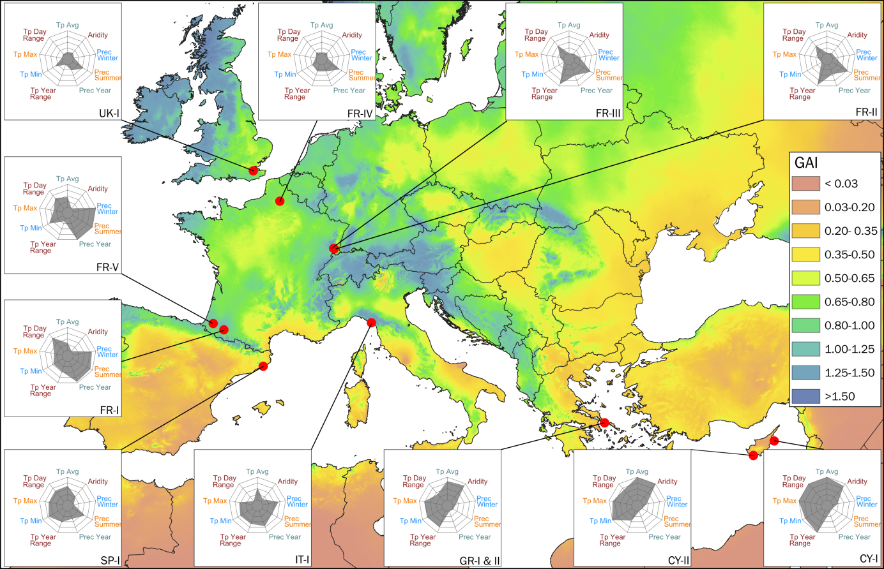

Figure 1. Map of the locations sampled. The background colour is scaled on Global Aridity Index (GAI) (Trabucco and Zomer, 2019). The radar charts display the values of some important climatic variables: (from top, clockwise) annual temperature average (Tp Avg), 1/global aridity index (Aridity), precipitations of the coldest quarter (Prec Winter), precipitations of the warmest quarter (Prec Summer), total year precipitations (Prec Year), temperature annual range (Tp Year Range), minimal temperature of the coldest month (Tp Min), maximal temperature of the warmest month (Tp Max), mean diurnal range (Tp Day Range).

## 3 Plant material

### Plant production

French bean (*Phaseolus vulgaris* cv. Contender) plants were grown from seeds in 2 L pots (diameter: 15 cm, height: 17 cm) (CEP, HR 17YPP) filled with 815 g (R.H. about 30%, measured with a soil moisture sensor HH150 (Delta-T Devices Ltd, Cambridge, UK)) of peat mix (Huminsubstrat N2, Neuhaus, Klasmann-Deilmann, Geeste, Germany). Two sets of pots were differentiated according to the watering regime: well-watered plants (high water regime) were watered to saturation every day and drought-stressed plants (low water regime) were watered only once at sowing time with 200 ml of water. Pots were first kept in a regulated greenhouse with additional light when necessary (25 ± 7°C / 40 ± 30% RH) for ten days after sowing.

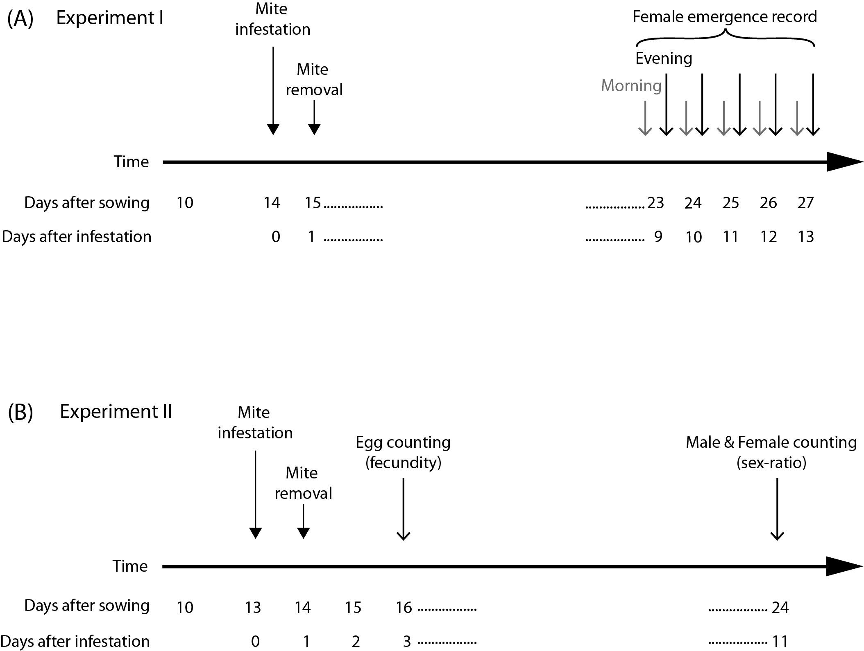

Figure 2. Timing of assessment of development time in female mites in Experiment I (A); timing of assessment of fecundity and sex ratio in Experiment II (B).

### Drought stress maintenance and assessment

Ten days after sowing, bean seedlings that had two expanded cotyledons were transferred to a climate chamber where they were watered differentially according to water treatment. Light was provided by agro red and blue LED lamps (Philipps Green Power LED). We manipulated water availability differently in our two experiments. Well-watered plants were maintained with a soil moisture above 45% (substrate saturation) and drought stressed plants with a soil moisture between 10-8% (8% is over the wilting point). In experiment I we used an automatically regulated drip irrigation system. Soil water content (RH) was measured and recorded using 5 moisture sensors (SM150 with GP2 Data Logger, Delta-T Devices Ltd, Cambridge, UK) in each watering treatment and linked to DeltaLINK 3.1.1 PC software (Delta-T Devices Ltd, Cambridge, UK) for setting up and downloading data from a GP2 station. In the well-watered treatment, when the average soil moisture dropped to 45%, each plant was automatically watered for 30 seconds (delivering 17 ml of water) by a drip. In the drought-stressed treatment, watering was activated (same duration and amount of water per watering event) when soil moisture dropped to 8% (see Supplementary Figure S2 as an example). In experiment II, plants were watered manually. In the well-watered regime, beans received 100 ml of water daily. In the drought-stressed regime, they received once 20 ml of water a single time when transferred to the climate chamber (10 days after sowing). Seven days later, we started watering these drought-stressed plants with 20 ml of water daily.

Water stress level of plants was assessed several times during the experiments. In both experiments, we measured leaf stomatal conductance a commonly used drought indicator (Verslues et al., 2006) using a leaf porometer (SC-1 Leaf Porometer, Decagon Devices, Inc., Pullman, WA, USA). For each population 10 plants were used to estimate stomatal conductance, 7 times between ages 11 days and 27 days after sowing. For young plants (less than 20 days after sowing) the sensor was placed head in the upper third of the seed leaf (the part closest to the petiole of the leaf), on the side of the leaf. For older plants (21-27 days after sowing) measurements were taken in the first trifoliate leaf, placing the sensor head on the side of the central leaflet (see Supplementary Figure S3). In experiment II, we also assessed, with the same frequency, the soil moisture using a soil moisture sensor (HH150, Delta-T Devices Ltd, Cambridge, UK) and by weighing the pot (seedling, pit mix and pot) using a balance (KSR1 Proline, Darty Ptc, UK) on 10 plants (the same ones along the experiment) per water regime (see Supplementary Figure S4).

## 4 Mite rearing

Thirty to 50 female mites per sample location were used to initiate stock populations. Mite stock populations were maintained separately on detached bean leaves (*Phaseolus vulgaris* cv Contender), commonly used as a “neutral” plant (Sabelis, 1981; Fellous et al., 2014; Sousa et al., 2019). Leaves were placed on moist cotton blanket in double-bottom plastic boxes (13.5 x 9.5 x 5 cm) with water reservoir and maintained in growth chambers at 21 ± 1°C, 60 ± 10% RH with a photoperiod of L/D 16/8 h which allows the development of one generation on two weeks. Each population was maintained for at least six generations before being used in the experiments.

## 5 Experimental design

Due to restricted space available, each population was assayed separately in random order. All the experiments were conducted in a climate room with diurnal (25 ± 1°C) and nocturnal (23 ± 1°C) temperatures and using a light cycle of L/D 16/8 h. Relative humidity was maintained at 50 ± 20% RH using a dehumidifier (Rexair 2500T, Rexair, 95330 Domont, France).

### Experiment I (Figure 2A)

Experiment I was designed to estimate the development time of mites. Well-watered and drought-stressed plants with two expanded cotyledons were randomly arranged in the climate chamber and then infested with mites 14 days after sowing, at point steady stress conditions were reached in plants assigned to the drought-stressed treatment (Supplementary Figure S3).

Plants were infested by gently transferring 10 females of unknown age with a fine camel hairbrush, five per each cotyledon, into a squared arena built on leaves upper surface (Supplementary Figure S6). Females placed in these arenas were allowed to lay eggs for 24 hours and then removed (Figure 2A) using a Rena vacuum. Twelve to 15 replicates (12-15 plants) per water regime were performed for each mite population. From day 9 to 13 after infestation, newly emerged adult females were recorded and then removed twice a day, at 8 am and 4 pm (Figure 2A), using a stereomicroscope Leica EZ4 (Leica microsystems CMS GmbH, Wetzlar, Germany).

### Experiment II (Figure 2B)

Experiment II was designed to assess the effect of plant drought stress on female fecundity and leaving rate and sex ratio of the progeny. Plants were produced with the same protocol than experiment I and transferred in the climate chamber 13 days after sowing. Then, they were infested with *T. urticae* females of known age. The mites used were transferred from plants under the same watering regime and monitoring as the treatment for which they were used (see Supplementary Figure S5).

A first batch of plants was infested with three-day-old females and six days later, a second batch (plants of the same age – 13 days after sowing) with nine-day-old females. The procedures for plant infestation and mite confinement, were the same as those mentioned in experiment I Females were allowed to lay eggs for 24 h and subsequently removed using a Rena vacuum. At this time, individuals were recorded as living, dead or drowned in the oily barrier. The mites found in the barrier were recorded to estimate attempts to leave the patch of leaf. Female fecundity was assessed by counting eggs two days after females were removed from arena with the aid of a stereomicroscope Leica EZ4 (Leica Microsystems, Weltzar, Germany). The eggs were kept on plants until hatching, and offspring allowed to develop to adulthood. The sex-ratio of newly emerged adult mites was then assessed 11 days after mite infestation.

## 5 Data analysis

All data analyses were conducted using R 3.5 (R Core Team, 2018). Graphics were produced using the libraries ggplot2 (Wickham, 2016).

The development time of mites was calculated by using a logit regression (library MASS, Venables and Ripley, 2002) to determine the time of 50% of emergence of adults. For each population, an ANOVA analysis (Chi2 model) was used to test the effect of watering regime on logistic regression representing the development time.

Differences in fecundity, leaving rate and sex ratio between mites from drought-stressed and well-watered plants were evaluated with *t*-tests for each population. Because escape rate (expressed as number of escaped females per plant / number of females deposited per plant) and sex-ratio (expressed as number of female per plant/ (number of females per plant + number of males per plant) are both limited from 0 to 1, they were respectively transformed to [arcsin(√(1-x))] and [arcsin(√x)] before analysis. Raw values are used in graphs and tables.

Our estimate of development time is a population-level estimate, and thus for each there is only one value per population and plant watering regime. To examine trends related to watering treatment and dryness of the climate of origin, ANOVAs were conducted on mean values per populations. For each response variable, we ran models that included watering regime (well-watered or drought stress) and categorical climate of origin (wet, medium or dry), as determined from Global Aridity Index values (see Table 1) and the interaction between the two. Population was not in the model because the populations in this case are the replicates, with only a single estimate for each watering regime. Normality of the residuals was tested by a Shapiro-Wilks test and homoscedasticity by a Levene test.

To further explore the relationship between observed changes in response variables between watering regimes and each of the 20 climatic variables (19 Bioclimatic variables + Global Aridity Index) we used linear regressions.

# Results

## 1 Development time

Mites from all populations developed faster when reared on drought-stressed plants (Figure 2 and 3A, Supplementary Table S1). The reduction in development time from the egg to adult ranged from 0.54 day (GR-II) to 1.35 day (FR-II).

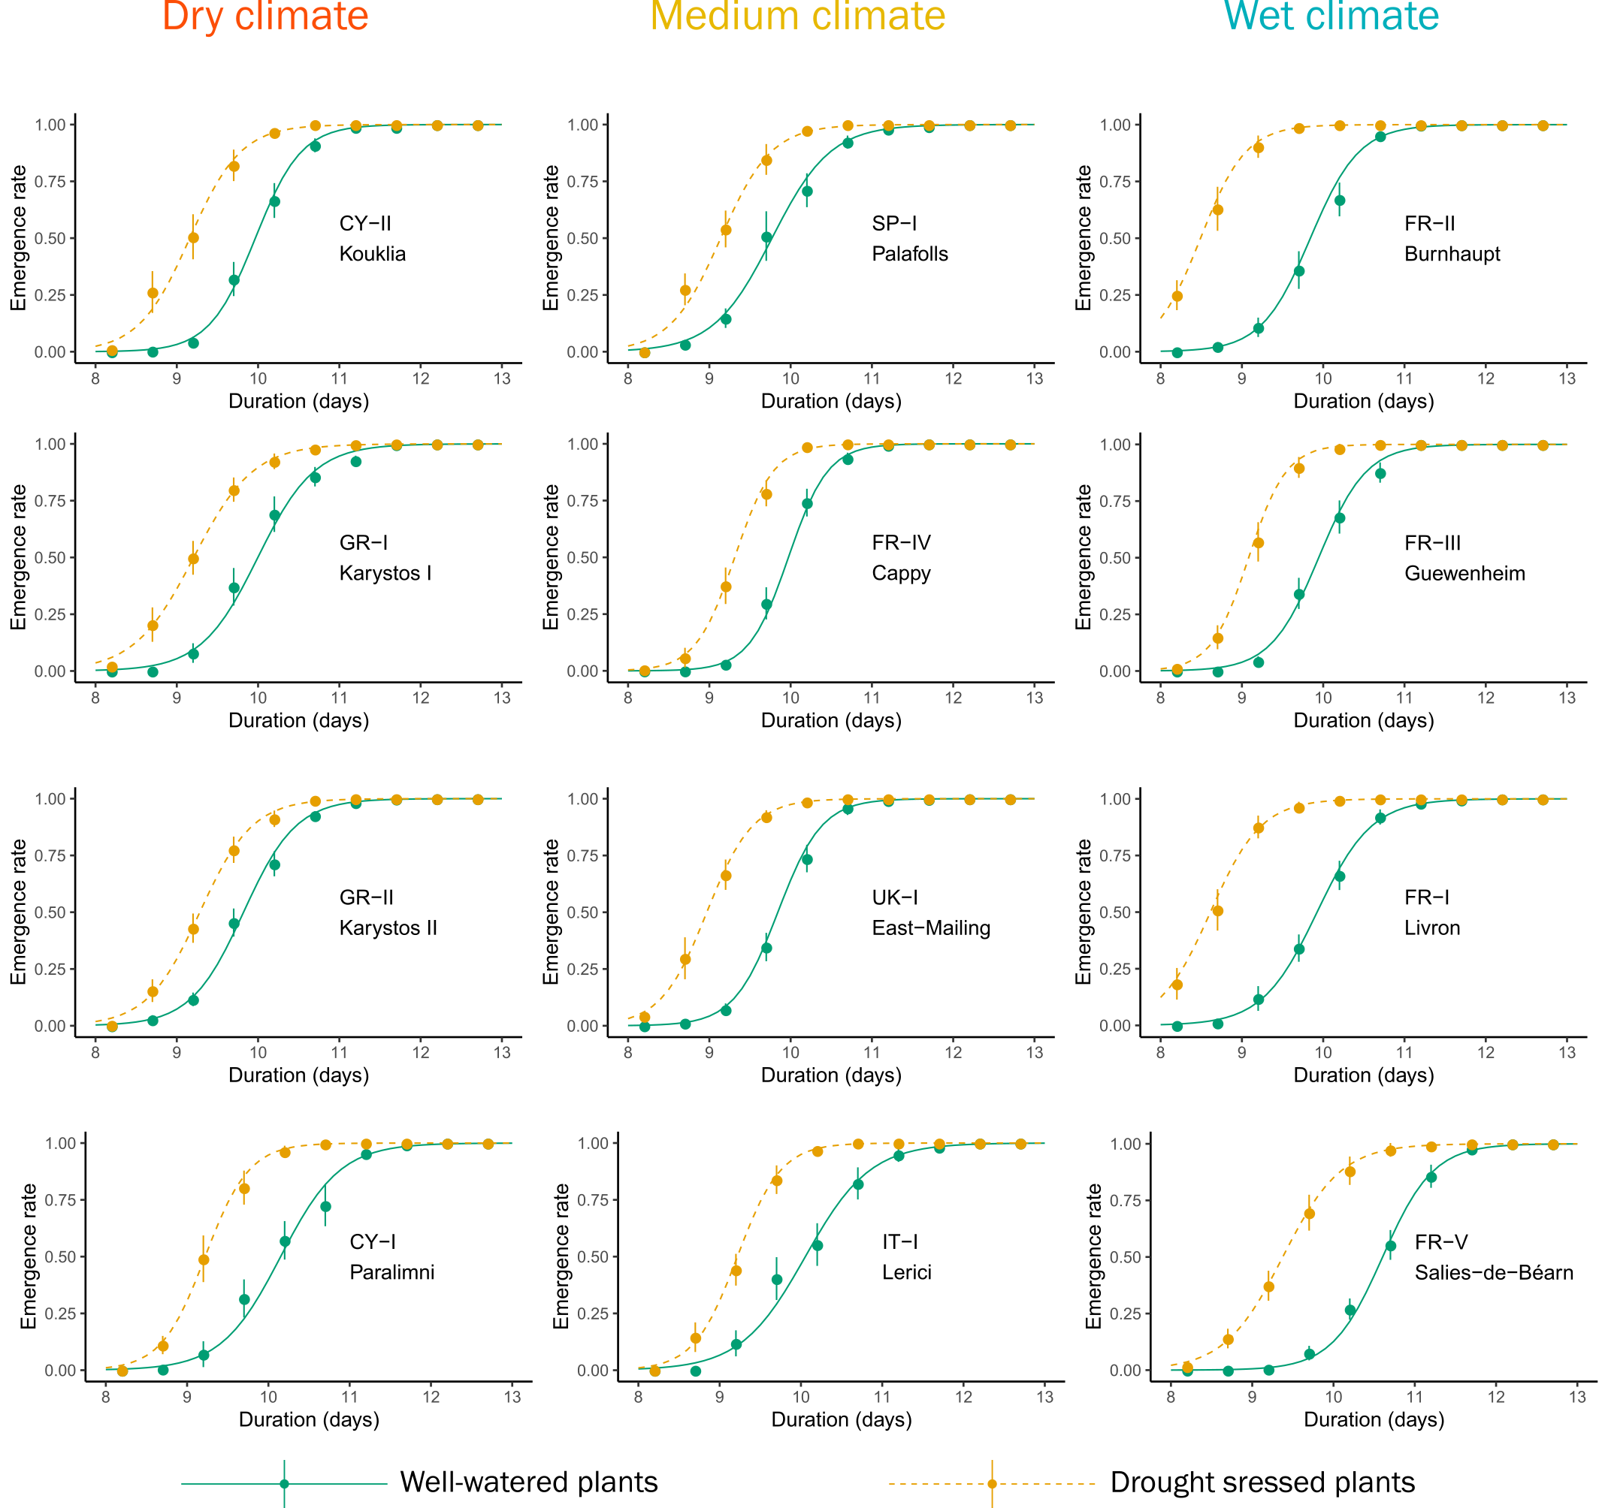

Figure 2. Development time from egg to adult of the twelve populations of Tetranychus urticae reared on well-watered and drought-stressed plants. Values are mean emergence rate of adults ± standard error at each observation point. Curves represent the logit regression.

Matching the individual population analyses, the ANOVA also showed a strong effect of water regime on development time (*F*(1, 18) = 82.5, *p* < 0.001). The reduction in development time when mites were on drought-stressed plants was positively correlated with the Global Aridity Index (see Figure 3B and Table 2). Mites from locations with high summer humidity (high Global Aridity Index) responded more strongly to drought stress than mites from locations with low summer humidity (Figure 4). In addition, a significant correlation between the reduction in development time and five others climatic variables was also observed (see Table 2). All but one of the climatic variables (BIO19, Winter Precipitations) refer to summer hydric local conditions that may be responsible for plant water stress, which is in line with the correlation obtained with the Global Aridity Index.

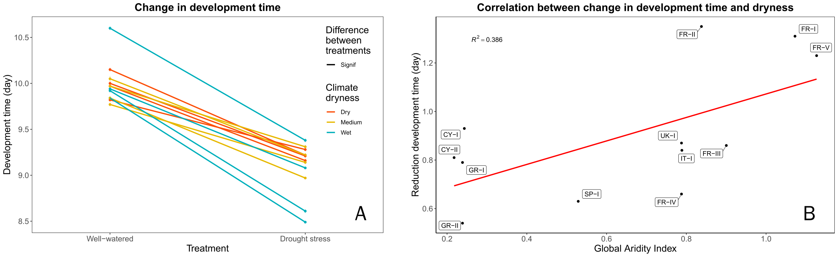

Figure 3. Change in development time of 12 populations of *Tetranychus urticae* between the two watering regimes. A: Development time on well-watered and drought stressed plants. Values are mean development time (day) ± standard error for each population. B: Correlation between the change in development time and the Global Aridity Index for each population.

Table 2. Correlations between change in the life-history trait response of *Tetranychus urticae* between the two watering treatments and bioclimatic variables. R2 and *p*-values are reported when a significant correlation was observed.



## 2 Fecundity

The fecundity of three-day-old females increased significantly (Figure 4 and Supplementary Table S2) for 7 (FR-I, FR-II, FR-V, GR-I, GR-II, IT-I, UK-I) out of the 12 mite populations studied on drought-stressed plants. This increase ranged from 0.26 (SP-I) to 2.62 (FR-II) for a mean of 10.54 on well-watered plants and 11.52 eggs/female/day on drought stressed plants. One population (CY-II) showed a significant decrease of fecundity on drought stressed plants. The increase in fecundity when mites were on drought-stressed plants was positively correlated with the annual mean temperature (Figure 5 and Table 2) and with three other climate variables linked to temperature (Table 3), especially winter temperatures.

The fecundity of nine-day-old females increased significantly on drought-stressed plants (Figure 4 and Supplementary Table S2) for 3 out of the 12 mite populations studied (FR-III, GR-II and IT-I). The increase in fecundity when mites were on drought-stressed plants was positively correlated with the isothermality (Table 2). We also observed a correlation between fecundity of three-day-old and nine-day-old females reared on well-watered plants (r2 = 0.395, *p* = 0.029).

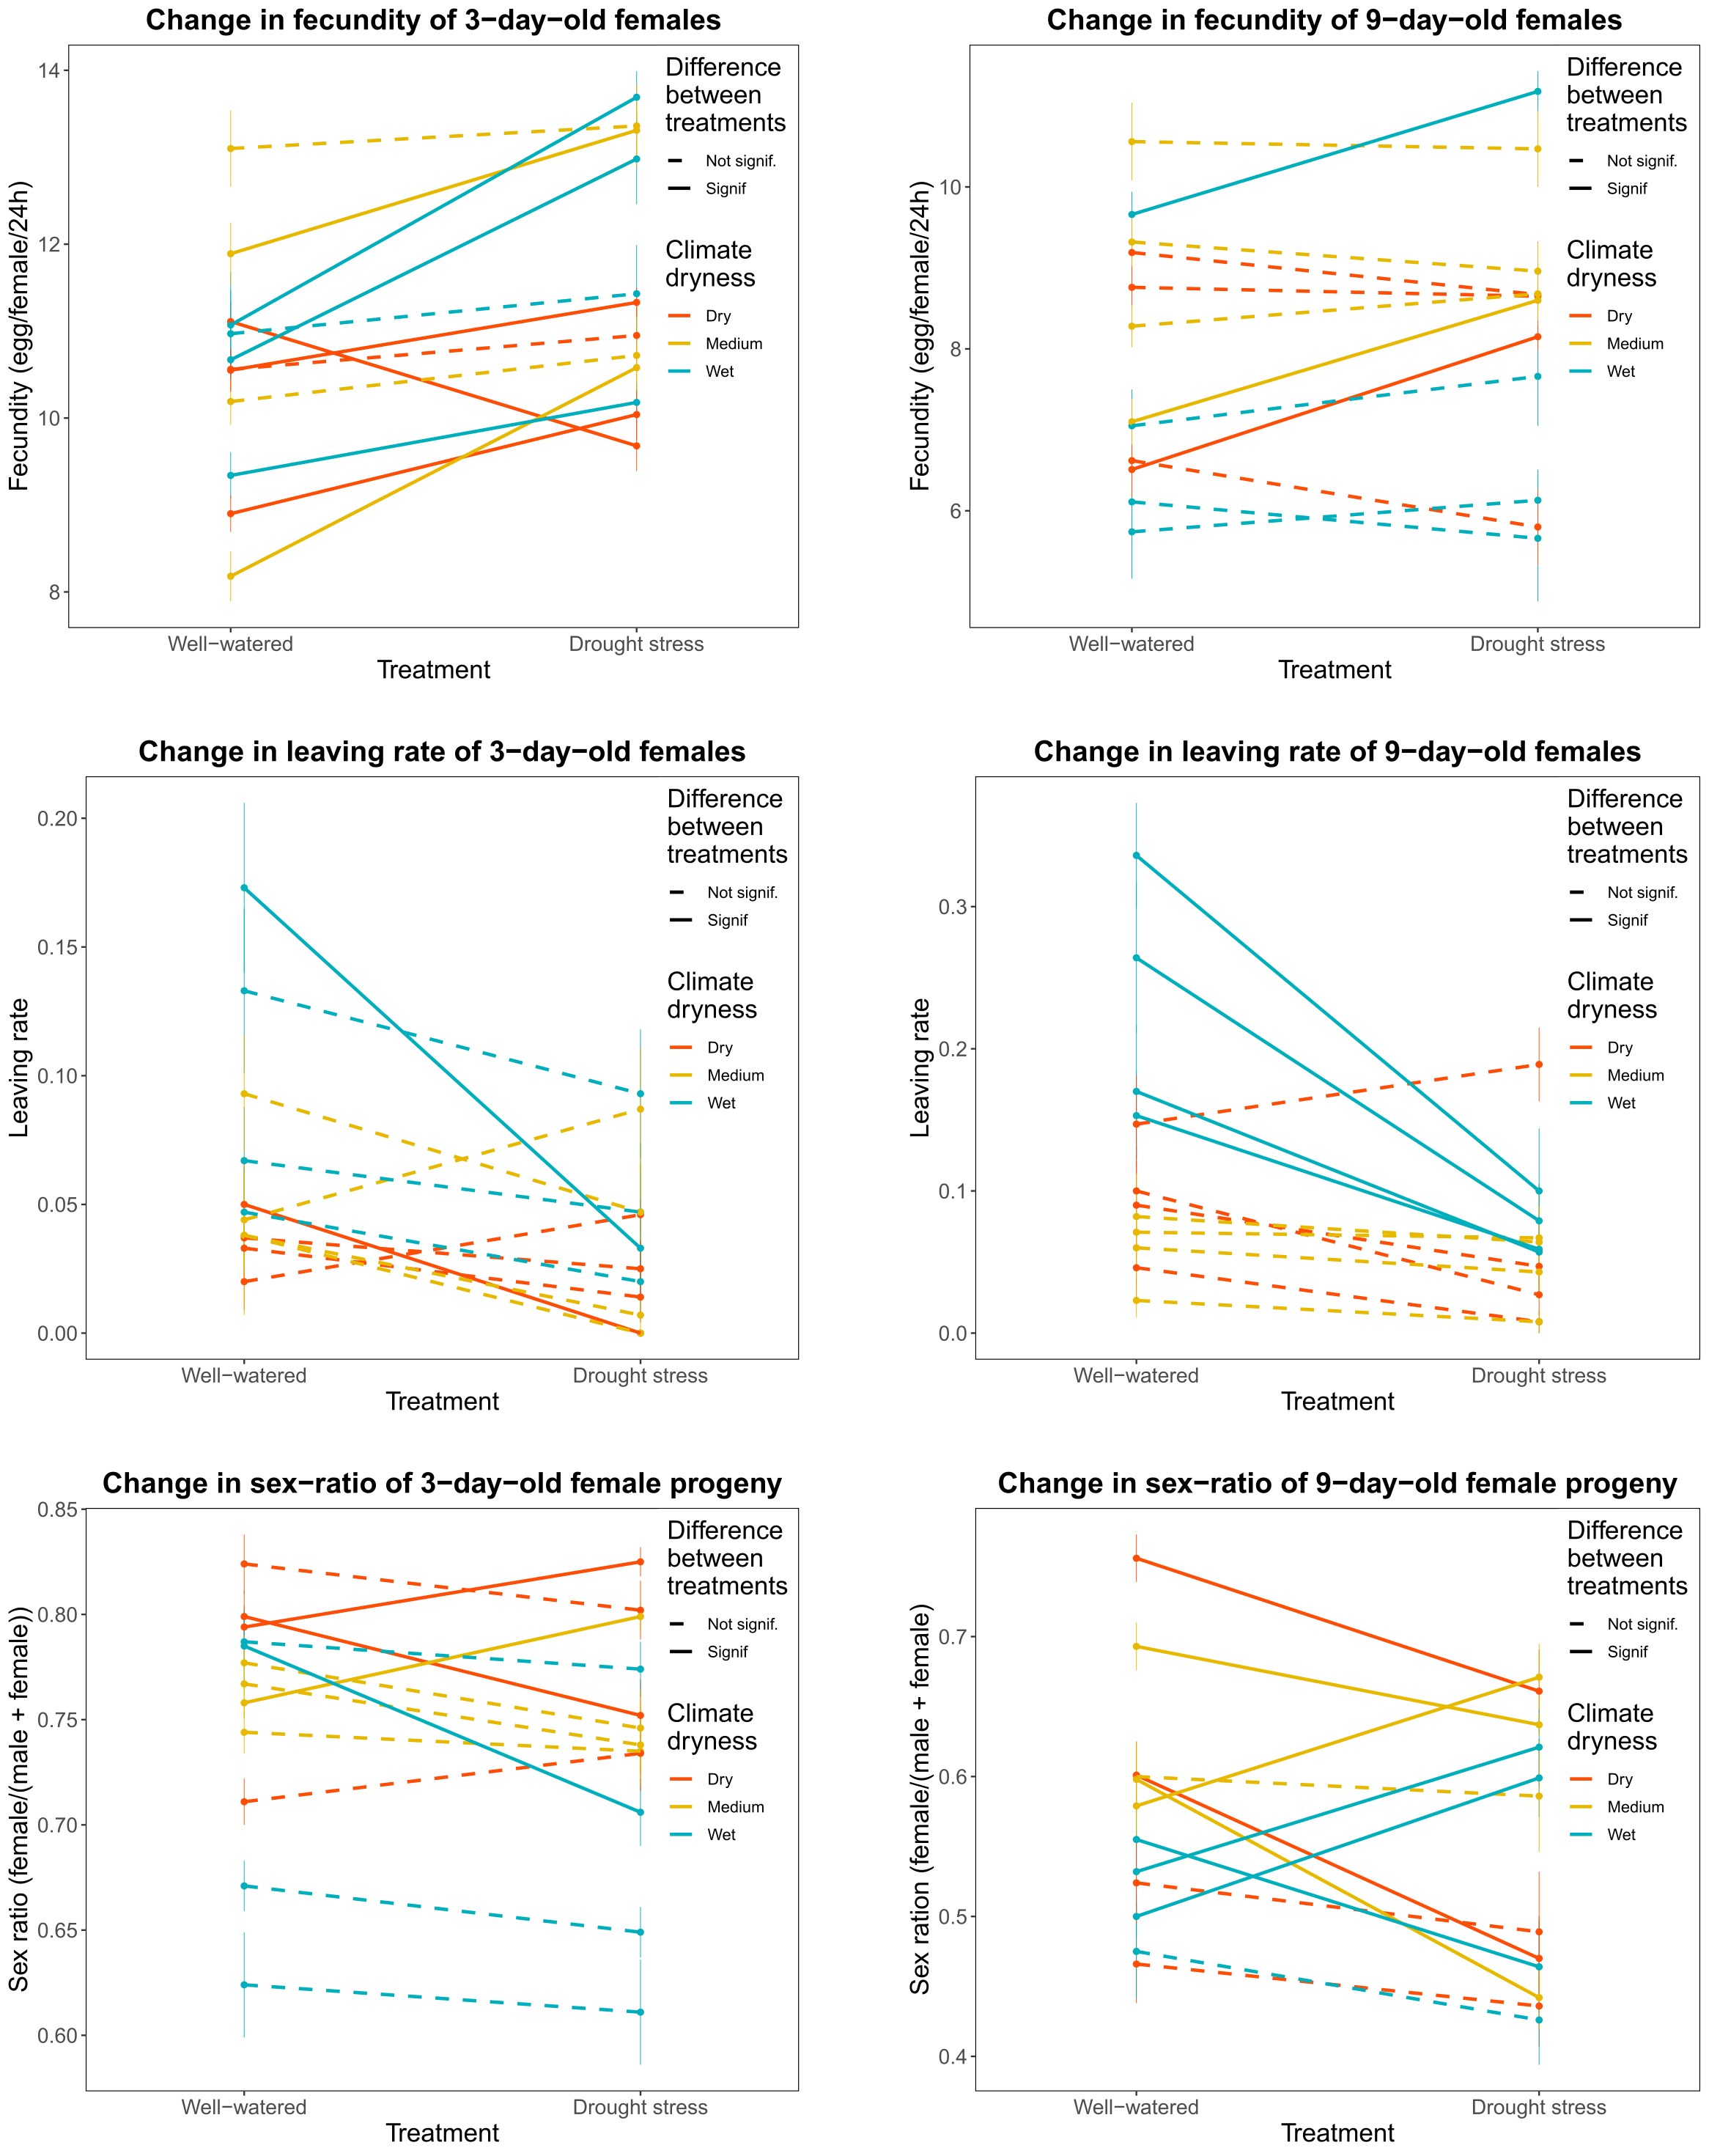

Figure 4. Variation in life history traits among the 12 populations of *Tetranychus urticae* studied, in response to plant watering regime. For each of the traits, values are mean ± standard error for each population.

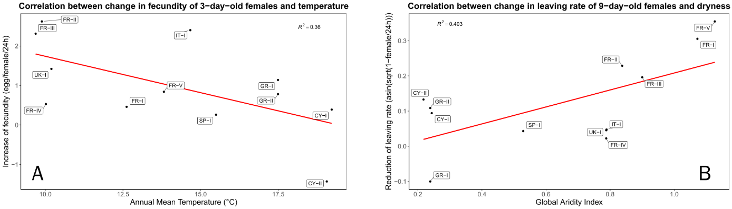

Figure 5. Relationships between changes in life history traits values between mites reared on well-watered or drought stressed plants of 12 populations of *Tetranychus urticae*. A: Correlation between the change in the fecundity of 3-day old females and Annual Mean Temperature for each population. B: Correlation between the change in the leaving rate of 9-day old females and Global Aridity Index for each population.

## 3 Leaving rate

Ten of the twelve populations studied showed a decrease in the leaving rate of three-day-old females on drought-stressed plants (Supplementary Table S3) ranging from 1.2% (GR-II) to 13.9% (FR-II) females leaving/24 h. Nevertheless, results were significant for only two of them (CY-I and FR-II). The average mite leaving rate from drought-stressed plants (3.5%) was approximately half that from well-watered ones (6.4%). The ANOVA showed an effect of watering regime on leaving rate (*F*(1, 18) = 5.0, *p* = 0.038). The decrease of leaving rate of three-day-old females on drought stressed plant was positively correlated with the annual temperature range.

The leaving rate of nine-day-old females was generally higher for mites exposed to well-watered plants. Eleven of the twelve populations studied showed a decrease in the leaving rate on drought-stressed plants (Supplementary Table S4) ranging from 0.05% (FR-IV) to 23.6% (FR-V) and four of them (FR-I, FR-II, FR-III, FR-V) were significant. The ANOVA revealed significant difference between the two water regimes (*F*(1, 18) = 8.5, *p* = 0.009) and also significant difference between climate condition (dryness) of the locations (*F*(2, 18) = 6.9, *p* = 0.006). Mites attempted to leave drought-stressed plants (6.2%) half as often as they did from well-watered plants (12.9%). The reduction in leaving rate when mites were on drought-stressed plants was positively correlated with the Global Aridity Index (see Table 2 and Figure 5). Mites from locations with high summer humidity (high Global Aridity Index) responded more strongly to drought stress than mites from locations with low summer humidity. Each of the six other climate variables BIO12, BIO14, BIO16, BIO17, BIO18 and BIO19 showing significant correlation with the reduction of leaving rate on drought stressed plants represent precipitations variables and six of them indicate water availability in summer.

As observed for the development time pattern, mites originating from the four most humid locations (FR-I, FR-II, FR-III, and FR-V) showed higher differences in the leaving rate between the two water regimes and in line with this, the climatic variables related to precipitation and dryness were linked to the correlations with differences in the two water regimes.

## 4 Progeny sex-ratio

The sex ratio of the progeny of three-day-old females showed significant differences between water regimes in four populations but two of them represented an increase (CY-II and FR-V) and two others (CY-I and SP-I) a decrease of male proportion (Figure 4 and Supplementary Table S4). The ANOVA showed significant differences (*F*(2, 18) = 4.6, *p* = 0.024) related to climate dryness, but no related to water regime. No correlations were observed between change of sex-ratio depending on water regime and climate variables.

The sex-ratio of the progeny of nine-day-old females showed significant differences between water regimes in eight populations but three of them represented an increase (FR-II, FR-III, SP-I) and five a decrease (CY-I, FR-V, GR-II, IT-I, UK-I) of male proportion (Figure 4 and Supplementary Table S4). The ANOVA did not reveal any significant trends of change between water regime nor between climate dryness. The correlation between change in sex-ratio was only significant with the Mean Temperature of the Wettest Quarter (BIO08).

# Discussion

Mites developed faster, were generally more fecund and dispersed less when reared on drought stressed plants. These three factors could together allow mite populations on drought-stressed plants to grow more rapidly. Not all the mite populations tested responded equally, and differences between them depended on the climate conditions experienced in their area of origin.

### 1 Drought-stressed versus non-stressed plants

The shortening of development time for all the studied populations is in line with previous experiments conducted on spider mites (Chandler et al., 1979; Youngman and Barnes, 1986; Youngman et al., 1988; English-Loeb, 1989; Nikolova et al., 2014). Mites collected from different origins have similar development time when reared on well-watered plants, suggesting that mite development time on physiologically balanced plants depends only on the host-plants species and the temperature. Temperature is a well-known factor governing development time of ectotherms (Logan et al., 1976). However, Van Petegem et al. (2016) found a relationship between development time and latitude (which in their study corresponds to a thermal gradient). Variation in development time was driven by faster development in the northern edge of the mite’s distribution, where new populations settle. They interpreted their results as a combination of local adaptation and spatial selection. In our study, on well-watered plants we did not observe a relationship between development time and any of the climatic variables of the locations where the mite populations were collected. This can might be because we deliberately collected our spider mite populations from locations with different climatic profiles that were still within the core climate conditions of the species (Litskas et al., 2019).

The increase of fecundity of *T. urticae* mites reared on drought-stressed plants confirms the other reports (Chandler et al., 1979; Youngman and Barnes, 1986; Youngman et al., 1988; Ximénez-Embún et al., 2017a;Santamaria et al., 2018). Thus the physiological changes that occur in drought-stressed plants are reliable changes. These shifts in mite life history are likely linked to increased concentration of essential amino acids and free sugars in tomato plants, as it was observed by the same authors, which improved the nutritional value of drought-stressed tomato plants.

On drought-stressed plants, the decrease of development time and the increase of fecundity of young females are concomitant. The higher fecundity of young females on drought stressed plants does not appear to come at a cost in fecundity of nine-day-old females. These results are not in accordance with Youngman et al. (1988) about *T. pacificus* on almond trees. They observed a shift in peak fecundity, in which an increase in fecundity in the first ten days on drought-stressed plant was counterbalanced by a decrease after ten days. Our experimental design did not allow us to observe females older than nine days and so does not rule out a later shift in fecundity. When mites were placed on well-watered tomatoes plants, Alzate et al. (2017) described a quadratic relationship between fecundity and longevity, suggesting an optimal balance between these two traits. Our experiments highlight this relationship between fecundity of young and older females and reinforce the hypothesis of optimal balance proposed by Alzate et al. (2017). The correlations we observed between fecundity of three-day-old and nine-day-old females reared on well-watered plants suggests that our populations differ inherently in their reproductive output. These results are also in line with Van Petegem et al. (2016) who reported variation in lifetime fecundity of mites for populations originated from the mite’s core distribution varying in a scale from 20 to 110 eggs per female and not linked to latitude or temperature. Fecundity, dispersal and sex-ratio are often linked by complex relationships (Van Petegem et al., 2016) and the quality of the environment which in turn can shape the nutritional quality and the attractiveness of the host plants to the arthropods, also impacts these relationships. Wrensch and Young (1983) also observed an increase in the proportion of females on plants of poor nutritional value that was linked to a decrease of fecundity and Yano and Takafuji (2002), using an artificial selection experiment of low and high dispersal strains, observed an increase of diapause incidence and a decrease of general performance, especially in non-appetent plants for highly dispersal strains.

### 2 The importance of climatic condition of sampled locations

Our study, by comparing populations from distinct climatic origins reveals that changes in life-history traits of mites feeding on drought stressed plants depended on the climate conditions experienced in their area of origin. Since all the females coming from the different locations were reared under identical conditions, it is reasonable to accept that observed variations resulted from genetic differentiation in the tested populations. Our main finding is that mites originating from wet to cool locations displayed a stronger response, with a larger shift in shortened development time on drought-stressed plants than mites from drier hotter locations. They also exhibited higher tendency to leave well-watered plants than mites from dryer locations. Previous studies (Chen et al., 2020) highlighted that genetic variation for two closely related species *Tetranychus truncatus* and *Tetranychus pueraricola*, were associated with climatic parameters, mainly temperature and precipitation across China. For both species, genotype association was stronger with precipitation parameters together with the neuropeptide receptor NPR-9 gene adjacent genomic region. The NPR-9 affects foraging behaviour and nutrient storage (Bendena et al., 2015) and as a consequence development time and fecundity. Literature tends then to support that local adaptation to diverse levels of aridity could shape mite responses allowing them to adjust feeding behaviour in accordance with native local climatic conditions and nutritional quality of the host plants.

### 3 Conclusion

Populations originating from wet to cool locations (Alsace and Pays Basque) have not (or rarely) been submitted to drought-stressed host plants before, while populations from Cyprus and Greece had to face harsh climate and dryness half of the year. Our results, although not proving it, do suggest that the “over-reaction” of the French and British populations could have a cost which limit the response to drought of populations from dry locations. A genomic analysis would be necessary to disentangle or at least to bring out the mechanisms underlying the variability of the responses to drought for this widely distributed mite.

Under climate change, it is expected that mites will experience harsher drought episodes with environmental conditions leading to the selection of drought-adapted mites. In agricultural, intensification of damage in humid areas during the first years of drought (see Legrand et al., 2000 for example) will probably be limited by physiological costs but progressively lead to adaptation as suggested by the mite responses in the driest areas of this study. These are important issues to be taking into account for future strategies of pest management.

# Acknowledgements

We thank Judit Linka (NIAB EMR, East Malling, United Kingdom), Lucía Adriana Escudero-Colomar (IRTA, Estació Experimental Agricola Mas Badia, Spain), Vassilis Litskas and Menelaos Stavrinides (Cyprus University of Technology, Cyprus) and Jean-Baptiste Thibord and Cyril Hannon (Arvalis - Institut du Végétal, France) who helped us for providing mites populations and Nathalie Smit (INRAE Montpellier) for her statistical advice. This work was funded by the FACCE ERA-NET Plus— FACCE JPI GENOMITE project through EC and national sources (EC contract 618105), including the French Agence Nationale de la Recherche (Grant ANR-14-JFAC-0006-01), and the metaprogramme Adaptation of Agriculture and Forest to Climate Change launched by the French National Institute for Agricultural Research (INRAE). The works was initiated before 2018 but completed during the SuperPests grant, supported by the European Union's Horizon2020 research and innovation program (grant 773 902-SuperPests). RAH was supported by USDA NIFA Hatch project 1012868 during this work.

# Conflict of interest

The authors of this preprint declare that they have no financial conflict of interest with the content of this article. Ruth HUFBAUER is one of the PCI Zool recommenders.

# Data

Data and statistical analysis are available here

<https://doi.org/10.15454/ICM8EF>

# References

Alzate A., Bisschop K., Etienne R.S., Bonte D. 2017. Interspecific competition counteracts negative effects of dispersal on adaptation of an arthropod herbivore to a new host. Journal of Evolutionary Biology, 30: 1966-1977.

Antonio T., Robert Z. Global Aridity Index and Potential Evapotranspiration (ET0) Climate Database v2 [Internet]. Available from: https://figshare.com/articles/dataset/Global_Aridity_Index_and_Potential_Evapotranspiration_ET0_Climate_Database_v2/7504448

Auger P., Migeon A., Ueckermann E.A., Tiedt L., Navajas M. 2013. Evidence for synonymy between *Tetranychus urticae* and *Tetranychus cinnabarinus* (Acari, Prostigmata, Tetranychidae): Review and new data. Acarologia, 53: 383-415.

Bendena W.G., Boudreau J.R., Papanicolaou T., Maltby M., Tobe S.S., Chin-Sang I.D. (2008) A *Caenorhabditis elegans* allatostatin/galanin-like receptor NPR-9 inhibits local search behavior in response to feeding cues. Proceedings of the National Academy of Sciences, 105: 1339-1342.

Boubou A., Migeon A., Roderick G., Navajas M. 2011. Recent emergence and worldwide spread of the red tomato spider mite, *Tetranychus evansi*: genetic variation and multiple cryptic invasions. Biological Invasions, 13: 81-92.

Boubou A., Migeon A., Roderick G.K., Auger P., Cornuet J.-M., Magalhães S., Navajas M. 2012. Test of colonisation scenarios reveals complex invasion history of the red tomato spider mite *Tetranychus evansi*. Plos One, 7: e35601.

Bowman L.L., Kondrateva E.S., Timofeyev M.A., Yampolsky L.Y. 2018. Temperature gradient affects differentiation of gene expression and SNP allele frequencies in the dominant Lake Baikal zooplankton species. Molecular Ecology, 27: 2544-2559.

Chandler L.D., Archer T.L., Ward C.R., Lyle W.M. 1979. Influences of Irrigation Practices on Spider Mite 1 Densities on Field Corn 2. Environmental Entomology, 8: 196-201.

Chaves M.M., Maroco J.P., Pereira J.S. 2003. Understanding plant responses to drought - from genes to the whole plant. Functional Plant Biology, 30: 239-264.

Chen L., Sun J.-T., Jin P.-Y., Hoffmann A.A., Bing X.-L., Zhao D.-S., Xue X.-F., Hong X.-Y. (2020) Population genomic data in spider mites point to a role for local adaptation in shaping range shifts. Evolutionary Applications, 00: 1-15.

Crooker A. 1985. Embryonic and juvenile development. In:Helle W., Sabelis M.W., (Eds). Spider mites. Their biology, natural enemies and control. Elsevier. Amsterdam. p. 149-163.

Crozier R.H. 1985. Adaptative consequences of male-haploidy. In: Helle W., Sabelis M.W., (Eds). Spider mites. Their biology, natural enemies and control. Elsevier. Amsterdam. p. 201-222.

English-Loeb G.M. 1989. Nonlinear responses of spider mites to drought-stressed host plants. Ecological Entomology, 14: 45-55.

Fellous S., Angot G., Orsucci M., Migeon A., Auger P., Olivieri I., Navajas M. 2014. Combining experimental evolution and field population assays to study the evolution of host range breadth. Journal of Evolutionary Biology, 27: 911-919.

Fick S.E., Hijmans R.J. 2017. WorldClim 2: new 1-km spatial resolution climate surfaces for global land areas. International Journal of Climatology, 37: 4302-4315.

Gillman J.H., Rieger M.W., Dirr M.A., Braman S.K. 1999. Drought Stress Increases Densities but Not Populations of Two-spotted Spider Mite on Buddleia davidii `Pink Delight'. 34: 280.

Hamann E., Blevins C., Franks S.J., Jameel M.I., Anderson J.T. 2021. Climate change alters plant–herbivore interactions. New Phytologist, 229: 1894-1910.

Helle W., Bolland H.R. 1967. Karyotypes and sex-determination in spider mites (Tetranychidae). Genetica, 38: 43-53.

Hummel I., Pantin F., Sulpice R., Piques M., Rolland G., Dauzat M., Christophe A., Pervent M., Bouteillé M., Stitt M. et al. 2010. Arabidopsis Plants Acclimate to Water Deficit at Low Cost through Changes of Carbon Usage: An Integrated Perspective Using Growth, Metabolite, Enzyme, and Gene Expression Analysis. Plant Physiology, 154: 357-372.

IPCC. 2021. Summary for Policymakers. In:Masson-Delmotte V., Zhai P., Pirani A., Connors S.L., Péan C., Berger S., Caud N., Chen Y., Goldfarb L., Gomis M.I. *et al.* , (Eds). Climate Change 2021: The Physical Science Basis. Contribution of Working Group I to the Sixth Assessment Report of the Intergovernmental Panel on Climate Change. Cambridge University Press.

Kelley A.L., de Rivera C.E., Buckley B.A. 2011. Intraspecific variation in thermotolerance and morphology of the invasive European green crab, *Carcinus maenas*, on the west coast of North America. Journal of Experimental Marine Biology and Ecology, 409: 70-78.

Legrand G., Wauters A., Muchembled C., Richard-Molard M. 2000. The common yellow spider mite (*Tetranychus urticae* Koch) (Acari: Tetranychidea) in sugarbeet in Europe: a new problem. 63e Congrès Institut International de Recherches Betteravières, Interlaken, Switzerland.

Litskas V.D., Migeon A., Navajas M., Tixier M.-S., Stavrinides M.C. 2019. Impacts of climate change on tomato, a notorious pest and its natural enemy: small scale agriculture at higher risk. Environmental Research Letters, 14: 084041.

Logan J.A., Wollkind D.J., Hoyt S.C., Tanigoshi L.K. 1976. An analytic model for description of temperature dependent rate phenomena in arthropods. Environmental Entomology, 5: 1133-1140.

Magalhães S., Forbes M.R., Skoracka A., Osakabe M., Chevillon C., McCoy K.D. 2007. Host race formation in the Acari. Experimental and Applied Acarology, 42: 225-238.

Meynard C.N., Migeon A., Navajas M. 2013. Uncertainties in predicting species distributions under climate change: a case study using *Tetranychus evansi* (Acari: Tetranychidae), a widespread agricultural pest. Plos One, 8: e66445.

Migeon A., Auger P., Hufbauer R., Navajas M. 2015. Genetic traits leading to invasion: plasticity in cold hardiness explains current distribution of an invasive agricultural pest, *Tetranychus evansi* (Acari: Tetranychidae). Biological Invasions, 17: 2275-2285.

Migeon A., Dorkeld F. 2019. Spider Mites Web: a comprehensive database for the Tetranychidae [Internet]. INRA; [cited]. Available from: http://www.montpellier.inra.fr/CBGP/spmweb

Migeon A., Tixier M.-S., Navajas M., Litskas V.D., Stavrinides M.C. 2019. A predator-prey system: *Phytoseiulus persimilis* (Acari: Phytoseiidae) and *Tetranychus urticae* (Acari: Tetranychidae): worldwide occurrence datasets. Acarologia, 59: 301-307.

Mitlin D., Beard V.A., Satterthwaite D., Du J. 2019. Unaffordable and Undrinkable: Rethinking Urban Water Access in the Global South. Washington, DC: World Resources Institute. Working Paper.

Nikolova I., Georgieva N., Naydenova J. 2014. Development and reproduction of spider mites *Tetranychus turkestani* (Acari: Tetranychidae) under water deficit condition in soybeans Pesticidi i fitomedicina, 29: 187-195.

Oloumi-Sadeghi H., Helm C.G., Kogan M., Schoeneweiss D.F. 1988. Effect of water stress on abundance of twospotted spider mite on soybeans under greenhouse conditions. Entomologia Experimentalis et Applicata, 48: 85-90.

R Core Team R.C. 2018. R: A Language and Environment for Statistical Computing. Vienna, Austria: R Foundation for Statistical Computing.

Sabelis M.W. 1981. Biological control of two-spotted spider mites using phytoseiid predators. I. Modelling the predator-prey interaction at the individual level. Wageningen: Centre for Agricultural Publishing and Documentation.

Sadras V.O., Wilson L.J., Lally D.A. 1998. Water Deficit Enhanced Cotton Resistance to Spider Mite Herbivory. Annals of Botany, 81: 273-286.

Santamaria M.E., Auger P., Martinez M., Migeon A., Castanera P., Diaz I., Navajas M., Ortego F. 2018. Host plant use by two distinct lineages of the tomato red spider mite, *Tetranychus evansi*, differing in their distribution range. Journal of Pest Science, 91: 169-179.

Santamaria M.E., Diaz I., Martinez M. 2018. Dehydration stress contributes to the enhancement of plant defense response and mite performance on barley. Front. Plant Sci. 9:458

Seagraves M.P., Riedell W.E., Lundgren J.G. 2011. Oviposition Preference for Water-Stressed Plants in *Orius insidiosus* (Hemiptera: Anthocoridae). J Insect Behav, 24: 132-143.

Sengupta S., Cai W. 2019. A Quarter of Humanity Faces Looming Water Crises. The New York Times. New-York.

Showler A.T. 2013. Water Deficit Stress - Host Plant Nutrient Accumulations and Associations with Phytophagous Arthropods. In: Vahdati K., Leslie C., (Eds). Abiotic Stress - Plant Responses and Applications in Agriculture. London: IntechOpen. p. 387-410.

Sousa V.C., Zélé F., Rodrigues L.R., Godinho D.P., Charlery de la Masselière M., Magalhães S. 2019. Rapid host-plant adaptation in the herbivorous spider mite *Tetranychus urticae* occurs at low cost. Current Opinion in Insect Science, 36: 82-89.

Stillwell R.C., Blanckenhorn W.U., Teder T., Davidowitz G., Fox C.W. 2010. Sex differences in phenotypic plasticity affect variation in sexual size dimorphism in insects: from physiology to evolution. Annual Review of Entomology, 55: 227-245.

Tomczyk A., Kropczyńska D. 1985. Effects on the host plant. In:Helle W., Sabelis M.W., (Eds). Spider mites. Their biology, natural enemies and control. Elsevier. Amsterdam. p. 317-329.

Trabucco A., Zomer. Global Aridity Index and Potential Evapotranspiration (ET0) Climate Database v2 [Internet]. [cited]. Available from: https://figshare.com/articles/dataset/Global_Aridity_Index_and_Potential_Evapotranspiration_ET0_Climate_Database_v2/7504448

Van Petegem K.H.P., Boeye J., Stoks R., Bonte D. 2016. Spatial selection and local adaptation jointly shape life-history evolution during range expansion. Am. Nat., 188: 485-498.

Venables W.N., Ripley B.D. 2002. Modern Applied Statistics with S. New-York: Springer.

Verslues P.E., Agarwal M., Katiyar-Agarwal S., Zhu J., Zhu J.-K. 2006. Methods and concepts in quantifying resistance to drought, salt and freezing, abiotic stresses that affect plant water status. The Plant Journal, 45: 523-539.

Walter J., Hein R., Auge H., Beierkuhnlein C., Löffler S., Reifenrath K., Schädler M., Weber M., Jentsch A. 2012. How do extreme drought and plant community composition affect host plant metabolites and herbivore performance? Arthropod-Plant Interactions, 6: 15-25.

Wickham H. 2016. ggplot2: Elegant Graphics for Data Analysis. New York: Springer-Verlag.

Wrensch D.L., Young S.S.Y. 1983. Relationship between Primary and Tertiary Sex Ratio in the Two-Spotted Spider Mite (Acarina: Tetranychidae). Annals of the Entomological Society of America, 76: 786-789.

Ximénez-Embún M.G., Castañera P., Ortego F. 2017a. Drought stress in tomato increases the performance of adapted and non-adapted strains of *Tetranychus urticae*. Journal of Insect Physiology, 96: 73-81.

Ximénez-Embún M.G., Glas J.J., Ortego F., Alba J.M., Castañera P., Kant M.R. 2017b. Drought stress promotes the colonization success of a herbivorous mite that manipulates plant defenses. Experimental and Applied Acarology, 73: 297-315.

Ximénez-Embún M.G., Ortego F., Castañera P. 2016. Drought-Stressed Tomato Plants Trigger Bottom–Up Effects on the Invasive *Tetranychus evansi*. PLoS One, 11: e0145275.

Yano S., Takafuji A. 2002. Variation in the life history pattern of *Tetranychus urticae* (Acari: Tetranychidae) after selection for dispersal. Experimental and Applied Acarology, 27: 1-10.

Youngman R.R., Barnes M.M. 1986. Interaction of Spider Mites (Acari: Tetranychidae) and Water Stress on Gas-exchange Rates and Water Potential of Almond Leaves. Environmental Entomology, 15: 594-600.

Youngman R.R., Sanderson J.P., Barnes M.M. 1988. Life History Parameters of *Tetranychus pacificus* McGregor (Acari: Tetranychidae) on Almonds Under Differential Water Stress. Environmental Entomology, 17: 488-495.