Microbiome-mediated tolerance to biotic stressors: a case study of the interaction between a toxic cyanobacterium and an oomycete-like infection in Daphnia magna

Authors: Shira Houwenhuyse^{1*}, Lore Bulteel^{1*}, Isabel Vanoverberghe¹, Anna Krzynowek², Naina Goel^{1,3}, Manon Coone¹, Silke Van den Wyngaert⁴, Arne Sinnesael¹, Robby Stoks⁵ & Ellen Decaestecker¹
* Shira Houwenhuyse and Lore Bulteel contributed equally to this work. ¹ Laboratory of Aquatic Biology, Department of Biology, University of Leuven- KU Leuven, Campus KULAK, E. Sabbelaan 53, 8500 Kortrijk, Belgium.² Laboratory of Molecular Bacteriology, Department of Microbiology, Immunology and Transplantation, Rega Institute for Medical Research - KU Leuven, Herestraat 49, PO Box 1037, 3000 Leuven, Belgium. ³ Faculty of Bioscience Engineering, Department of Animal Sciences and Aquatic Ecology, University of Ghent - UGent, Oostende, Belgium. ⁴ Department of Biology, University of Turku, Vesilinnantie 5, 20014 Turku, Finland. ⁵Evolutionary Stress Ecology and Ecotoxicology, University of Leuven – KU Leuven, Charles Debériotstraat 32, 3000, Leuven, Belgium

Abstract
Organisms are increasingly facing multiple, potentially interacting stressors in natural populations. The ability of populations coping with combined stressors depends on their tolerance to individual stressors and how stressors interact, which may not be correctly captured in controlled laboratory settings. One largely unexplored reason for this is that the microbial communities in laboratory settings often differ from the natural environment, which could result in different stressor responses and interaction patterns. In this study, we investigated the impact of single and combined exposure to a toxic cyanobacterium and an oomycete-like parasite on the performance of three Daphnia magna genotypes. Daphnia individuals were first sterilized and then experimentally given a natural or a laboratory-derived microbial inoculum. Survival, reproduction and body size were monitored for three weeks and gut microbiomes were sampled and characterized at the end of the experiment. Our study confirmed that natural and laboratory microbial inocula and gut microbiomes are differently structured with natural microbiomes being more diverse than laboratory microbiomes. Our results showed that exposure to the stressors reduced D. magna performance compared to the D. magna not exposed to any stressor. An antagonistic interaction between the two biotic stressors was revealed with respect to D. magna survival when Daphnia individuals were exposed to the laboratory microbial inoculum. This effect was consistent across all three genotypes. In Daphnia exposed to a natural microbial inoculum this antagonistic interaction could not be detected and the genotype x exposure interaction was genotype-dependent. Our results indicate that host-stressor interactions depend on the microbial inoculum and that the gut microbiome potentially has a strong role in this, thereby providing a largely unexplored dimension to multiple-stressor research.
Introduction
Facing stressful environmental conditions can trigger a number of responses (e.g., butterflies develop differently under different temperatures (Rodrigues and Beldade; 2020); many aquatic invertebrates move towards or away from light (i.e., phototaxis; negative phototaxis upon predation stress, Decaestecker et al., 2002)) in an organism, which can vary greatly between species, but also between the type of stress experienced. There is increasing evidence that different stressors co-occur and interact (Jackson et al., 2016) and generate complex effects on natural populations (Piggott et al., 2015). Organisms can simultaneously be affected by different biotic stressors (e.g., predator and pathogen: Decaestecker et al. 2002, Adamo, 2020), abiotic stressors (e.g., drought and salinity: Sun et al., 2015), or combined biotic and abiotic stressors (e.g., pathogen and salinity: Bai et al., 2018; predation, parasitism and pesticide: Coors and De Meester, 2008; predation and temperature: Janssens et al., 2015). The net impact of multiple stressors can be either greater than (i.e., synergistic interaction), equal to (i.e., additive interaction), or lower than (i.e., an antagonistic interaction) the sum of their single effects (Holmstrup et al., 2010; Jackson et al., 2016). Although mostly synergistic interactions are expected between multiple stressors, a meta-analysis by Jackson et al. (2016) showed that antagonistic interactions between stressors frequently occur in freshwater ecosystems. For example, in catfish (Ictalurus punctatus) an antagonistic interaction between warming and acute toxicity of copper sulphate was detected (Perschbacher, 2005), and in zebrafish (Danio rerio), nickel chloride and oxygen depletion acted antagonistically on locomotor activity (Kienle et al., 2008).
In the last decade, studies have shown that it is not just the host’s genome that determines host fitness and reaction towards stressors, but rather the complex interplay of the host genome and the microbiome (McFall-Ngai et al., 2013; Macke et al., 2017; Stock, Callens et al., 2021). Gut microbiome, the genetic material of all microorganisms present in the host’s gut, plays a key mediating role in host physiology (e.g., organ development: McFall-Ngai et al., 2013; immunoregulation: Renz et al., 2011; metabolism: Turnbaugh et al., 2006). In addition, studies on fish and mice have shown that the gut microbiota from hosts in laboratory conditions differ in terms of diversity from its free-roaming counterpart under natural conditions, which may modulate a different response to stressors (Roeselers et al., 2011; Adamovsky et al., 2018; Rosshart et al., 2017; 2019). Host organisms under laboratory conditions encounter fewer microbes compared with their free-roaming counterparts, which could ultimately be reflected in (1) less diverse microbial communities and/or (2) less adapted host microbiomes. In most cases, a high bacterial diversity is a factor in protecting the host against its stressors. For example, a higher soil bacterial diversity reduces the invasion of pathogens (van Elsas et al., 2012). In addition, when encountering a smaller pool of environmental bacteria, the host could encounter fewer opportunities to recruit certain strains and as such obtain a less adapted host microbiome. As the host microbiome plays a crucial role in, amongst others, immune responses, exogenous exposure to laboratory microbiota could potentially not mirror expected tolerances to a given stressor as occurring in natural populations (Greyson-Gaito et al., 2020).
In this paper we focused on the effect of multiple stressors on the fitness and gut microbiota of the zooplankter Daphnia magna. Daphnia magna is a keystone grazer in many ponds and lakes worldwide, and a well-known model system to study both plastic and genetic responses to environmental stress (e.g., Hochmuth et al., 2015, Stoks et al., 2016). The microbial community in Daphnia is structured, amongst others, by diet (Callens et al., 2016), host genetics (Macke et al., 2017; 2020; Bulteel et al., 2021), antibiotics (Callens et al., 2018; Motiei et al., 2020), temperature (Sullam et al., 2018; Frankel-Bricker et al., 2020) and cyanobacterial exposure (Macke et al., 2017). So far, little is known about the dynamics of bacterial colonization within the Daphnia gut. Mushegian et al. (2018) suggested that Daphnia functioning is largely determined by environmental bacteria, suggesting a role of horizontally transmitted symbionts. Callens et al. (2020) showed that exogenous exposure to different environmental pools of bacteria, resulted in different gut microbial communities. These results show an important role of the environmental bacterioplankton community in structuring the gut microbial community in Daphnia. During the colonization process of horizontally transmitted bacterial strains, attachment to the gut epithelium seems crucial, which makes it ideal for microbiota to establish to the gut epithelium or to induce infections (Duneau et al. 2011). Throughout the colonization process, different competitive processes, besides an initial priority effect (Callens et al., 2020), can influence the bacterial community. In addition, it has been suggested that the host can recruit specific strains (Macke et al., 2017; Houwenhuyse et al., 2021). The many stressor studies on D. magna have mostly used lab-derived bacterioplankton communities, which have a reduced species richness compared to natural bacterioplankton communities (Callens et al., 2020).
One important biotic stressor that is becoming increasingly dominant in aquatic ecosystems, is exposure to cyanobacteria (Visser et al., 2016; Huisman et al., 2018). The negative effect of cyanobacteria on zooplankton fitness is well documented (Ferrão-Filho et al., 2000; Asselman et al., 2012; Lemaire et al., 2012). Cyanobacteria are known to produce a wide range of toxic, secondary metabolites, cyanotoxins, among which hepatotoxins, neurotoxins and dermatotoxins (De Figueiredo et al., 2004; Bittner et al., 2021). Another increasing threat, especially driven by global change, are parasites (Chomicz et al., 2016; Cable et al., 2017; Marcogliese, 2008). Parasites are a classic example of a biotic stressor as they exploit host resources. Fungal parasitism received increasing scientific interest (for zooplankton: e.g., Decaestecker et al., 2005; Civitello et al., 2015; Banos et al., 2020; for cyanobacteria: e.g., Gerphagnon et al., 2015; Gleason et al., 2015). Fungal infections of Daphnia populations occur frequently and negatively impact Daphnia fitness and population densities (Johnson et al., 2006; 2009, Duffy et al. 2008, 2009, Ebert et al. 2000). Also, oomycete (i.e., fungal-like eukaryotic microorganisms) infections impact zooplankton populations in the field (Wolinska et al., 2008; 2009) and in the laboratory (Prowse 1954; Seymour et al., 1984), by affecting survival and host population densities.
The increasing abundance of cyanobacterial blooms and increasing interest in mold-like parasites, sparked some studies to examine potential interactions between cyanobacteria and fungi on aquatic organisms. For example, Agha et al. (2016) and Kagami et al. (2007) focused on chytrid infections of respectively cyanobacterial populations and inedible algae and studied their effects on Daphnia. They showed that the presence of both stressors had a positive effect on Daphnia fitness and growth (i.e., age at maturity, fecundity, body size and growth rate) compared to exposure to only one stressor (i.e., the toxic cyanobacteria or inedible algae). This positive effect on Daphnia fitness was obtained because: (i) Daphnia can feed on chytrid zoospores, (ii) chytrids can break down cyanobacterial filaments, making them more edible for Daphnia, and (iii) chytrids can consume nutrients from the algal cells and these can in turn be grazed by Daphnia (Kagami et al., 2007; Agha et al., 2016). This resulted in a transfer of energy and nutrients from cyanobacteria or inedible algae to zooplankton via chytrids (Kagami et al., 2007, Frenken et al. 2017). Other research focused on altered host-parasite interactions by feeding infected Daphnia populations with cyanobacteria (Coopman et al., 2014; Boudry et al., 2020). Boudry et al. (2020) revealed an antagonistic interaction between a mold-like parasite and the cyanobacteria Microcystis aeruginosa in the lab. A higher survival was obtained in infected Daphnia compared with non-infected Daphnia when fed with M. aeruginosa. Antagonistic interactions between different biotic stressors have also been revealed by other Daphnia studies (e.g., predation x parasitic bacterium: Coors and De Meester, 2008; pesticide x parasitic bacterium: De Coninck et al., 2013; salinity x parasitic bacterium: Hall et al., 2013; cyanobacteria x parasitic iridovirus: Coopman et al., 2014; microsporidium x parasitic bacterium: Lange et al., 2014).
In the current study, we investigated D. magna performance to single and combined stressors when exposed to either a natural or a laboratory-derived microbial community. We imposed four stressor treatments: a control treatment, exposure to the toxic cyanobacterium M. aeruginosa, infection with an oomycete-like parasite, and the combination of both M. aeruginosa and the infection. We tested three predictions. Firstly, we expected that single stressor treatments would have a negative impact on the measured host traits (survival, fecundity and body size) compared with the control treatment. In addition, we expected an antagonistic interaction between the two stressors for survival within the multiple stressor treatment (based on earlier results described in Boudry et al., 2020), i.e., a higher survival in Daphnia when exposed to both stressors simultaneously than when exposed to a single stressor only. Secondly, we expected that tolerance to stressors in Daphnia is microbiome-mediated, i.e., Daphnia receiving the natural microbial inoculum will have a higher tolerance to stressors (i.e., have a higher survival, fecundity and body size) compared with Daphnia that received a laboratory-derived microbial community, which may also change the interaction type between the two stressors. We hypothesized that this will be reflected in (i) a more diverse gut host microbial community and/or (ii) the presence of strains involved in tolerance to the cyanobacterium and/or the infection in the Daphnia receiving the natural inoculum compared with the laboratory-derived inoculum. Thirdly, we expected genotypic differences in the D. magna responses to the stressors under the different exogenous microbial exposures, as previous research has revealed strong genotype effects on the gut microbial community and genotype x microbiome interactions with respect to stress tolerance in Daphnia (Macke et al., 2017; 2020; Callens et al., 2020; Massol et al., 2020; Bulteel et al., 2021; Houwenhuyse et al., 2021).

Materials and methods
Daphnia culturing
To investigate the genotype effect, we used three D. magna genotypes: KNO 15.04, OM2 11.3 and T8. The KNO 15.04 genotype (further referred to as KNO) was isolated from a small pond (350m²) in Knokke, at the Belgian coast (51°20’05.62”N, 03°20’53.63”E) and was used in Macke et al. (2017, 2020). The OM2 11.3 genotype (further referred to as OM2) was isolated from a 3.7 ha inland pond located in Heverlee, in Belgium (50°51’45.0”N, 04°42’58.8”E) and was part of the clone set of Decaestecker et al. (2007). The T8 genotype was isolated from an 8.7 ha shallow, manmade pond, located in Oud Heverlee, Belgium (50°50’24.0”N, 04°39’40.4”E) and was part of the clone set of Cousyn et al. (2001). All clonal lineages were established from resting eggs, isolated from the lake sediment. Two months before the start of the experiment, three independent iso-female lines for each genotype were cultured in separate jars for at least two generations to control for maternal effects. These iso-female lines were kept in a mixture of filtered tap and pond water in a 9:1 ratio and fed every other day with a saturating amount of the green algae Chlorella vulgaris. Medium (filtered tap water and pond water) was refreshed once per week. Animals were kept at a temperature of 19 ± 1°C and under a 16:8h light:dark cycle in 2L glass jars (at a density of 20 individuals/L). They were fed three times per week with saturating amounts of C. vulgaris. The first brood of the second generation was discarded, whereas eggs from the second brood were collected to obtain sterilized juveniles following the protocol of Bulteel et al. (2021) and Houwenhuyse et al. (2021).
Algae culturing
Daphnia were fed with C. vulgaris (strain SAG 211-11 B), relatively good-quality food for D. magna (Munirasu et al. 2016). One of the stressors used in this experiment is the toxic cyanobacterial strain M. aeruginosa (strain PCC 7806), isolated from the Braakman reservoir in the Netherlands (51°19’22”N, 3°44’16”E) and part of the Culture Collections at Institute Pasteur (Paris, France). Chlorella vulgaris and M. aeruginosa were grown in Wright’s Cryptophyte (WC) medium and modified WC medium (without Tris), respectively. The algae were cultured under sterile conditions in a climate chamber at 22 ± 1°C with a light:dark cycle of 16:8h in 2L glass bottles, with constant stirring and aeration. Filters (0.22 µm) were placed at the input and output of the aeration system to avoid any bacterial contamination. The algae were weekly harvested in the stationary phase. The axenity of the algal cultures was checked by sequencing and plating on LB- and R2A-plates.
Experimental design
With this experiment we aimed to investigate the impact of the exposure of a natural versus a laboratory microbial inoculum on the tolerance of D. magna when exposed to two different stressors in single and combined exposures (Figure 1). Individuals, inoculated with either a natural or a laboratory-derived microbial community, were exposed to one of the four following stressor treatments: an opportunistic oomycete-like parasite (further referred to as infection or I, Figure SI1A), a toxic cyanobacterium M. aeruginosa (further referred to as cyanobacterium or C, Figure SI1B), the combination of both the infection and the cyanobacterium (I+C), and a control treatment (fed with C. vulgaris instead of a mixture of C. vulgaris and the cyanobacterium and no exposure to the infection, further referred to as control or CTL). Each of the 24 combinations of the infection, cyanobacterium, microbial inoculum treatment and genotype was replicated independently three times using independent iso-female lines.

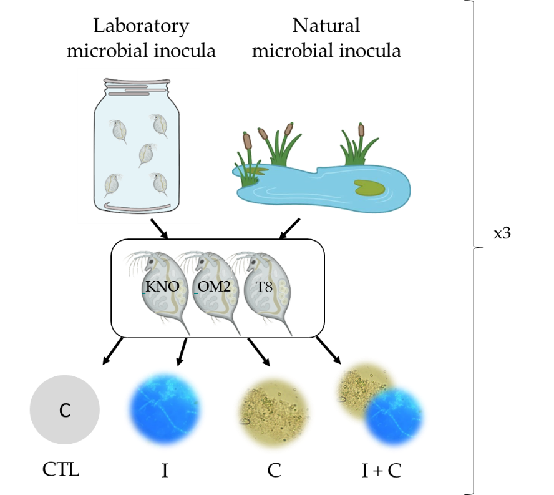
Figure 1: Graphic overview of the experimental design. Sterilized Daphnia individuals from three genotypes were exposed to a natural or laboratory-derived microbial community (microbial inoculum treatment). Daphnia receiving a natural microbial community were exposed to 10 µm filtered pond water. Daphnia receiving a laboratory-derived microbial community were exposed to 10 µm filtered tap water conditioned by Daphnia stock cultures for one year. Next, hatched Daphnia individuals from the sterilized eggs were exposed to one of the four different stressor treatments: control, oomycete infection, cyanobacterium or their combination. The experiment was performed in triplicate.

Microbial inocula
All sterilized Daphnia juveniles received either a natural or a laboratory-derived microbial inoculum at the start of the experiment. Each microbial inoculum consisted of a water sample with a microbial community. All water samples were filtered over 100 µm and subsequently over 10 µm to remove debris. The natural microbial inocula were sampled from three natural ponds from Kortrijk. Replicate 1 received bacterioplankton from the Kennedy pond (50°48’05.7”N 3°16’33.0”E), replicate 2 from the Marionetten pond (50°47’43.5”N 3°15’00.2”E), and replicate 3 from the KU Leuven Kulak pond at the Ecolab (50°48’30.8”N 3°17’37.0”E). The laboratory-derived microbial inocula were sampled from the medium in which three different D. magna genotypes (different from the studied ones) had been cultured in the laboratory for more than one year. The different replicates received bacterioplankton form the culture medium of genotype M5 (replicate 1), genotype T7 (replicate 2), and genotype ZWE 2B (replicate 3). In this manner, we were able to mimic bacterioplankton communities under natural (high bacterial diversity) and laboratory (low bacterial diversity) conditions.

Stressors
Based on comparison with pictures in Prowse 1954, Green 1974 and Seymour et al. 1984, we estimated the infection to be an oomycete-like infection (see figure SI1). Further sequencing should reveal which genus/species the infection belongs to. Pre-trials showed that infection with the oomycete-like parasite caused high mortality, especially in (germ-free) juveniles, and reduced fecundity, which appeared to differ among D. magna genotypes. Infection of the oomycete-like parasite was visible by the presence of long, separated hyphae in biofilms on the wall of the culture jar, on the medium surface, and on dead individuals in cultures with high infection rates.
A commonly occurring and well-studied cyanobacterium is Microcystis sp. (von Elert et al., 2003), which is known to be detrimental for Daphnia for many different reasons: (i) the production of various toxins, (ii) low food quality due to the absence of polyunsaturated fatty acids and (iii) colony formation which interferes with the filtering process of zooplankton (von Elert et al., 2003; Martin-Cruezburg et al., 2008; DeMott et al., 2001). In response, zooplankton has developed multiple tolerance mechanisms such as production of proteases or increased expression of genes associated with secondary metabolite transport and catabolism (Schwarzenberger et al., 2014; 2020). Microcystis aeruginosa is a colonial cyanobacterium that produces toxic metabolites such as microcystins. Many studies demonstrated negative effects of M. aeruginosa on D. magna performance (Huang et al., 2020). In addition, the effects of M. aeruginosa on D. magna are genotype dependent (Lemaire et al., 2012), whereby the host-genotype dependent gut microbiome drives D. magna tolerance to M. aeruginosa (Macke et al., 2017, 2020).

Stressor treatments
Individuals in the control treatment were not exposed to any stressor and were fed with C. vulgaris from day 3 onwards. Individuals in the oomycete-like infection treatment received a spore solution of lab infected individuals. The spore solution was obtained by squashing infected Daphnia individuals and was administered in a 1:3 ratio (1 infected, squashed, individual was used to infect 3 germ-free individuals in the stressor treatment). We assume little impact from the small bacterial community associated with the spore solution as the administered volume was low and as administration occurred after the exposure and colonization of the microbial inocula, for which we assumed a priority effect (Vass and Langenheder, 2017; Callens et al., 2020). Samples of the spore solution were sequenced to assess bacterial composition to correct for contamination if necessary. Daphnia in the infection treatment also received C. vulgaris as a food source from day 3 onwards. Individuals in the cyanobacterium treatment received a mixture of the toxic cyanobacterial strain M. aeruginosa and the non-toxic C. vulgaris in a 50:50 ratio on a daily base from day 5 onwards. Before the start of the stressor treatment (days 3 and 4), cyanobacterium-exposed individuals were fed with 100% C. vulgaris. Individuals in the stressor combination treatment received both the spore solution on day 5 and the combination of the toxic M. aeruginosa and the non-toxic C. vulgaris in a 50:50 ratio from day 5 onwards. Similarly, as in cyanobacterium-stressed individuals, combination-stressed individuals were fed with 100% C. vulgaris on days 3 and 4 (before the stressor treatment started).

Execution of the experiment
Sterilized juveniles (0-1 day old) were individually placed in a closed vial filled with 18 mL sterile filtered tap water and 2 mL of the corresponding microbiome treatment (natural or laboratory-derived microbial community). After receiving the corresponding microbial inoculum, the individuals remained in these conditions for 48h, allowing for the microbiota to colonize the Daphnia guts. On the third day, all individuals were fed with C. vulgaris (100*10³ cells/mL). On the fifth day, individuals were exposed to their corresponding stressor treatment (Figure 1). Thereafter, the medium volume in the falcon tubes was gradually increased to 50 mL by adding 10 mL of sterile filtered tap water per day, and this for three consecutive days (day 6-8). Food concentration in the first 6 days was low (1*10⁵ cells/mL) to ensure a sufficient stress response. From day 7 onwards, food concentration was increased to 2*10⁵ cells/mL. All individuals were monitored for survival and reproduction for 21 days. At the end of the experiment (day 21), the body size was measured from top of the head to the base of the tail. The guts of the surviving Daphnia were dissected under a stereomicroscope with sterile dissection needles and collected per treatment in an Eppendorf tube filled with 10 µL of sterile MilliQ. This resulted in 72 gut samples, representing 2 infection treatments x 2 cyanobacteria treatments x 2 microbiome inocula x 3 genotypes x 3 replicates (Table SI1). In addition, samples of the donor microbial inocula (3 natural and 3 laboratory-derived microbial inocula), stressor treatment (oomycete infection and M. aeruginosa) and food (C. vulgaris) were collected. Samples were stored at -20°C until further processing.

Library preparation and sequencing
DNA was extracted using a PowerSoil DNA isolation kit (MO BIO laboratories, Carlsbad, CA, USA). DNA was dissolved in 20 µL milliQ water. Because of initially low bacterial DNA concentrations in some samples, a nested PCR was applied to increase specificity and amplicon yield. The full-length 16S rRNA gene was first amplified with EUB8F and 1492R primers on 10 ng of template using a high-fidelity SuperFi polymerase (Thermofisher, Merelbeke, Belgium) for 30 cycles: 98°C – 10 s; 50°C – 45 s; 72°C – 30 s. PCR products were subsequently purified using the CleanPCR kit (Qiagen, Antwerp, Belgium). To obtain dual-index amplicons of the V4 region, a second amplification was performed on 5 µL (=20-50 ng) of PCR product using 515F and 806R primers for 30 cycles: 98°C – 10 s; 50°C – 45 s; 72°C – 30 s. Both primers contained an Illumina adapter and an 8-nucleotide (nt) barcode at the 5’-end. For each sample, PCRs were performed in triplicate. Afterwards the PCR products were pooled, and a small volume (5 µL) was loaded on a gel to check if the PCR amplified the correct fragment. The remaining volume of the PCR products were purified using the CleanPCR kit (Qiagen, Antwerp, Belgium). An equimolar library was prepared by normalizing amplicon concentrations with a SequalPrep Normalization Plate (Applied Biosystems, Geel, Belgium) and subsequent pooling. Amplicons were sequenced using a v2 PE500 kit with custom primers on the Illumina Miseq platform (KU Leuven Genomics Core), producing 2 x 250-nt paired-end reads.

Analysis of Daphnia performance traits
To assess tolerance of the Daphnia to the stressor treatments, we analyzed survival, fecundity and body size. Survival was analyzed using a log-rank or Mantel-Haenszel test. The survival times of individuals that were still alive at the end of the 21-day experiment were coded as right-censored. Normality and skewness of body size and fecundity data were examined with Shapiro–Wilk test, ggqqplot function (package ggpubr to make quantile-quantile plots) and Levene test. For fecundity and body size, we used the Akaike information criterion (AIC) to select the best subset of variables to represent the best model. We first evaluated to include maternal line as a random factor (with a linear mixed-effect model) or not (with a general linear model). Secondly, we tested the significance of the fixed factors in the model with the best combination of fixed and random factors according to the AIC. Type II ANOVA tables for fixed-effect terms with Satterhwaite and Kenward-Roger methods for dominator degrees of freedom for F-tests and p-values were created (Anova function of the car package). Following the AIC criterium, a linear mixed-effect model was chosen to evaluate fecundity and body size. In the final model, we included microbiome treatment, infection (absent or present), cyanobacterium (absent or present) and genotype as fixed factors, and maternal line as random effect. We also included all possible interactions. Post hoc analyses were performed using the ‘emmeans’ function with a ‘Tukey’ adjustment from the emmeans R package. All statistical tests were performed in R 4.0.2 (R Core Team 2020).

Analysis of Daphnia microbiome data
DNA sequences were processed following Callahan et al. (2016a). Sequences were trimmed (the first 10 nucleotides and from position 180 onwards) and filtered (maximum of 2 expected errors per read) on paired ends jointly. Sequence variants were inferred using the high-resolution DADA2 method, which relies on a parameterized model of substitution errors to distinguish sequencing errors from real biological variation (Callahan et al. 2016b). Chimeras were subsequently removed from the data set. Taxonomy was assigned with a naïve Bayesian classifier using the SILVA v138 training set. ASVs with no taxonomic assignment at the phylum level or which were assigned as “chloroplast” or “cyanobacteria” were removed from the data set. After filtering, a total of 3 552 490 reads were obtained with on average 39 038.35 reads per sample, with most samples having more than 1000 reads. To visualize the bacterial orders that differed between the treatments, ASVs were grouped at the order level, and orders representing <1% of the reads were discarded.
Measures for α-diversity of the recipient gut microbial communities within the different treatments (ASV richness) were calculated using the vegan package in R following Borcard et al. (2011). All samples were rarified to a depth of 1000 reads, based on the number of reads per sample and rarefaction curves (Figure SI2), before analyzing α-diversity. The effects of sample type (donor bacterioplankton or recipient), infection (absence or presence), cyanobacterium (absent or present), and microbiome (lab and natural) treatments, genotype (KNO, OM2 and T8), and all possible interactions on ASV richness were assessed through a generalized linear model (GLM), assuming a Poisson distribution of the data and corrected for overdispersion (i.e., Quasi-Poisson). Maternal line was not included as a random factor as the AIC criterium indicated that the model without inclusion of the maternal line was a better predictive model of the data. Pairwise comparisons among significant variables and their interactions were performed using the ‘emmeans’ function with a ‘Tukey’ adjustment from the emmeans R package.
To examine differences in gut microbial community composition (β-diversity) among samples, Bray-Curtis, weighted and unweighted Unifrac distance matrices were calculated and plotted using Principal Coordinates Analysis with the phyloseq package in R. Multivariate community responses to treatments and genotype were investigated by means of PCA. The effect of the infection, cyanobacterium, and microbiome treatments, genotype, and all possible interactions on β-diversity were assessed through a permutation MANOVA, using the Adonis2 function in the vegan package in R. Obtained p-values were adjusted for multiple comparisons through the control of the false discovery rate (FDR).
Pearson correlations were executed between the number of sequenced guts and the ASV richness to check for interdependence. No significant correlation could be detected between the number of sequenced guts and ASV richness, dismissing the issue of interdependence (Table SI2). Additionally, correlation tests were executed between the three life history traits and the ASV richness of the gut microbial communities. Obtained p-values were adjusted for multiple comparisons through the control of the false discovery rate (FDR).
To identify which bacterial orders significantly differed between the treatments, relative abundances per order were calculated on the raw sequencing data, excluding the samples removed by the rarefaction. The uptake of bacteria by the recipient Daphnia from the donor bacterioplankton, was also analyzed with Union plots using the wilkox/unionplot function from Github (results see supplementary information, Figure SI3). Additionally, differential abundance analyses were performed (edgeR function) on the raw sequencing data from which samples with less than 2 counts per million (CPM) in at least three samples were filtered out. All statistical tests were performed in R 4.0.2 (R Core Team 2020).

Results
Performance traits of the Daphnia host
The survival analysis revealed an infection x cyanobacterium x microbial inoculum x genotype interaction on Daphnia survival (Table 1). To further investigate the four-way interaction we analyzed the data for the lab and natural microbial inocula separately (results are shown in Table SI3). When Daphnia received a laboratory-derived microbial inoculum, there was a significant infection x cyanobacterium interaction (X²=9.5, df=3, p=0.02). Interaction plots (Figure 2) show an antagonistic interaction between the two stressors on survival: survival was higher (i) in the control treatment than when exposed to the cyanobacterium (X²=4.9, df=1, p=0.03), but not when exposed to the infection (X²=1.9, df=1, p=0.2) and (ii) when exposed to both stressors than exposed to a single stressor (infection: X²=3.5, df=1, p=0.05; cyanobacterium: X²=6.9, df=1, p=0.009, Figure 3). When Daphnia received a natural microbial inoculum, the interaction between the stressor treatments was genotype dependent (infection x cyanobacterium x genotype interaction, X²=22, df=11, p=0.02, Table SI3). For none of the genotypes, there was a significant antagonistic interaction between the two biotic stressors (KNO: X²=2.6, df=3, p=0.5; OM2: X²=4.4, df=3, p=0.2; T8: X²=2.3, df=3, p=0.5; Table SI3).

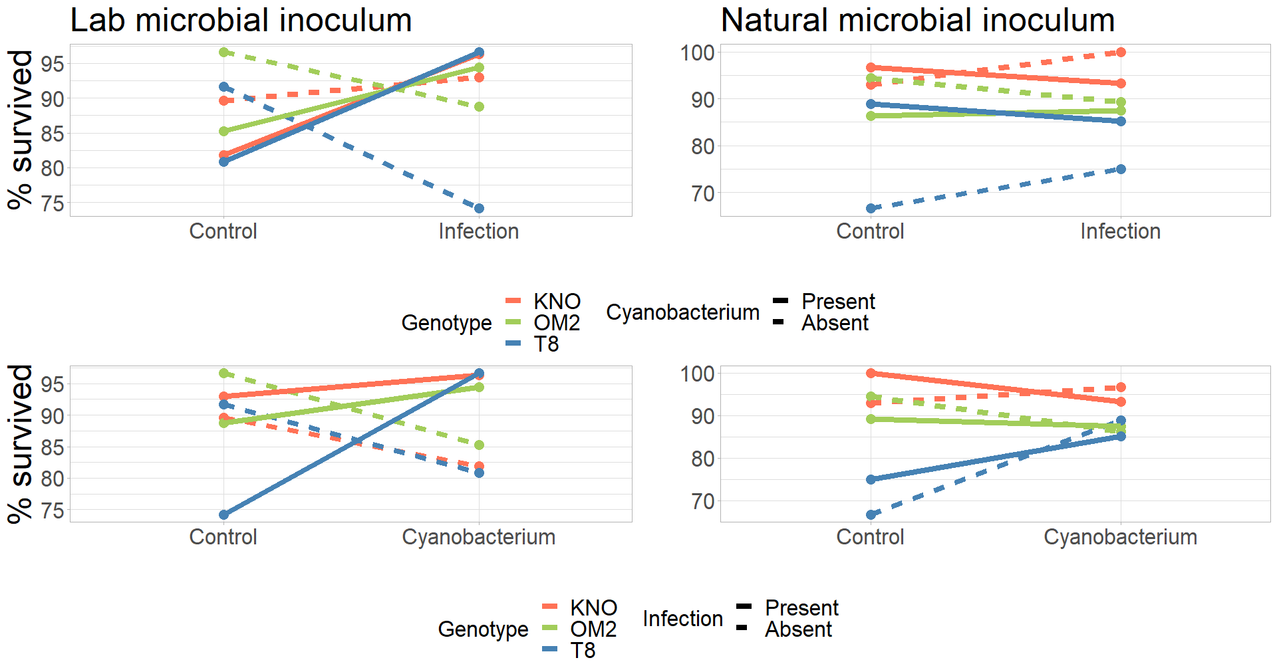
Figure 2: Interaction plot for the effects of the infection and the cyanobacterium on the percentage survived Daphnia grouped per microbial treatment (lab microbial inoculum: Daphnia that received a laboratory microbial inoculum, natural microbial inoculum: Daphnia that received a natural microbial inoculum). The colors represent the different genotypes: red: KNO, green: OM2 and blue: T8. The line type shows the presence (full line) or absence (dotted line) of the cyanobacterium (upper row) or the infection (bottom row).

The analyses on the total fecundity (total number of hatched eggs per Daphnia individual) revealed an infection x cyanobacterium x microbiome x genotype interaction (Table 1). Separate analyses per microbial inoculum treatment (statistical results in Table SI4) indicated that fecundity was reduced for all three genotypes (KNO: F=77.62, df=1,215.04, p<0.0001; OM2: F=69.46, df=1,206.04, p<0.0001, T8: F=5.75, 1, 164.67, p=0.01) when exposed to M. aeruginosa in both microbial inoculum treatments (laboratory: F=42.46, df=1,292.02, p<0.0001, natural: F=126.36, df=1,295.02, p<0.0001; Figure 3). When exposed to the infection, fecundity increased (for two of the three genotypes in the laboratory microbial inoculum treatment: F=3.14, df=2,192.05, p=0.04, and for all three genotypes in the natural microbial inoculum treatment: F=13.77, df=1,295.02, p=0.0002), especially when Daphnia received a natural microbial inoculum. For fecundity, no significant infection x cyanobacterium interaction was detected neither when exposed to the lab microbial inoculum (F=1.15, df=1,292.01, p=0.28) or the natural microbial inoculum (F=0.75, df=1,295.04, p=0.38). This means that no antagonistic interaction between the two stressors could be detected for fecundity.

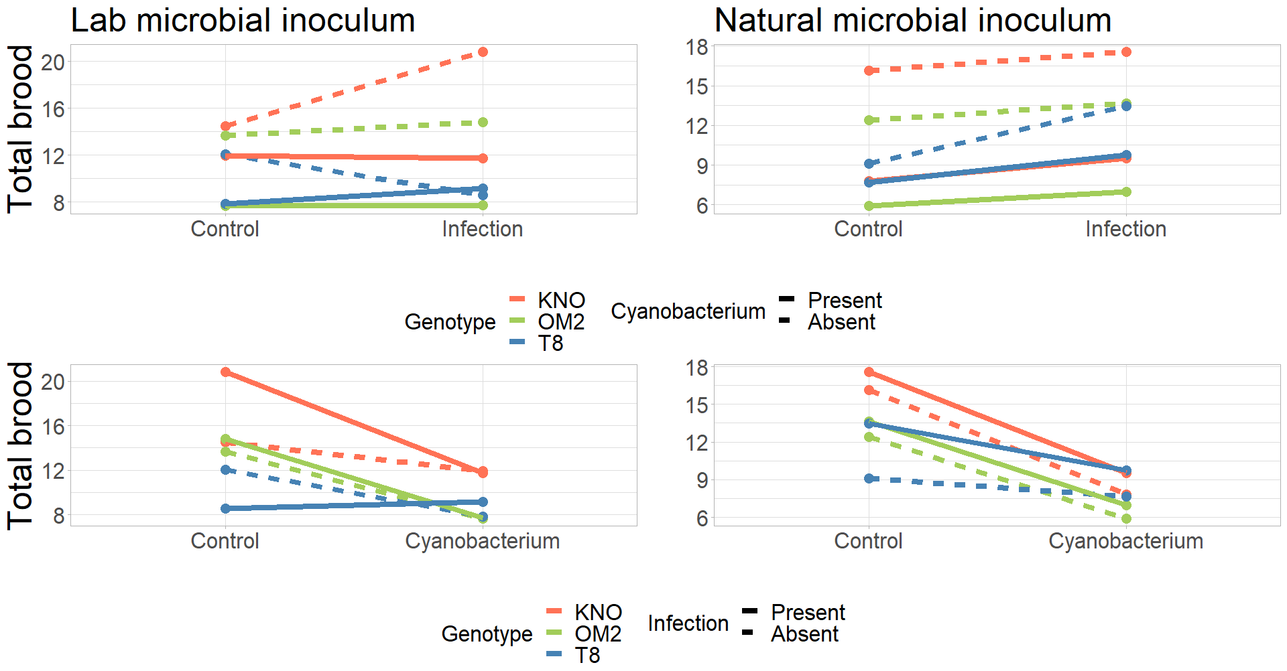
Figure 3: Interaction plot for the effects of the infection and the cyanobacterium on the total reproduction in Daphnia grouped per microbial treatment (lab microbial inoculum: Daphnia that received a laboratory microbial inoculum, natural microbial inoculum: Daphnia that received a natural microbial inoculum). The colors represent the different genotypes: red: KNO, green: OM2 and blue: T8. The line type shows the presence (full line) or absence (dotted line) of the cyanobacterium (upper row) or the infection (bottom row).
Analyses on Daphnia body size revealed significant effects of the single infection or cyanobacterium treatment, but not of their interaction. Effects of the stressor treatments on body size, did not depend on Daphnia genotype or microbial inoculum (Table 1, Figure 4). Post hoc analyses showed a significant difference between all stressor treatments, except between the single stressor cyanobacterium and the combination treatment (Table SI5). Individuals in the control treatment had the highest body size, followed by, in decreasing order of body size, individuals exposed to the infection, cyanobacterium and the combination treatment, from which the last two did not significantly differ (Figure 4).
Positive correlations were observed between survival and fecundity (r=0.32, t= 2.84, df=70, p-adj=0.017; Table SI6, Figure SI14), and between fecundity and body size (r=0.33, t= 2.96, df=70, p-adj=0.017; Table SI6, Figure SI4).
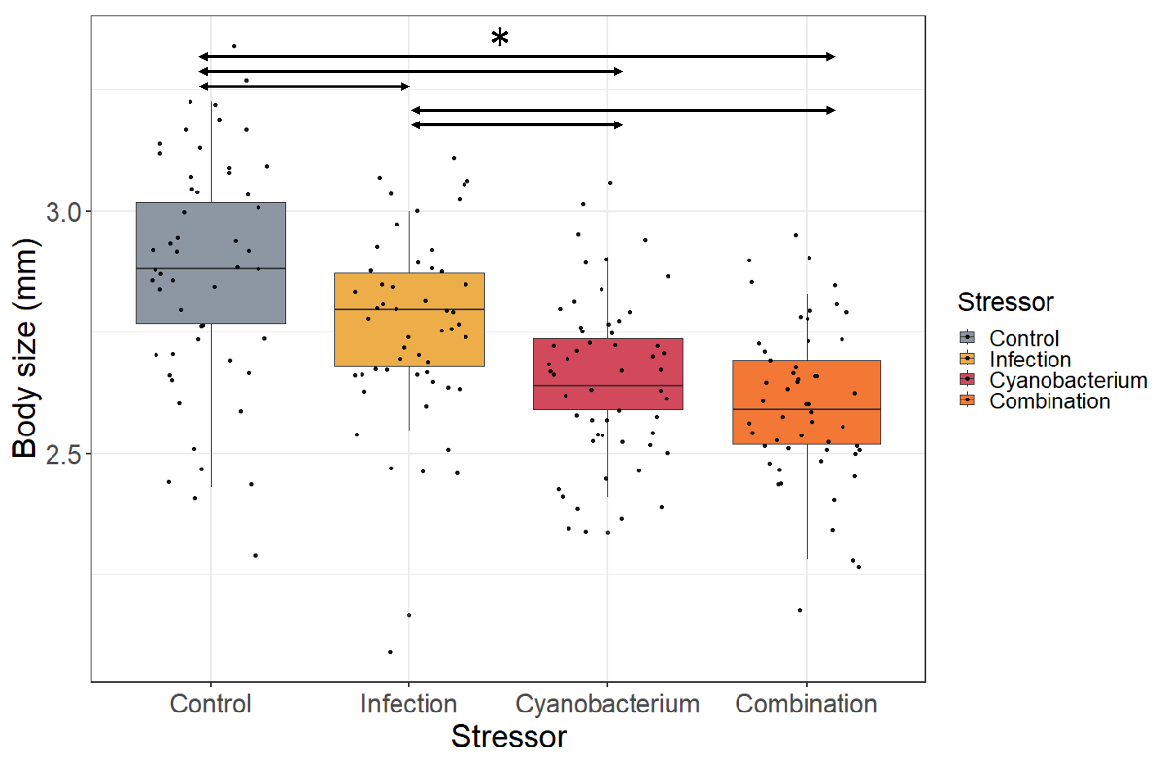
Figure 4: Box plots of the body size of Daphnia at the end of the experiment per stressor treatment. Colors indicate the different stressor treatments. Black dots represent the individual data points. Arrows above the boxplots represent treatments that significantly differed.

Microbial composition
The laboratory microbial inocula were dominated by Micrococcales (40.56%), Burkholderiales (23.28%) and Chitinophagales (16.23%), while the natural microbial inocula were dominated by Burkholderiales (31.33%), Kapabacteriales (25.05%), Sphingobacteriales (9.19%), Flavobacteriales (7.24%), and Chitinonphagales (6.2%). In the recipient Daphnia microbial communities, the same top four most abundant bacterial orders were observed between the two microbial inoculum treatments, the presence and absence of the infection, the presence and absence of the cyanobacterium, and the three different genotypes (Table 2). The observed top four taxa in the Daphnia guts consisted of: Burkholderiales, Pseudomonadales, Verrucomicrobiales, and Rhizobiales. Relative abundance tables can be found in the supplementary information (Table SI7).
ASV richness
In both donor inocula and recipient gut microbiomes, ASV richness was significantly higher in the natural conditions (donor: mean= 87.000, sd= 42.036, recipient: mean= 26.550, sd= 9.556) compared with the laboratory conditions (donor: mean= 30.333, sd= 10.970, recipient: mean= 19.652, sd= 5.441, Table SI8, Figure 6). ASV richness was also significantly higher in the microbial inocula (mean= 58.667, sd= 41.452) compared with the gut microbiomes of the recipient Daphnia (mean= 22.860, sd= 8.303; p<0.001, z-value=-12.13, Figure 5). Analysis of the recipient Daphnia revealed a significant microbial inoculum effect and a significant cyanobacterium x microbial inoculum x genotype interaction on ASV richness (Table 1). A separate analysis per microbial inoculum treatment did not reveal a significant main effect of the stressor treatment in Daphnia that received a natural microbial inoculum (infection: F=0.11, df=1,0.37, p=0.75; cyanobacterium: F=0.92, df=1,3.15, p:0.36). Daphnia that received a laboratory microbial inoculum showed a marginally significant interaction between infection and genotype or cyanobacterium treatment (infection x genotype: F=3.29, df=2,6.7, p=0.07 and infection x cyanobacterium: F=3.99, df=1, 4.1, p=0.07). No correlations were observed between the Daphnia performance traits and ASV richness of the gut microbial community (Table SI6, Figure SI5).

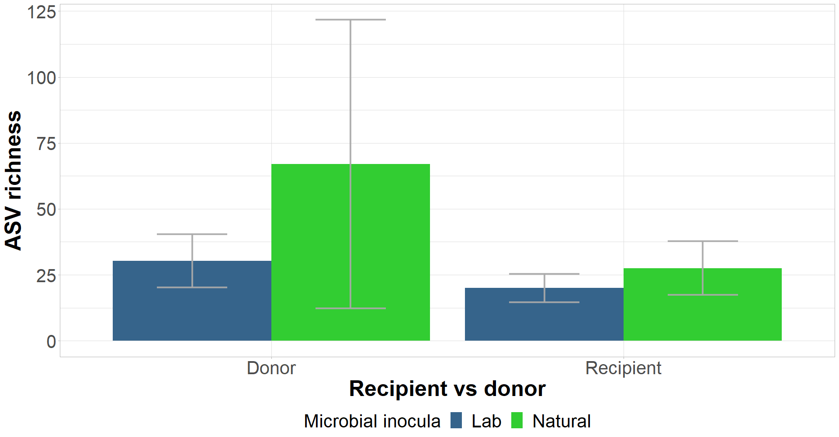
Figure 5: Bar plots of ASV richness of donor inoculum and recipient Daphnia samples grouped per sample type (donor inoculum vs recipient Daphnia) and microbial inocula. Colors indicate the different microbial inocula. Error bars indicate one standard error.
Beta diversity
The beta diversity analyses on the microbial donor inocula revealed a significant difference between the natural and laboratory microbial inocula, based on unweighted Unifrac distance (Table 1, Figure 6A). Analyses on beta diversity on the gut microbial composition revealed that Daphnia receiving the natural microbial inoculum differed significantly from those receiving the lab microbial inoculum based on unweighted Unifrac distances (Table 1, Figure 6B). All other factors or interactions were not significant (Table 1). Separate analyses per microbial inoculum treatment did not reveal a significant main effect of the infection, cyanobacterium or the genotype or any significant interaction in the gut microbiome composition of Daphnia that received a laboratory or a natural microbial inoculum based on unweighted Unifrac distances.
Microbial community
The EdgeR analysis revealed highly significant differences for 213 ASVs between the donor bacterioplankton and the recipient Daphnia (Table SI9). Within the donor bacterioplankton, only the relative abundance of one ASV (Aurantimicrobium sp.) was significantly different between the laboratory and natural microbial inocula (Table SI9, the three laboratory microbial inocula were pooled and the three natural microbial inocula were pooled). Within the recipients the relative abundance of 141 ASVs were significantly different between the four stressor treatments, the relative abundance of 285 ASVs between the microbial inoculum treatments, the relative abundance of 34 ASVs differed when stressor and microbial inoculum treatments were combined and the relative abundance of 5 ASVs differed when stressor, microbial inoculum treatment and Daphnia genotype were combined (Table SI10; Figure SI6). Analysis per microbial inoculum treatment revealed that the relative abundance significantly differed between the stressor treatments for 12 ASVs within the laboratory microbial inoculum treatment and for 24 ASVs within the natural microbial inoculum treatment (Figure SI7, Table SI10). A summary of significant differences in the relative abundance of the most abundant ASVs between the stressor treatments per microbial treatment can be found in Table 3. This table shows that the relative abundance of the Microbacteriaceae was significantly higher in the infection-cyanobacteria combination treatment when Daphnia received a laboratory microbial inoculum. In addition, this table also shows that the relative abundance of this ASV was higher in the gut microbial community of Daphnia that received the laboratory versus the natural microbial inoculum.

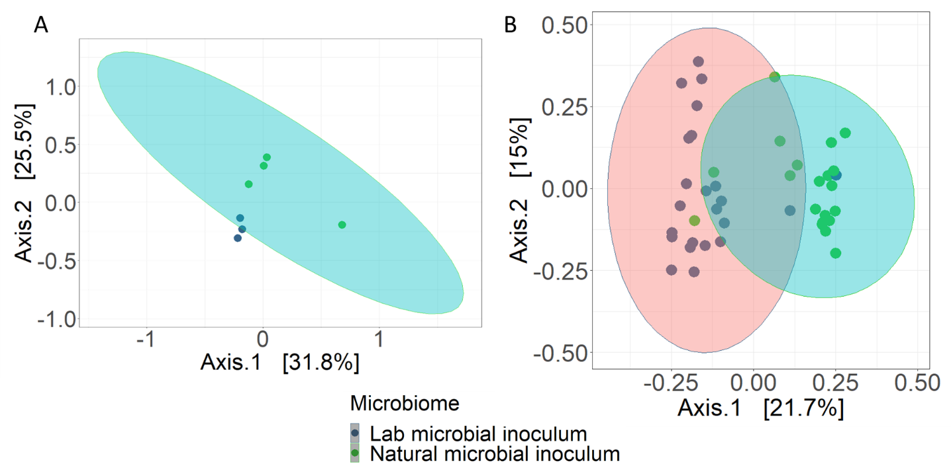

Figure 6: PCA showing significant differences between natural and laboratory microbial inocula (A), and the resulting Daphnia gut microbiomes (B), based on the unweighted Unifrac distances. Colors represent the two microbial inoculum types. Ellipse shows the 95% confidence ellipse of the data (in plot A, the ellipse of natural microbiomes is missing due to few datapoints to make an ellipse).

Discussion
We showed that natural and laboratory microbial inocula were differently structured, as were the resulting gut microbial communities in the recipient hosts, with the natural microbiomes being more diverse (i.e., higher ASV species richness) than the laboratory microbiomes. Analysis of the Daphnia performance traits showed that exposure to cyanobacteria reduced survival, fecundity and body size compared to the control, while exposure to the oomycete-like infection only reduced body size. Effects on survival and fecundity were also dependent on the microbial inoculum type. There was an interaction between the oomycete-like infection and cyanobacterium depending on the microbial inoculum type: the infection and cyanobacterium interacted antagonistically on survival when Daphnia were exposed to a laboratory-derived microbial inoculum, but not when they were exposed to a natural microbial inoculum. The results of this experiment also showed that Daphnia responses to the stressors and microbial inocula treatments were genotype dependent for survival and fecundity, but not for body size.
As expected, natural microbial inocula were more diverse (i.e., higher ASV richness) and differently structured than laboratory-derived microbial inocula, and this was also reflected in the gut microbiomes of the recipient Daphnia. These results confirm the findings of Callens et al. (2020), which reported a general trend, where Daphnia exposed to treatments with a higher environmental bacterial diversity showed a higher bacterial diversity in the gut microbiome; most likely due to the presence of a larger pool of potential colonizers. A higher bacterial diversity or differently structured bacterial community in natural versus laboratory environments was also observed for other hosts (e.g., Drosophila: Chandler et al., 2011; Limulus polyphemus: Friel et al., 2020; zebrafish: Roeselers et al., 2011; mice: Rosshart et al., 2017).
Survival, fecundity and body size were all reduced when exposed to the cyanobacterium, while only body size was reduced when exposed to the oomycete-like infection. For survival and fecundity these effects were dependent on the microbial inoculum and the recipient D. magna genotype. This is consistent with M. aeruginosa being detrimental for Daphnia fitness (Ferrão-Filho et al., 2000; Asselman et al., 2012; Lemaire et al., 2012). Based on personal observations of this virulent oomycete-like infection in the laboratory, we also expected negative effects of the infection on D. magna survival and fecundity. This was based on the observation of high mortality in stock cultures when the infection was present, also upon the presence of infected eggs in the brood pouch, and low hatching success after sterilization of infected eggs. The lower impact of the infection compared with the cyanobacterium (i.e., the infection impacted one of the three observed performance traits, while the cyanobacterium impacted all three observed performance traits) can be because the genotypes used in this experiment showed relatively low susceptibility to the infection. The genotypes used in this experiment survived previous outbreaks of the infection in the laboratory. This is in accordance with Duffy and Hall (2008), who investigated the effect of two parasites, the bacterium Spirobacillus cienkowskii and the fungus Metschnikowia bicuspidata on Daphnia population dynamics. They found that both parasites were virulent to individuals hosts, but only the bacterial parasite caused significant changes in Daphnia population dynamics and density, while the fungal M. bicuspidata infection did not significantly affect population dynamics. It was suggested that amongst others, high genetic variation for susceptibility within host populations may have moderated that effect. Strong Daphnia – parasite genotype interactions have been confirmed before and are considered as the drivers of Red Queen dynamics in Daphnia – parasite interactions (Decaestecker et al. 2003, 2007).
We observed the expected antagonistic interaction between the two stressors, but only when the Daphnia received a laboratory microbial inoculum and not when they received a natural microbial inoculum. Kagami et al. (2007), Agha et al. (2016) and Boudry et al. (2020), also showed an antagonistic interaction between mold-like infections and cyanobacteria for Daphnia survival in laboratory experiments. Kagami et al. (2007) and Agha et al. (2016), explained this antagonism by the observation that obligate, fungal parasites from inedible diatoms and cyanobacteria, can transfer energy and nutrients from otherwise inedible algae to Daphnia, and thereby increase Daphnia growth and survival. It is not known whether the oomycete-like infection used here also infects cyanobacteria, but most likely not. The obtained results are in line with our second hypothesis: that tolerance to the stressors and the stressor interaction type is microbiome mediated. Daphnia survival was differently impacted when they received the natural or the laboratory-derived microbial inoculum. When Daphnia were exposed to the lab microbial inoculum, an antagonistic interaction between the two stressor treatments was observed, while this was not the case when Daphnia were exposed to a natural microbial inoculum.
Thus, the interaction between the stressors differed between the two microbial inocula treatments. This can be explained because the natural microbial community was more diverse and differently structured, and as such could provide a broader pool of microbiota. Originally, we expected this broader pool of bacteria to be beneficial for Daphnia fitness. A broader pool of bacteria is beneficial if (i) a general uptake of more strains includes strains that have a positive effect on defense mechanisms linked with survival, or (ii) if Daphnia recruits microbial strains to protect the host against the stressor. Nevertheless, in the obtained results, we found that when Daphnia were inoculated with a less diverse laboratory microbial inoculum, the antagonistic effect between the stressors appeared. In that combination the relative abundance of one class, the Microbacteriaceae, was significantly higher. This can potentially be due to reduced competition between multiple bacterial strains if bacterial diversity is lower, such that beneficial strains (e.g., Microbacteriaceae) can thrive better. Additionally, these bacterial strains in guts with low bacterial diversity, may interact more strongly with the stressors or boost host tolerance more strongly (as they do not have to compete with many other bacterial strains). Interestingly, Microbacteriaceae are bio-degraders capable of producing hydrolytic enzymes, such as chitinase, cellulase and glucanase (Motiei et al., 2020, Shivlata and Satyanarayana, 2015). Part of these components are present in cyanobacteria and oomycetes. As such the presence of this group of bacteria could have increased the availability of essential nutrients and substrates for the Daphnia individuals, which may in turn could have contributed to the increased Daphnia survival (Motiei et al., 2020). The causal role of Microbacteriaceae in increasing Daphnia survival under combined stressor treatments needs, however, further investigation, e.g., through mono-association experiments.
A broader pool of microbiota can reduce host survival, if next to beneficial and neutral microbial strains, also obligate and opportunistic strains are taken up. Aquatic environments contain, next to a plethora of beneficial and neutral microbial strains, obligate and opportunistic pathogens (Schulze et al., 2006), so it could be that with a higher microbial diversity more opportunistic, pathogenic strains were present (Callens et al., 2016). We did, however, not find a direct correlation between gut microbial diversity and the observed Daphnia performance traits, which suggests that the diversity of the gut community did not predominantly determine tolerance in Daphnia. Whatever the exact underlying mechanism, the finding that the interaction type between two stressors can be mediated by the gut microbiome adds a new perspective to multi-stressor research. There is increasing concern and research on combined stressor effects and particularly on how stressors interact as this may crucially determine their impact on natural populations (Côté et al., 2016; Orr et al., 2020). Our ability to predict the interaction type is, however, still very limited, and improved insights in the determinants of the interaction type are therefore highly needed. Our finding that the microbial inoculum can change the interaction type between the two biotic stressors tested and that this is linked with the presence of strains, even for the same host genotype, suggests that the gut microbiome may be an important determinant to consider in future studies to understand the occurrence of stressor interaction patterns.
his effect may be explained through a protective effect of the infection on D. magna
towards M. aeruginosa. Such a protective effect could be linked to a parasite-mediated reduction in
toxicity of M. aeruginosa et al. (2014) and 
et al. (2012), who demonstrated the biodegradation of M. aeruginosa by the algicidal fungus Trichoderma
citrinoviride and the biodegradation of Microcystin-LR by Trichaptum abietum, respectively. The removal
or lysation of algal cells by fungi can happen indirectly through the production of extracellular substances
or by degrading them directly after encasing the algae in a mucous membrane. This biodegradation is
  
feeding inhibition in D. magna and, although this effect would not affect the low nutritional value
of M. aeruginosa, it could explain the higher survival of D. magna upon cyanobacterial exposure in
Experiment 1. Moreover, recent research showed that chytrid fungi may even provide a food source for
zooplankton through the production of zoospores and that chytrid infections make cyanobacteria a more
valuable food source, which may offset feeding inhibition and low nutritional values and may ultimately
contribute to the protective effect suggested by our study ( et al. 2018). Further examples of
similar biotic interactions are found in the literature. A study conducted by  et al. (2014)
suggested a protective effect of M. aeruginosa on D. magna    
is a viral infection ( et al. 2014;  et al. 2018). Recently,  et al. (2019)
detected a medicinal effect of cyanobacteria on Daphnia dentifera increasing its tolerance to parasitism.
These results suggest that biotic interactions may be important in the response of zooplankton towards
particular stressors, given that these biotic interactions can interact with and even weaken the toxic
effects of an antagonist. Alternatively, it can be that the host is boosted by the presence of one stressor
and that defenses towards other s (with particular toxins) is increased.
We also found support for the hypothesis that responses to the stressors in terms of survival and fecundity are host genotype dependent. These results are in accordance with the literature as responses to cyanobacteria (e.g., Lemaire et al. 2012; Macke et al., 2017) and parasites (e.g., Decaestecker et al., 2003, 2007) in Daphnia are generally considered to be genotype dependent. In contrast, genotype effects on the interaction between stressors are not often documented. One other study investigated the effect of an insecticide and a parasite on two D. magna genotypes. They showed that the interaction between the two stressors differed between the genotypes (De Coninck et al., 2013). Daphnia genotypes differ in their selective capacities to take up bacteria (Macke et al., 2017; Frankel-Bricker et al., 2020; Callens et al., 2020; Bulteel et al., 2021), which can in turn result in different responses to the stressor treatments. Some Daphnia genotypes will be highly selective, and for example take up bacteria that help in the protection against toxic cyanobacteria, while other Daphnia genotypes will be less selective and will randomly take up bacterial strains from the environment. Interestingly, Houwenhuyse et al. (2021) showed a local adaptation effect for this response, with genotypes selecting more consistently for the same bacterial strains upon sympatric microbial exposure, which was not the case if bacterial strains of the microbiome were allopatric.
In conclusion, single exposure to the stressor treatments, negatively impacted the observed performance traits. Survival, fecundity and body size of the Daphnia were negatively impacted by the exposure to a cyanobacterium, while the oomycete-like infection only negatively impacted Daphnia body size. The impact of the combined exposure to both stressors was microbiome mediated for survival and fecundity. The stressors acted antagonistically on Daphnia survival, but only when they were exposed to a laboratory microbial inoculum (and not when they were exposed to a natural microbial inoculum). For fecundity, no antagonistic interaction could be detected. Our finding that the microbial inoculum can change the interaction type between the two biotic stressors tested, suggests that the gut microbiome may be an important determinant to consider in future studies to understand the occurrence of stressor interaction patterns.

Acknowledgments
The authors thank Noé Cuvelier, Bart Soens and Jesse Vandenbussche for their assistance with the experimental work. We would also like to thank Dieter Ebert, Meghan Duffy and Justyna Wolinska for their help with the oomycete characterization. In addition, we thank Mathilde Scheifleer and Bertanne Visser for their constructive comments and improvement of the manuscript.

Funding
Funding was provided by the KU Leuven research project C16/17/002; ID-N PlasticDaphnia and the FWO projects G092619N and G06216N.

Data availability
The datasets and scripts generated for this study can be found in the NCBI, under accession number PRJNA731313 and on Zenoda with DOI: 10.5281/zenodo.4778716.

Conflict of interest
The authors declare that there is no conflict of interest.

References
Adamo SA. Animals have a plan B: how insects deal with the dual challenge of predators and pathogens. Journal of Comparative Physiology B, Biochemical, systemic, and environmental physiology. 2020, 190(4):381-390
Adamovsky O, Buerger AN, Wormington AM, Ector N, Griffitt RJ, Bisesi Jr JH, Martyniuk CJ. The gut microbiome and aquatic toxicology: An emerging concept for environmental health. Environmental Toxicology and Chemistry. 2018, 37(11): 2758-2775
Agha R, Saebelfeld M, Manthey C, Rohrlack T, Wolinska J. Chytrid parasitism facilitates trophic transfer between bloom-forming cyanobacteria and zooplankton (Daphnia). Scientific Reports. 2016, 6: 35039. DOI: 10.1038/srep35039
Asselman J, De Coninck DIM, Glaholt S, Colbourne JK, Janssen CR, Shaw JR, De Schamphelaere KAC. Identification of pathways, gene networks, and paralogous gene families in Daphnia pulex responding to exposure to the toxic cyanobacteria Microcystis aeruginosa. Environmental Science & Technology. 2012, 46: 8448-8457
Bai Y, Kissoudis C, Yan Z, Visser RGF, van der Linden G. Plant behaviour under combined stress: tomato responses to combined salinity and pathogen stress. The plant Journal. 2018, 93(4): 781-793
Banos S, Gysi DM, Richter-Heitmann T, Glöckner FO, Boersma M, Wiltshire KH, Gerdts G, Wichels A, Reich M. Seasonal dynamics of pelagic mycoplanktonic communities: interplay of taxon abundance, temporal occurrence, and biotic interactions. Frontiers in Microbiology. 2020, 11: 1305. DOI: 10.3389/fmicb.2020.01305
Bittner M, Štern A, Smutná M, Hilscherová K and Žegura B. Cytotoxic and genotoxic effects of cyanobacterial and algal extracts-microcystin and retinoic acid content. Toxins. 2021, 13(2) doi:http://dx.doi.org.kuleuven.ezproxy.kuleuven.be/10.3390/toxins13020107
Borcard D, Gillet F, Legendre P. Numerical ecology with R. SpringerLink. 2011
Boudry A, Devliegere S, Houwenhuyse S, Clarysse L, Macke E, Vanoverberghe I, Decaestecker E. Daphnia magna tolerance to toxic cyanobacteria in the presence of an opportunistic infection within an evolutionary perspective. Belgian Journal of Zoology. 2020, 150: 81-93. DOI: 10.26496/bjz.2020.75
Bulteel L, Houwenhuyse S, Declerck SAJ, Decaestecker E. The role of microbiome and genotype in Daphnia magna upon parasite re-exposure. Genes. 2021, 12(1): 70. DOI: 10.3390/genes12010070
Cable J, Barber I, Boag B, Ellison AR, Morgan ER, Murray K, Pasoe EL, Sait SM, Wilson A, Booth M. Global change, parasite transmission and disease control: lessons from ecology. Philosophical transactions of the royal society B, Biological sciences. 2017, 372: 1719.
Callahan BJ, Sankaran K, Fukuyama JA, McMurdie PJ, Holmes SP. Bioconductor workflow for microbiota data analysis: from raw reads to community analyses. F1000Research. 2016a, 5: 1492
Callahan bJ, McMuridue PJ, Rosen MJ, Han AW, Johnson AJA, Holmes SP. DADA2: high resolution sample interference from Illumina amplicon data. Nature Methods. 2016b, 13:581-583
Callens M, Macke E, Muylaert K, Bossier P, Lievens B, Waud M, Decaestecker E. Food availability affects the strength of mutualistic host-microbiota interactions in Daphnia magna. The ISME Journal. 2016, 10: 911-920
Callens M, Watanabe H, Kato Y, Miura J, Decaestecker E. Microbiota inoculum composition affects holobiont assembly and host growth in Daphnia. Microbiome. 2018, 6: 56. DOI: 10.1186/s40168-018-0444-1
Callens M, De Meester L, Muylaert K, Mukherjee S, Decaestecker E. The bacterioplankton community composition and a host genotype dependent occurrence of taxa shape the Daphnia magna gut bacterial community. FEMS Microbiology Ecology. 2020, 96, 8: fiaa128. DOI: 10.1093/femsec/fiaa128
Chandler JA, Lang JM, Bhatnagar S, Eisen JA, Kopp A. Bacterial communities of diverse Drosophila species: ecological context of a host-microbe model system. PLOS Genetics. 2011, 7(9): e1002272. DOI: 10.1371/journal.pgen.1002272
Chomicz L, Conn DB, Szaflik JP, Szostakowska B. Newly emerging parasitic treaths for human health: national and international trends. Biomed Research International. 2016. 4283270.
Civitello DJ, Penczykowski RM, Smith AN, Shocket MS, Duffy MA, Hall SR. Resources, key traits and the size of fungal epidemics in Daphnia populations. Journal of Animal Ecology. 2015, 84(4): 1010-1017
Coopman M, Muylaert K, Lange B, Reyserhove L, Decaestecker E. Context dependency of infectious disease: the cyanobacterium Microcystis aeruginosa decreases white bacterial disease in Daphnia magna. Freshwater Biology. 2014, 59: 714-723. DOI: 10.1111/fwb.12298
Coors A and De Meester L. Synergistic, Antagonistic and Additive Effects of Multiple Stressors: Predation Threat, Parasitism and Pesticide Exposure in Daphnia magna. The Journal of Applied Ecology. 2008, 45(6): 1820-1828.
Côté IM, Darling ES, Brown CJ. Interactions among ecosystem stressors and their importance in conservation. Proceedings of the Royal Society B Biological Sciences. 2016. 283(1824). https://doi.org/10.1098/rspb.2015.2592.
Cousyn C, De Meester L, Colbourn JK, Brendonck L, Verschuren D, Volkaert F. Rapid, local adaptation of zooplankton behavior to changes in predation pressure in the absence of neutral genetic changes. Proceedings of the National Academy of Sciences of the United States of America. 2001, 98(11): 6256-6260. DOI: 10.1073/pnas.111606798
Decaestecker E, De Meester L, Ebert D. In deep trouble: habitat selection constrained by multiple enemies in zooplankton. Proceedings of the National Academy of Sciences. 2002, 99(8): 5481-5485.
Decaestecker E, Vergote A, Ebert D, De Meester L. Evidence of strong host clone-parasite species interactions in the Daphnia microparasite system. Evolution. 2003, 57(4): 784-792.
Decaestecker E, Declerck S, De Meester, Ebert D. Ecological implications of parasites in natural Daphnia populations. Oecologia. 2005, 144: 382-390. DOI: 10.1007/s00442-005-0083-7
Decaestecker E, Gaba S, Raeymaekers JAM, Stoks R, Van Kerckhoven L, Ebert D, De Meester L. Host-parasite ‘Red Queen’ dynamics archived in pond sediment. Nature. 2007, 450: 870-873
De Coninck DIM, De Schamphelaere KAC, Jansen M, De Meester L and Janssen CR. Interactive effects of a bacterial parasite and the insecticide carbaryl to life-history and physiology of two Daphnia magna clones differing in carbaryl sensitivity. Aquatic Toxicology. 2013, 130: 149 – 159
De Figueiredo DR, Azeiteiro UM. Esteves SM, Gonçalves FJM, Pereira MJ. Microcystin-producing blooms – a serious global public health issue. Ecotoxicology and Environmental Safety. 2004, 59(2): 151-163. DOI: 10.1016/j.ecoenv.2004.04.006
DeMott WR, Gulati RD and Van Donk E. Daphnia food limitation in three hypereutrophic Dutch lakes: evidence for exclusion of large-bodied species by interfering filaments of cyanobacteria. Limnology and Oceanography. 2001, 46: 2054-2060
Duffy MA, Hall SR. Selective predation and rapid evolution can jointly dampen effects of virulent parasites on Daphnia populations. The American Naturalist. 2008. 171(4). Doi: 10.1086/52998.
Duffy MA, Brassil CE, Hall SR, Tessier AJ, Cáceras CE, Conner JK. Parasite-mediated disruptive selection in a natural Daphnia population. BMC Evolutionary Biology. 2008. 8(80). Doi:10.1186/147-21-48-8-80.
Duffy MA, Hall SR, Cáceras CE, Ives AR. Rapid evolution, seasonality, and the termination of parasite epidemics. Ecology. 2009. 90(6): 1441-1448.
Duneau D, Luijckx P, Ben-Ami F, Laforsch C, Ebert D. Resolving the infection process reveals striking differences in the contribution of environment, genetics and phylogeny to host-parasite interactions. BMC Biology. 2011. 9(11): https://doi.org/10.1186/1741-7007-9-11.
Ebert D, Lipsitch M, Mangin KL. The effect of parasites on host population density and extinction: experimental epidemiology with Daphnia and six microparasites. The American Naturalist. 2000. 156(5)
Ebert D. Host–parasite coevolution: Insights from the Daphnia–parasite model system. Current Opinion in Microbiology. 2008, 11(3): 290-301. DOI: https://doi.org/10.1016/j.mib.2008.05.012
Ferrão-Filho AS, Azevedo AMFO, DeMott WR. Effect of toxic and non-toxic cyanobacteria on the life history of tropical and temperate cladocerans. Freshwater Biology. 2000, 45(1): 1-19. DOI: 10.1046/j.1365-2427.2000.00616.x
Frankel-Bricker J, Song MJ, Benner MJ, Schaack S. Variation in the microbiota associated with Daphnia magna across genotypes, populations, and temperature. Microbial Ecology. 2020, 79(3): 731-742. DOI: 10.1007/s00248-019-01412-9
Frenken T, Alacid E, Berger SA, Bourne EC, Gerphagnon M, Grossart HP, Gsell AS, Ibelings BW, Kagami M, Küpper FC, Letcher PM, Loyau A, Miki T, Nejstgaard JC, Rasconi S, Reñé A, Rohrlack T, Rojas-Jimenez K, schmeller DS, Scholz B, Seto K, Sime-Ngando T, Sukenik A, Van de Waal DB, Van den Wyngaert S, Van Donk E, Wolinska J, Wurzbacker C, Agha R. Integrating chytrid fungal parasites into plankton ecology: research gaps and needs. Environmental Microbiology. 2017, 19(10): 3802-3822. DOI: 10.111/1462-2920.13827
Friel AD, Neiswenter SA, Seymour CO, Bali LR, McNamara G, Leija F, Jewell J, Hedlund BP. Microbiome shifts associated with the introduction of wild Atlantic horshoe crabs (Limulus polyphemus) into a touch-tank exhibit. Frontiers in Microbiology. 2020, 11: 1398. DOI: 10.3389/fmicb.2020.01398
Gerphagnon, M., Macarthur, D.J., Latour, D., Gachon, C.M.M., Van Ogtrop, F., Gleason, F.H., and Sime‐Ngando, T. Microbial players involved in the decline of filamentous and colonial cyanobacterial blooms with a focus on fungal parasitism. Environmental Microbiology 2015, 17: 2573–2587
Gleason, F.H., Jephcott, T.G., Küpper, F.C., Gerphagnon, M., Sime‐Ngando, T., Karpov, S.A., et al. Potential roles for recently discovered chytrid parasites in the dynamics of harmful algal blooms. Fungal Biol. Rev. 2015, 29: 20–33
Green J. Parasites and epibionts of Cladocera. Trans Zool Soc Lond. 1974, 32, 417-515.
Greyson-Gaito CJ, Bartly TJ, Cottenie K, Jarvis WMC, Newman AEM, Stothart MR. Into the wild: microbiome transplant studies need broader ecological reality. Proceedings of the Royal Society B, Biological sciences. 2020, 287: 1921
Hall MD, Vettiger A and Ebert, D. Interactions between environmental stressors: The influence of salinity on host-parasite interactions between daphnia magna and pasteuria ramosa. Oecologia. 2013, 171(4): 789-96. DOI: 10.1007/s00442-012-2452-3
Hochmuth JD, De Meester L, Pereira CMS, Janssens CR, De Schamphelaere KAC. Rapid adaptation of a Daphnia magna population to metal stress is associated with heterozygote excess. Environ. Sci. Technol. 2015, 49(15): 9298-9307
Holmstrup M, Bindesbøl AM, Oostingh GJ, Duschl A, Scheil V, Köhler HR, Loureiro S, Soares AM, Ferreira AL, Kienle C, Gerhardt A, Laskowski R, Kramarz PE, Bayley M, Svendsen C and Spurgeon DJ. Interactions between effects of environmental chemicals and natural stressors: a review. Sci. Total Environ. 2010, 408(18): 3746-62. DOI: 10.1016/j.scitotenv.2009.10.067
Houwenhuyse S, Stoks R, Mukherjee S, Decaestecker E. Locally adapted gut microbiomes mediate host stress tolerance. The ISME Journal. 2021, 15: 2401-2414. DOI: 10.1038/s41396-021-00940-y
Huang J, Yurou L, Zhou Q, Sun Y, Zhang L, Gu L, Lyu K, Huang Y, Chen Y, Yang Z. Non-toxic and toxic Microcystis aeruginosa reduce the tolerance of Daphnia pulex to low calcium in different degrees: based on the changes in the key life-history traits. Chemosphere. 2020, 248: 126101
Huisman J. Codd GA, Pearl HW, Ibelings BW, Verspagen JMH, Visser PM; Cyanobacterial blooms. Nature Review Microbiology. 2018, 16: 471-483
Jackson MC, Loewen CJG, Vinebrooke RD and Chimimba CT. Net effects of multiple stressors in freshwater ecosystems: a meta‐analysis. Global Change Biology. 2016, 22 (1): 180-189
Janssens L, Van Dievel M, Stoks R. Warming reinforces nonconsumptive predator effects on prey growth, physiology, and body stoichiometry. Ecology. 2015. 96(12): 3270-3280
Johnson PTJ, Longcore YE, Stanton DE, Carnegie RB, Shields JD, Preu ER. Chytrid infections of Daphnia pulicaria : development, ecology, pathology and phylogeny of Polycaryum leave. Freshwater Biology. 2006, 51, 634-648.
Johnson PTJ, Ives AR, Lathrop RC, Carpenter SR. Long-term disease dynamics in lakes: causes and consequences of chytrid infections in Daphnia populations. Ecology, Ecological society of America. 2009, 90(1), 132-144.
Kagami M, de Bruin A, Ibelings BW, Van Donk E. Parasitic chytrids: their effects on phytoplankton communities and food-web dynamics. Hydrobiologia. 2007, 578: 113-129. DOI: 10.1007/s10750-006-0438-z
Kienle C, Köhler HR, Filser J, Gerhardt A. Effects of nickel chloride and oxygen depletion on behavior and vitatlity of zebrafish (Danio rerio, Hamilton, 1822) (Pisces, Cypriniformes) embryos and larvae. Environmental Pollution. 2008. 152: 612-620.
Lange B, Reuter M, Ebert D, Muylaert K, Decaestecker E. Diet quality determines interspecific parasite interactions in host populations. Ecology and Evolution. 2014, 4(15): 3093-3102. DOI: 10.1002/ece3.1167
Lemaire V, Brusciotti S, van Gremberghe I, Vyverman W, Vanoverbeke J, De Meester L. Genotype genotype interactions between the toxic cyanobacterium Microcystis and its grazer, the waterflea Daphnia. Evolutionary Applications. 2012, 5(2): 168-182. DOI: 10.1111/j.1752-4571.2011.00225.x
Macke E, Callens M, De Meester L, Decaestecker E. Host-genotype dependent gut microbiota drives zooplankton tolerance to toxic cyanobacteria. Nature Communications. 2017, 8: 1608. DOI: 10.1038/s41467-014-01714-x
Macke E, Callens M, Massol F, Vanoverberghe I, De Meester L, Decaestecker E. Diet and genotype of an aquatic invertebrate affect the composition of free-living microbial communities. Frontiers in Microbiology. 2020, 11: 380. DOI: 10.3389/fmicb.2020.00380
Marcogliese DJ. The impact of climate change on the parasites and infectious diseases of aquatic animals. Rev. Sci. Tech. Off. Int. Epiz. 2008, 27(2): 467-484.
Martin-Creuzburg D, von Elert E and Hoffmann KH. Nutritional constraints at the cyanobacteria-Daphnia magna interface: the role of sterols. Limnology and Oceanography. 2008, 53: 456-468
Massol F, Macke E, Callens M, Decaestecker E. A methodological framework to analyse determinants of host-microbiota network, with an application to the relationships between Daphnia magna’s gut microbiota and bacterioplankton. Journal of Animal Ecology. 2020, 90(1): 102-119. DOI: 10.1111/1356-2656.13297
McFall-Ngai M, Hadfield MG, Bosch TCG, Carey HV, Domazet-Loso T, Douglas AE, Dubilier N, Eberl G, Fukami T, Gilbert SF, Hentschel U, King N, Kjelleberg S, Knoll AH, Kremer N, Mazmanian SK, Metcalf JL, Nealson K, Pierce NE, Rawls JF, Reid A, Ruby EG, Rumpho M, Sanders JG, Tautz D, Wernegreen JJ. Animals in a bacterial world, a new imperative for the life sciences. Proceedings of the National Academy of Sciences of the United States of America. 2013, 110(9): 3229-3236. DOI: 10.1073/pnas.1218525110
Motiei A, Brindefalk B, Ogonowki M, El-Shehawy R, Pastiszek P, Ek K, Liewenborg B, Udekwu K, Gorokhova E. Disparate effects of antibiotic-induced microbiome change and enhanced fitness in Daphnia magna. PLoS ONE. 2020, 15(1): e0214833. DOI: 10.1371/journal.pone.0214833
Munirasu S, Uthajakumar V, Arunkumar P, Ramasubramanian V. The effect of different feeds such as Chlorella vulgaris, Azolla pinnata and yeast on the population growth of Daphnia magna commonly found in freshwater systems. International Journal of Fisheries and Aquatic Studies. 2016, 4: 05–10
Mushegian AA, Walser JC, Sullam KE, Ebert D. The microbiota of diapause: how host-microbe associations are formed after dormancy in an aquatic crustacean. Journal of Animal Ecology. 2018, 87: 400-413. DOI: 10.1111/1365-2656.12709
Orr JA, Vinebrooke RD, Jackson MC, Kroeker KJ, Kordas RL, Mantyka-Pringle C, Van den Brink PJ, De Laender F, Stoks R, Holmstrup M, Matthaei CD, Monk WA, Penk MR, Leuzinger S, Schäfer RB, Piggott JJ. Towards a unified study of multiple stressors: divisions and common goals across research disciplines. Proceedings of the Royal society B Biological Sciences. 2020. 287(1926). https://doi.org/10.1098/rspb.2020.0421.
Perschbacher PW, Temperature effects on acute copper toxicity to juvenile channel catfisch Ictalurus punctatus, Aquaculture. 2005. 243: 225-228.
Piggott JJ, Townsend CR and Matthaei CD. Reconceptualizing synergism and antagonism among multiple stressors. Ecology and Evolution. 2015, 5(7): 1538-1547. DOI:http://dx.doi.org.kuleuven.ezproxy.kuleuven.be/10.1002/ece3.1465
Prowse GA. Aphanomyces daphniae sp. Nov., parasitic on Daphnia hyalina. Biology, Evinormental science, Transaction of The British Mycological Society. 1954. DOI: 10.1016/S0007-1536(54)80062-3.
Renz H, von Mutius E, Brandtzaeg P, Cookson WO, Autenrieth IB, Haller D. Gene-environment interactions in chronic inflammatory disease. Nature Immunology. 2011, 12: 273-277. DOI: 10.1038/ni0411-273
Rodrigues YK, Beldade P. Thermal plasticity in Insect's response to climate change and to multifactorial environments. Frontiers in Ecology and Evolution Sec. Evolutionary and Population Genetics. 2020, 8.
Roeselers G, Mittge EK, Stephends WZ, Parichy DM, Cavanaugh CM, Guillemin K, Rawls JF. Evidence for a core gut microbiota in the zebrafish. The ISME Journal. 2011, 5:1595-1608
Rosshart SP, Vassallo BG, Angeletti D, Hutchinson DS, Morgan AP, Takeda K, Hickman HD, McCulloch JA, Badger JH, Ajami NJ, Trinchieri G, de Villena FPM, Yewdell JW, Rehermann B. Wild mouse gut microbiota promotes host fitness and improves disease resistance. Cell. 2017, 171(5): 1015-1028.e13. DOI: 10.1016/j.cell.2017.09.016
Rosshart SP, Herz J, Vassallo BG, Huntner A, Wall MK, Badger JH, McCulloch JA, Anastasakis DG, Sarshad AA, Leonarde I, Collins N, Blatter JA, Han SJ, Tamoutounoir S, Potapoca S, Foster st Claire MB, Yuna W, Sen SK, Dreier MS, Hild B, Hafner M, Wang D, Iliev ID, Belkaid Y, Trinchieri G, Rehermann B. Laboratory mice born to wild mice have natural microbiota and model human immune responses. Science. 2019, 365(6452): eaaw4361. DOI: 10.1126/science.aaw4361
Schulze AD, Alabi AO, Tattersall-Sheldrake AR and Miller KM. Bacterial diversity in a marine hatchery: Balance between pathogenic and potentially probiotic bacterial strains. Aquaculture. 2006, 256(1–4): 50-73. DOI: 10.1016/j.aquaculture.2006.02.008
Schwarzenberger A, Sadler T, Motameny S, Ben-Khalifa K, Frommolt P, Altmüller J, Konrad K, von Elert E. Deciphering the genetic basis of microcystin tolerance. BMC Genomics. 2014, 15:776
Schwarzenberger A, Hasselman M, Von Elert E. Positive selection of digestive proteases in Daphnia: a mechanism for local adaptation to cyanobacterial protease inhibitors. Molecular Ecology. 2020, 29: 912-919.
Seymour R. Occurrence of Aphanomyces daphnia infection in laboratory cultures of Daphnia magna. Journal of invertebrate pathology. 1984, 43, 109-113.
Seyedmojtaba Seyedmousavi, Jacques Guillot, Pascal Arné, G. Sybren de Hoog, Johan W. Mouton, Willem J. G. Melchers, Paul E. Verweij, Aspergillus and aspergilloses in wild and domestic animals: a global health concern with parallels to human disease, Medical Mycology, Volume 53, Issue 8, November 2015, Pages 765–797, https://doi.org/10.1093/mmy/myv067
Shivlata L, Satyanarayana T. Thermophilic and alkaliphilic Actinobacteria: biology and potential application. Frontiers Microbiology. 2015, 6: 1014.
Stock W, Callens M, Houwenhuyse S, Schols R, Goel N, Coone M, Theys C, Delnat V, Boudry A, Eckert EM, Laspoumaderes C, Grossart HP, De Meester L, Stoks R, Sabbe K, Decaestecker E. Human impact on symbioses between aquatic organisms and microbes. Aquatic Microbial Ecology. 2021. 87: 113-138.
Stoks R, Govaert L, Pauwels K, Jansen B, De Meester L. Resurrecting complexity: the interplay of plasticity and rapid evolution in the multiple trait response to strong changes in predation pressure in the water flea Daphnia magna. Ecology Letters. 2016, 19(2): 180-190
Sullam KE, Pichon S, Schae TMM, Ebert D. The combined effect of temperature and host clonal line on the microbiota of a planktonic crustacean. Microbial Ecology. 2018, 76(2): 506-517. DOI: 10.1007/s00248-017-1126-4
Sun C, Gae X, Fu J, Zhou J, Wi X. Metabolic responses of maize (Zea mays L.) plants to combined drought and salt stress. Plant and Soil. 2015, 388(1/2): 99-117
Tanapichatsakul C, Khruengsai S, Pripdeevech P. In vitro and in vivo antifugal activity of Cuminum cyminum essential oil against Aspergillus aculeatus causing bunch rot of postharvest grapes. Plos One. 2020; Doi:10.1371/journal.pone.0242862
Turnbaugh PJ, Ley RE, Mahowald MA, Magrini V, Mardis ER, Gordon JI. An obesity-associated gut microbiome with increased capacity for energy harvest. Nature. 2006, 444(7122): 1027-1031. DOI: 10.1038/nature05414
van Elsas JD, Chiurazzi M, Mallon CA, Elhottovā D, Krištůfek V and Falcão Salles J. Microbial diversity determines the invasion of soil by a bacterial pathogen. Proceedings of the National Academy of Sciences. 2012, 109(4): 1159-1164. DOI: 10.1073/pnas.1109326109
Vass M and Langenheder S. The legacy of the past: effects of historical processes on microbial metacommunities. AME Special 6. 2017, 79: 13-19
Visser PM, Ibelings BW, Bormans M, Huisman J. Artificial mixing to control cyanobacterial blooms: a review. Aquatic Ecolgy. 2016, 50: 423-441. DOI: 10.1007/s10452-015-9537-0
von Elert E, Martin-Creuzburg D and Le Coz JR. Absence of sterols constrains carbon transfer between cyanobacteria and a freshwater herbivore (Daphnia galeata). Proceedings of the Royal Society of London Series B-Biological Sciences. 2003, 270: 1209-1214
Wolinska J, King KC, Vigneux F, Lively CM. Virulence, cultivating conditions, and phylogenetic analysis of oomycete parasites in Daphnia. Parasitology. 2008, 135(14): 1667-1678.
Wolinska J, Giessler S, Koerner H, Molecular identification and hidden diversity of novel Daphnia parasites from European lakes. Applied and Environmental Microbiology. 2009, 75(22): 7051-7059.

Tables
Table 1: Overview results LMER for life history traits for the recipients and amplicon sequencing (species richness and beta diversity, based on unweighted Unifrac distance) for the combination of donor bacterioplankton and recipient Daphnia, the donor bacterioplankton separately and the recipient Daphnia separately. Sample type refers to the origin of the sample, i.e. donor bacterioplankton or recipient gut Daphnia. Significant results (p<0.05) are indicated with *. Highly significant results (p<0.001) are indicated with ***. df = degrees of freedom.
 | df | Survival |  |  |  | Fecundity |  |  |  | Body Size |  |  |  | ASV richness |  |  |  | Beta diversity
 |  | p-value |  | Chi² |  | p-value |  | F |  | p-value |  | F |  | p-value |  | F |  | p-value |  | R2
Donor bacterioplankton + Recipient Daphnia
Microbiome | 1 |  |  |  |  |  |  |  |  |  |  |  |  | 0.001*** |  | 11.52 |  | 0.002* |  | 0.062
Sample type | 1 |  |  |  |  |  |  |  |  |  |  |  |  | <0.001 |  | 23.64 |  | 0.001* |  | 0.107
Microbiome x Sample type | 1 |  |  |  |  |  |  |  |  |  |  |  |  | 0.13 |  | 2.34 |  | 0.019* |  | 0.040
Donor bacterioplankton
Microbiome | 1 |  |  |  |  |  |  |  |  |  |  |  |  | <0.001 |  | 1.69 |  | 0.021* |  | 0.262
Recipient Daphnia
Fungus | 1 | 0.3 |  | 0.9 |  | 0.001 |  | 9.6593 |  | <0.001 |  | 19.3880 |  | 0.99 |  | 0 |  | 0.227 |  | 0.026
Cyanobacterium | 1 | 1 |  | 0 |  | <0.001 |  | 129.3836 |  | <0.001 |  | 121.3782 |  | 0.42 |  | 0.68 |  | 0.301 |  | 0.023
Microbiome | 1 | 0.8 |  | 0 |  | 0.035 |  | 4.4413 |  |  |  |  |  | 0.007** |  | 8.84 |  | 0.001* |  | 0.145
Genotype | 2 | 0.009 |  | 9.4 |  | <0.001*** |  | 30.0048 |  |  |  |  |  | 0.76 |  | 2.93 |  | 0.470 |  | 0.041
Microbiome x Genotype | 5 | 0.02 |  | 13.9 |  | 0.077 |  | 2.5756 |  |  |  |  |  | 0.78 |  | 0.24 |  | 0.865 |  | 0.031
Fungus x Genotype | 5 | 0.05 |  | 11.1 |  | 0.318 |  | 1.1479 |  |  |  |  |  | 0.28 |  | 1.33 |  | 0.727 |  | 0.034
Cyanobacterium x Genotype | 5 | 0.02 |  | 13.2 |  | <0.001 |  | 9.8391 |  |  |  |  |  | 0.27 |  | 1.38 |  | 0.496 |  | 0.041
Fungus x Microbiome | 3 | 0.8 |  | 1.1 |  | 0.379 |  | 0.7749 |  |  |  |  |  | 0.42 |  | 0.65 |  | 0.507 |  | 0.020
Cyanobacterium x Microbiome | 3 |  | 0.9 |  | 0.4 |  | 0.254 |  | 1.3057 |  |  |  |  |  | 0.25 |  | 1.36 |  | 0.323 |  | 0.023
Fungus x Cyanobacterium | 3 |  | 0.4 |  | 3.3 |  | 0.274 |  | 1.1980 |  | 0.1138 |  | 2.5216 |  | 0.07 |  | 3.54 |  | 0.246 |  | 0.025
Fungus x Microbiome x Genotype | 11 |  | 0.1 |  | 16.9 |  | 0.041 |  | 3.2062 |  |  |  |  |  | 0.43 |  | 0.87 |  | 0.171 |  | 0.061
Cyanobacterium x Microbiome x Genotype | 11 |  | 0.05 |  | 19.9 |  | 0.519 |  | 0.6557 |  |  |  |  |  | 0.04* |  | 3.63 |  | 0.775 |  | 0.033
Fungus x Cyanobacterium x Genotype | 11 |  | 0.07 |  | 18.8 |  | 0.235 |  | 1.4519 |  |  |  |  |  | 0.12 |  | 2.28 |  | 0.729 |  | 0.034
Fungus x Cyanobacterium x Microbiome | 7 |  | 0.2 |  | 10.2 |  | 0.657 |  | 0.1976 |  |  |  |  |  | 0.78 |  | 0.07 |  | 0.359 |  | 0.022
Fungus x Cyanobacterium x Microbiome x Genotype | 23 |  | 0.04 |  | 36.3 |  | 0.015 |  | 4.2544 |  |  |  |  |  | 0.49 |  | 0.47 |  | 0.470 |  | 0.020

Table 2: Relative abundance of the top four most dominant bacterial orders in the recipient gut microbiomes, grouped per microbiome treatment, stressor treatment and genotype.
Order | Lab microbiome | Natural microbiome | Fungus absent | Fungus present | Cyanobacteirum absent | Cyanobacterium present | KNO | OM2 | T8
Burkholderiales | 57.00 | 41.17 | 49.48 | 49.84 | 47.87 | 51.68 | 46.77 | 44.75 | 57.32
Pseudomonadales | 12.46 | 34.73 | 23.26 | 22.26 | 24.67 | 20.68 | 27.81 | 24.61 | 15.22
Verrucomicrobiales | 5.83 | 5.25 | 5.13 | 6.10 | 4.80 | 6.44 | 4.81 | 6.59 | 5.58
Rhizobiales | 5.27 | 4.00 | 4.26 | 5.22 | 6.80 | 2.24 | 5.81 | 7.11 | 1.22

Table 3: Relative abundance of the top thirteen most dominant ASVs in the recipient gut microbiomes, grouped per microbiome treatment, fungus (absent or present) and cyanobacterium (absent or present). The last two columns represent the results from the EdgeR analysis, showing significant differences between the stressor treatments when exposed to a laboratory-derived or a natural bacterial inoculum.
OTU | Lab | Natural | Fungus absent | Fungus present | Cyano absent | Cyano present | p-value lab | p-value natural
ASV_2_Polynucleobacter_sp. | 38.28 | 24.62 | 33.30 | 30.19 | 27.85 | 36.62 | No | No
ASV _1_Pseudomonadaceae | 11.26 | 33.69 | 22.07 | 21.21 | 24.32 | 18.68 | No | No
ASV _3_Burkholderiales | 13.95 | 9.46 | 9.94 | 14.30 | 11.75 | 12.00 | No | No
ASV _7_Rhizobiaceae | 3.89 | 3.44 | 3.69 | 3.67 | 5.32 | 1.79 | No | No
ASV _6_Streptococcus_sp. | 3.81 | 1.27 | 2.46 | 2.84 | 3.10 | 2.09 | 3.89604E-07 | 1.09817E-05
ASV _10_Luteolibacter_sp. | 0.66 | 3.74 | 0.99 | 3.49 | 2.68 | 1.43 | No | No
ASV _14_Comamonadaceae | 2.60 | 1.57 | 3.11 | 0.87 | 3.87 | 0.12 | No | No
ASV _4_Microbacteriaceae | 3.02 | 0.83 | 1.77 | 2.30 | 1.93 | 2.09 | 3.89604E-07 | 1.17556E-06
ASV _5_Verrucomicrobiaceae | 3.13 | 0.45 | 2.81 | 0.72 | 1.10 | 2.79 | No | 1.89948E-06
ASV _9_Burkholderiales | 0.02 | 3.34 | 0.76 | 2.58 | 2.86 | 0.08 | No | No
ASV _24_Flavobacterium_sp. | 0.74 | 1.50 | 1.20 | 0.95 | 1.29 | 0.86 | 1.36035E-07 | No
ASV _8_Verrucomicrobiaceae | 1.85 | 0.27 | 1.10 | 1.14 | 0.43 | 1.91 | No | 7.27336E-06
ASV _16_Chitinophagales | 1.36 | 0.48 | 1.47 | 0.29 | 1.31 | 0.54 | No | No

